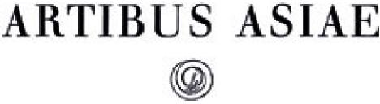

The Decoration of Mirrors of the Han Period

Author(s): A. Bulling and A Chronology

Source: *Artibus Asiae. Supplementum,* Vol. 20, The Decoration of Mirrors of the Han Period

(1960), pp. 3-5+7+9+11-32+34-39+41-46+48+50-52+54-64+66-74+76-78+80-116+I-L Published by: Artibus Asiae Publishers

Stable URL: <http://www.jstor.org/stable/1522594>

Accessed: 24/05/2011 16:04

Your use of the JSTOR archive indicates your acceptance of JSTOR's Terms and Conditions of Use, available at <http://www.jstor.org/page/info/about/policies/terms.jsp>. JSTOR's Terms and Conditions of Use provides, in part, that unless you have obtained prior permission, you may not download an entire issue of a journal or multiple copies of articles, and you may use content in the JSTOR archive only for your personal, non-commercial use.

Please contact the publisher regarding any further use of this work. Publisher contact information may be obtained at <http://www.jstor.org/action/showPublisher?publisherCode=artibus.>

Each copy of any part of a JSTOR transmission must contain the same copyright notice that appears on the screen or printed page of such transmission.

JSTOR is a not-for-profit service that helps scholars, researchers, and students discover, use, and build upon a wide range of content in a trusted digital archive. We use information technology and tools to increase productivity and facilitate new forms of scholarship. For more information about JSTOR, please contact [support@jstor.org](mailto:support@jstor.org).

|  |  |
| --- | --- |
|  | *Artibus Asiae Publishers* is collaborating with JSTOR to digitize, preserve and extend access to *Artibus Asiae. Supplementum.* |

A. BULLING

THE

DECORATION OF MIRRORS

OF THE HAN PERIOD

A CHRONOLOGY



MCMLX

PRINTED IN SWITZERLAND

*To the memory of my Mother*  
ANNE BULLING

CONTENTS

Foreword 9

Introduction II

Western Han period 16

Shou-chou mirrors with dragon arabesques 17

TLV mirrors 20

*Ts'ao-yeh* mirrors 23

Survey 24

Mirrors with simple spirals 25

Mirrors with four snakes z6

Inscription mirrors z6

Related mirrors *(ching-pai* or *ming-kuang* mirrors) 30

Hundred Nipples mirrors 32

Miscellaneous mirrors 35

Development of TLV mirrors 36

Shou-chou mirrors decorated with figures of human beings 42

The development of bird mirrors 43

Time of Transition and the Eastern Han period 45

TLV mirrors 46

Guide for Dating 59

Centre fields 61

Border patterns 6z

Animal figures 64

Immortals 67

*Shou-tai,* 'animal-belt' mirrors 68

*Lung-hu (p'an lung)* and some other mirrors 73

Animal Head *(,Thou-,Thou)* mirrors and related types 77

Mirrors with four square seal panels 81

Inscription mirrors 8z

Mirrors with pictorial decorations *(hua-hsiang* or *shin-fin hua-hsiang)* 8z

Mirrors arranged in tiers *(chung-lieb ching)* 96

Guide for dating 97

Centre fields 97

Immortals *(hsien or shan-fin)* 98

Border patterns with animals 99

Scrolls and geometrical patterns ro 1

Conclusions 102

Bibliography 105

List of plates 109

List of large figures 112

List of small figures 113

Index 115

PLATES I to 81 I to L

FOREWORD

wish to express my thanks to all those who kindly permitted me to reproduce photographs of mirrors in their possession, in particular to the many collectors and museums. Above all

I

my thanks are due to His Majesty, the King of Sweden; Mr. Frank Caro, C. T. Loo Successor, New York; and Professor A. Wenley, Director of the Freer Gallery of Art, Washington, who most generously supplied me with photographs. I am specifically grateful to Miss Florence Wa­terbury and Professor Sueji Umehara for their permission to include in the book some of the mirrors previously shown in their own publications. I would also like to thank Professor B. Karlgren for his help in acquiring several photographs.

I owe a special debt to Professor A. Soper for reading the manuscript before it was sent to the publisher, and most of all to the late Professor A. Salmony who encouraged me to under­take the work.

Furthermore I am grateful to the Bollingen Foundation for their financial assistance which enabled Artibus Asiae to publish the work.

ANNELIESE GUTKIND BULLING

April 1959, Philadelphia (Pa.)

INTRODUCTION

or the art historian the final aim of all studies should be to interpret the evolution of art in terms of the changing ideals and intellectual or emotional aspirations of successive gene‑

**F**

rations. Such an approach will eventually lead the student to an understanding of the subtle pro­cesses causing changes in stylistic expressions and help to elucidate the invisible forces which determine man's destiny and the course of history. However, this goal can only be reached in stages. It presupposes many preliminary, less ambitious studies dealing with such matters as dates, the working out of a chronology, and the problems of iconography.

The present study is no more than a modest first attempt to establish a typology and, when­ever possible, a chronology of mirrors of the Han period. Although the Han period lasted for over four hundred years, little is known about the development of art during this time. From a historical point of view it is a fascinating time in which great changes took place, remoulding the whole social and intellectual structure of China. Judging from the number of objects that have survived the ravages of time and can be studied in collections and publications, works of art were produced on a large scale during the Han period and their variety and vigour reflected the intel­lectual and emotional atmosphere of their era.

Through new finds and excavations in China the number of works of art of the Han period is constantly growing and the need for dating these objects has become more pressing. However, the reluctance of students of Chinese art to embark on this task is understandable as very little is known about the provenance or the date of works of art in our collections. It is to be hoped that the excavations in China will provide us in due course with more reliable data. This lack of information makes work on a chronology of the art of the Han period rather hazardous and accounts for the vagueness of explanatory labels or captions in museums and publications which restrict their information in most cases to 'Han Dynasty' leaving us free to select any date be­tween 206 B. C. and A.D. **220.** A beginning must be made, however, and it has to be based on the few works of art dated by inscriptions and on those which can be placed into a certain range of time because they were discovered in tombs containing coins, inscriptions, dated pieces or other information relevant to their approximate date. In general, objects found in one tomb need not necessarily be contemporary. While some may have been made during the lifetime of the deceased, others may have been cherished as heirlooms long before the family placed them in the tomb.

Coins, of which a great number have been found in tombs, are a different matter altogether. They are hardly ever of great value and may have been in circulation for a considerable period prior to the burial: *e.* g. some coins found in Western Han tombs were cast in earlier periods.

Actually the tomb was a place fit for obsolete coins as they could still presumably serve their purpose in the other world. For this study coins are important because their presence in a tomb can provide a terminus 'post-quam' for the time of the burial.

Since in spite of all these handicaps a first attempt has to be made to trace the changes of style in the Han period, it should be understood that this study is meant to be no more than a scaffold or a stepping stone on which further research can be based. This survey has been re­stricted to bronze mirrors because there is a tremendous variety of different types which can be examined in collections and excellent publications. These mirrors are richly decorated and the changes in the motifs and in the style of the patterns provide a very good medium for a study of this kind. In general ornaments are more susceptible to changes of style than the shape of vessels or of other utensils, which is usually determined by utilitarian considerations or other factors that foster a more conservative attitude. It is often assumed that the power of tradition in China is so strong as to prevent changes in the styles of works of art comparable to those typical of the evolution of art in Europe. Although the problems appear sometimes to be more complicated, in general Chinese art undergoes stylistic changes no less than European art. To a certain extent the assumed stability of Chinese art is due to our lack of sensitivity in recognising the subtle differences between one style and another. Moreover, at our present stage of know­ledge we cannot yet attempt to disentangle the intricacies of stylistic differences due to regional variants or other factors. However, there is certainly some truth in the alleged conservatism of Chinese art as reflected in the better known field of Chinese porcelain where certain patterns were meticulously copied for centuries. It will be shown presently that similar trends can be discovered in some decorations of the Han dynasty.

An analysis of stylistic elements of patterns must of necessity have certain shortcomings; for analysis always involves the risk of losing sight of the work of art as a whole. However, if these risks are unavoidable the advantages of this type of study are also considerable. Motifs and pat­terns characteristic of one period or the other can be selected in such a manner as to reflect clearly the sequence of their evolution so that it can be followed without difficulties. The short "guides for dating" point out some of the most conspicuous features essential for establish­ing a chronology. They are presented in such a way as to facilitate a quick and easy consulta­tion. Used with caution they can be of considerable help in the dating or classifying of mirrors. However, a warning should be added. No single feature or pattern however prominently it may appear in a work of art can be regarded as the decisive factor in determining its date unless the work in its entirety conforms to the style of the period. In order to accentuate the essential fea­tures of patterns the drawings have, in many cases, been reduced to the bare outlines picking out most clearly the elements of line movement and other factors particularly relevant for dating.

The Han period has been made the nucleus of this study. It is, however, to be understood that its end and its beginning coalesce with the art of the preceding and succeeding periods. To draw clearly defined limits according to historical changes would be a futile attempt because the evo­lution of art is rarely immediately influenced by dynastic changes or other historical events. It is affected by stimuli of an altogether different type. The Han period falls into two parts, the West­ern or Former (zo6 B. C. — 9 A. D.), and the Eastern or Later Han period (A. D. 25 — 22o) with the short interlude of the reign of Wang Mang, the so-called Hsin or New Dynasty, in between. It is not difficult to differentiate between special types of mirrors produced in either

the Former or the Later Han period. This work is divided into two parts : the first dealing with the Former, and the second with the Later Han period. Whenever possible mirrors have been grouped according to whether they originated in the early, middle, or later part of either the Western or the Eastern Han period. The time between roughly, the middle of the first century B. C. and the middle of the first century A. D., has been singled out as a period of transition linking the styles of the Western to that of the Eastern Han period. However, the absence of mir­rors in the Former Han period with dated inscriptions makes an accurate chronology sometimes very difficult. Thus a more widely spaced span of time will have to serve as a basis for the dat­ing of mirrors. The only dated mirrors found so far are from the last two years of the Western Han period. They increase in number in the course of the second and third century, enabling us to follow their development more closely. However, it will be a long time before we can trace this development in decades.

This survey does not aim at including all the known types of mirrors. On the contrary, it is limited to well-known examples which were apparently produced in large numbers. The great variety of mirrors and the changing style of their decoration reflect the continuous interest which the people of the Han Dynasty took in these objects. Mirrors were used in rites, temples and tombs, and for toilet purposes. Their value was based on their religious importance, their my­sterious magic potency, and the pleasure derived from their beauty as works of art. For a full appreciation of the intricacies of shapes and decorations it is essential to realize that these mir­rors were originally meant to be replicas or images of parasols and canopies such as were used in all kinds of rites and ceremonies. As has been explained elsewhere= these were intended to represent in some form or other "the canopy of heaven". Hence, they were decorated with sym­bols pertaining to the sky such as thunder and cloud patterns, stars, constellation signs, or else, spirits and immortals travelling across the sky. The importance attributed to heavenly bodies can­not be overestimated because it was believed that they controlled the ever recurring cycles of time, and ruled over space, and were masters over the never ending cycle of life and death as well as of all human destiny. In some way or other the decoration symbolizes the laws of the universe and, for this reason, they are rightly called "cosmic mirrors". To a certain extent it can be said that the changing manner of their decoration reflects different systems of cosmological and meta­physical speculations.

In any case, no better visual expression of the eternal flux of time could have been found than the dragons, birds or wafting cloud signs shown on early Western Han mirrors, or the animals symbolizing the great constellations of the four seasons on later mirrors. They all seem to pursue one another as if they were eternally revolving round the sky. The correlation of space and time is based on the sun's orbit. Each of the seasonal constellations is believed to rule over a quadrant of the universe, and each of the zodiacal constellations over one month equalling a duodecimal section of the sky. Though the understanding of the various signs and symbols on these mirrors is very important and a fascinating subject, it lies outside the scope of this study and will be touched on only in a few isolated cases.

The chronology of mirrors will be based on an analysis of their respective forms of decora­tion, i. *e.* "their style" in conjunction with other factors which have a bearing on the problem.

Bulling, A. "The Decoration of Some Mirrors of the Chou and Han Periods", *Artibus Asiae,* Vol. 18, No. t, 1955, p. — Abbrev. Decoration of Some Mirrors.

We call "the style of a period" those shortlived features, forms, or mannerisms which were fashionable only during a particular period of time. Although the vagaries of style criteria are well known and their danger apparent, especially in relation to the art of the Far East there is enough evidence to show that certain mirror types flourished only during one part or the other of the Han period as long as they satisfied particular aesthetic and intellectual aspirations. Some mirror types and some patterns stayed in favour for centuries; others disappeared after only a short time of popularity. In general, mirrors differ from paintings and other individual works of art be­cause they have to be made in workshops and a number of mirrors can be cast from the same mould, which is used for a long time. New features and signs can easily be added to existing types when the popularity of the old ones begins to wane; but when the mirror finally loses its appeal production declines and finally stops. The changes in the decorations of mirrors of the same type and the introduction of new features provide a guide for dating and help to discover the line of evolution. In some cases we are able to follow a particular type of mirror from its formative stages to its perfected design, or its disintegration and decline. It should, however, not be forgotten that the workshops were sometimes owned by families and it is possible that some moulds were kept for generations ready to be used if some customers showed interest in a mirror which had long gone out of fashion.

Innumerable mirrors have been discovered in tombs of the Han Dynasty not only in China but also in Korea, Manchuria, and other neighbouring countries. These excavations laid the foundations for the study of the art of the Han period. Recent archeological discoveries in China have added to our knowledge, and the results of the excavations and finds have been published in books and periodicals. Unfortunately, in many cases, the conditions under which the excavations took place prevented accurate dating of the tombs and their contents although others proved of great help in the establishment of a chronology of Han mirrors, such as *Ch'ang­sha fa-chfieh pao-kao.2* Moreover, the summary nature of many reports and the poor quality of the reproductions sometimes diminish their value for the following study. It should be understood, however, that in many cases this is neither the fault of the excavator nor of the scholar because a great number of objects were not discovered in carefully planned excavations but found in the course of irrigation work or building activities.3 A great number of finds discovered in various provinces and exhibited in museums have been published in periodicals such as the *K'ao-ku hsfieh-pao, fren-wu ts'an k'ao t.tir liao4,* or the *K'ao ku t'ung hsfin.5* Unfortunately, especially in the two last named periodicals, the illustrations are poor and the information given in some of the articles is limited to the barest minimum, recording simply the shape of the tombs and the number and size of objects found in them. Mirrors were often found in many different tombs situated in burial places used for long periods and the meagre contents of individual tombs provided hardly any clue to the actual time of burial. The shape and construction of tombs can often be taken as a guide for dating because they change in the course of the Han Dynasty. Tombs of the early West­ern Han period do not differ from those of the preceding one. They consist of simple earth pits filled with gravel, or of wooden tombs mostly oblong in shape and divided into small compart‑

2 abbrev. Ch'ang-sha report.

3 *e.g.Ch'fian-kuo chi pen chien she, kung Wing chung ch'u t'u wen-wu than Ian t'u lu, Peking, 19 f f.*

4 abbrev. *Win-wu.* (Whenever articles in Chinese periodicals are mentioned the capital letters [A B and so forth] refer to the exact titles as listed in the bibliography under Chinese Periodicals).

5 abbrev. *K'ao ku t'ung* (for title of articles see bibliography).

ments. The exact dating of these tombs is very difficult except when they contained *pan-fiang* coins which proved that they could not have been built before zzi B. C. or *wu-chu* En coins first cast during Wu-ti's reign. According to a report, in Ch'ang-sha tombs built in the Western Han pe­riod were often dug deeper into the ground than those of the preceding period. It was only in the course of the Western Han period that tombs were built which had a slightly sloping road lead­ing into them. They became even more popular in the Eastern Han period. Great changes oc­curred in the Eastern Han period when tombs sometimes had up to four or even more cham­bers containing more than one coffin — sometimes that of a husband, his wives and children. In the course of this period the wooden tombs were increasingly replaced by tombs built of bricks. The different constructions of tombs can thus help in the dating of objects found in them. Dated inscriptions are rarely found in early Western Han tombs. They begin to appear in late West­ern Han tombs and increase in number in the course of the Eastern Han period.

The present study could not have been undertaken without the preliminary works of other scholars and collectors; foremost among them are Sueji Umehara, Liang Shang-chun, and B. Karlgren. All of these found it expedient to group mirrors according to their similarity in the basic type of decoration, shape or inscription. Though they differ widely in their classification and dating they have done the spade work necessary for a more detailed chronology of the changes in mirror styles during this period.

THE WESTERN HAN PERIOD

rofessor Karlgren's excellent study "Huai and Han"6 is certainly the best known work on Han mirrors in the West. It does not, however, cover the whole period but is restricted to the

**p**

discussion of pre-Han and early Western Han mirrors. This erudite study is a pioneer work and most valuable in formulating principles on which studies of mirrors should be based. Because he has collected a great amount of material which is readily available it seemed advisable to fol­low his groupings of mirrors (categories) and his nomenclature in the discussion of mirror types he has dealt with.

The criteria underlying Professor Karlgren's dating will be briefly restated and examined. As this study is concerned only with Han mirrors the types of mirrors which are decidedly pre-Han will not be discussed. Professor Karlgren shows that inscriptions are the foremost means for distinguishing pre-Han mirrors from those of the Han period. They are all written in the small seal script (e. g. Pl. 8,9,1o) which makes their introduction before the beginning of the Han period very unlikely. Although the decision to unify the script had already been reached in 221 B. C. the small seal script was not adopted before 213 B. C. and, in fact, it became only *ge­nerally* used in the course of the second century B. C. Even more important for the dating of so-called Shou-chou mirrors is the fact that the small seal script was based on the ancient script of the Ch'in people and, for that reason, Shou-chou mirrors with an inscription can hardly have been made before the second century B. C. as the people of Ch'u would certainly not have used the script of their most hated enemy, the Ch'in State, on any of their objects. This, as Profes­sor Karlgren concludes, allows us to place these mirrors in the early Western Han Period al­though, as none of these inscriptions contains a date, we do not know when in the second cen­tury people began to adorn their mirrors with inscriptions.

The name Shou-chou is given to a particular type of mirror *(H. & H.* cat. E. F. and others) because they were discovered in great quantities in the region around Shou-chou in the Huai river valley. This town was made the capital of Ch'u in the second half of the third century B. C. (241-222 B. C.). This does not mean that all mirrors found in the neighbourhood were made during this short period. The town must have been of some importance for a considerable time before and after its eminence as a capital. It suffered some vicissitudes of fate during the tumultuous years at the end of the century but it was still a great center and a capital during part of the time up to the death of Liu An (the famous prince of Huai-nan) in 122 B. C. From then on according to Dr. Karlbeck7 it lost its importance and soon after bronze factories in the vicinity closed down.

**6** Abbrev.: *H. & H.*

Karlbeck, 0., "Selected Objects from Ancient Shou-chou'. *BMFEA,* No. 27, 1955, P. 45.

However, this does not necessarily mean a discontinuance of the Shou-chou mirrors. The dis­covery of similar types in other regions of China suggests that they were made in neighbouring states and not only in the Kingdom of Ch'u. From a stylistic point of view most of the mirrors classed together by Professor Karlgren in his categories E. and F. form a coherent group and for convenience's sake will be referred to as Shou-chou mirrors. Professor Umehara calls this group the "so-called Ch'in mirrors", and Liang Shang-ch'un "Ch'in mirrors", but both use this term as covering a much longer period than that of the shortlived Ch'in Dynasty, extending roughly from the fifth to the second century B. C. In any case, the discovery of a great number of Shou-chou mirrors in Western Han tombs provides ample evidence that they were still made in large quantities during the Western Han period.

In Chinese and Japanese publications mirrors are grouped together under different headings. The most important will be mentioned in this discussion. This is essential as recent excavation reports refer to these group headings when speaking of mirrors found in tombs and often fail to give illustrations. However, the nomenclature used in Chinese and Japanese publications is by no means uniform and one and the same mirror might be described under different headings. In older publications mirrors with the same or similar inscriptions are grouped together irre­spective of the type of decoration. Sometimes the headings contain only the first characters of the inscriptions or else phrases are selected which are characteristic of the type or time.

SHOU-CHOU MIRRORS WITH DRAGON ARABESQUES

Shou-chou mirrors decorated with winding dragons are often called *p'an ch'ih, 11M, winding dragon* mirrors *(ch'ib* is sometimes interpreted as being a young dragon without horns). Typical of Shou-chou mirrors are small fluted central bosses and concave rims with sharp outer edges. In addition, often a plain ring or twisted rope pattern runs around the border or centre field of the mirror. Karlgren divides these mirrors into two groups; those in cat. E. *(H. &H.)* he holds to have been made in the second part of the third century (Pl. **2** and 3), and those in cat. F. in the second century B. C. (Pl. 4, 8, i I and Pl. 31). According to Professor Karlgren Shou-chou mir­rors with animal-shaped knobs or those with crouching creatures decorating the centre field are typical of the second century B.C. (Pl. 3,8,9,1o). One of his main criteria is background patterns. Because none of the mirrors with an inscription has a background pattern consisting of "granu­lation-bordered zig-zag lines or lozenges", Karlgren believes that all mirrors with this type of de­coration belong to the pre-Han or third century period. On the other hand "volutes and trian­gles" (P1.4, 8, I I) are retained as background patterns and can still be found on mirrors with in­scriptions. An innovation of the second century B. C. is a background pattern formed by "con­verging groups of parallel lines" *(e.g.* pl. 9 and 3 1) as this type can only be found on mirrors with inscriptions. Also missing on pre-Han mirrors are background patterns of a somewhat cruder type (Pl. 17) which were apparently introduced in the course of the second century B. C. Finally background patterns were abandoned altogether and Professor Karlgren adopts the turn of the second and first century B. C. as roughly the line between mirrors with and without background patterns.

In recent excavations, according to reports from China, mirrors of the category E. and F.

have been found in Western Han tombs which seem to indicate that both flourished at the same time and that category E. mirrors were still made during the Western Han period.8 In Ch'ang­sha mirrors found in pre-Han tombs9 differ from those found in Western Han tombs.'° The dragon arabesque on pre-Han mirrors is often less compact and drawn in relatively thin lines which prevents the decoration from looking overcrowded and gives it a more graceful and ele­gant appearance (see also Pl. z and 3) than on typical Western Han mirrors. Moreover, the lines on early mirrors are much less adorned with spirals and hooks than on later ones. So-called "curl-borders" occur more often on mirrors found in tombs of the Han period.

Mirrors of category F. were still found in a number of tombs containing *22)u-chu* coins Rao which were first cast in 118 B. C.. Although some of these mirrors may been heirlooms the number found in Han tombs may well indicate that they were produced at least as late as the end of the second or beginning of the first century B. C. Another type of mirror (cat. G.) seems to have still been made in the Han period. It was found in various tombs of the Western Han period.12 The assumption that this type of mirror was first made in the third century B. C. is supported by other specimens found in pre-Han tombs..3 However, there is a difference be­tween the earlier and later decorations of these mirrors. The latter has a moulded dragon pat­tern of an unusual design placed upon the patterned background (Pl. Similar decorations can be found on other mirrors presumably made in the second or even the beginning of the first century B. C. Mirrors as on Pl. I are often referred to as *pa-yao hsien-lien hu* r. AN, mirrors because their main decoration consists of an eight-lobed star. Even mirrors with slanting T-signs such as Karlgren shows in cat. C (C. 33,34) and dates third century B. C. have recently been discovered in a Western Han tomb.14 However, this is an isolated case and unless more evidence is forthcoming the mirror should be classed as a pre-Han mirror.

Common to all Shou-chou mirrors and other types of pre-Han and early Han times is their thinness. Professor Karlgren believes that with the exception of a few examples *(e.* g. *H. & H.* cat. K. 11,12) Pl. 14, these went out of fashion at the beginning of the first century B. C. One should bear in mind that these thin mirrors imitated a very common type of parasol where the cover was made of a patterned or embroidered textile fabric's overlaid with dragon arabesques or other decorations. On some mirrors *(e. g.* Pl. z) one can see small double lines running across the bodies of the dragons. They imitate the threads with which the arabesques were sewn onto the textile base of the cover. The dragons may have been cut from leather or some textile fabric.

The dragon or dragon arabesque on Shou-chou mirrors are worked in two ways. They are either made of flat bands or of more deeply moulded threads of varying degress of thickness. The flat band can be found on many mirrors made in pre-Han times and is certainly the earlier version of the two. On P1. z and 3 four dragons are shown in flat band relief, their feet resting

8 In some reports the dates given to tombs and their contents are based on a rather arbitrary assessment of the available material and should be used with caution.

9 Ch'ang-sha report. Pl. zo (3) and Pl. 21 (z).

19 *Ibid.* Pl. 43 (I and 3), P1. 44 (3 and 4).

11 *e. g.* 1956, No. 5, p. 30 (B); *K'ao ku t'ung,* 1957, No. 3, p. 17 (F); *ibid.* 1957, No. 5, p. 44 (J).

12 *K'ao ku t'ung.* 1957, No. 5, P. 44 *(J); ibid.* 1958 No. 2, p. zz (M).

*e. g.* Ch'ang-sha report, Pl. 20 (I).

14 *Ibid.,* Ch'ang-sha report, Pl. 43 (z).

15 Bulling, A. 'Decorations of Some Mirrors', op. *cit.,* p. 24/25.

on the inside border of the main zone of decoration; on Pl. 3 their bodies are linked with open lozenges in such a way that a loosening or tightening of the coils of their bodies would effect an opening or closing of the lozenges. The centre of the mirror (Pl. 3) is adorned with three run­ning dragons with trunklike noses. They are worked in lightly moulded relief with stripes and raised hooks not unlike the dragons on Pl. i. Professor Karlgren thinks that both these mirrors (Pl. z and 3) were made in the third century B. C. because the main zone of decoration, although well filled, is not yet overcrowded and the dragons have not completely disintegrated into ara­besques. The leading lines although adorned with a few hooks and heart-shaped motifs are not yet frayed by curl-borders. However, recent excavations have shown that this system of dating cannot always be applied and that mirrors with this type of decoration were still very popular in the early Han period, though the narrow band and the line movement on Pl. 2 are more akin to the style of pre-Han days. This mirror may be compared with one discovered in a Ch'ang-sha tomb of the Warring Statesl6 while the more dynamic line movement (Pl. 3) resembles those on a mir­ror found in the same place in a Western Han tomb.'? The two mirrors shown on P1. 4 and 5 are definitely Western Han. Similar types have been discovered in Western Han tombs in Ch'ang­sha and other places's. Their arabesques are drawn in broader lines and lack the elegance of the pre-Han and transitional style.

The mirror on P1. 6 contains features which Karlgren lists as typical of second century types, such as the splitting of the band relief into double lines on parts of the bodies of the three dra­gons and on the open lozenges, (cf. Pl. 4) and the change in the shape of the dragon heads which look rugged with their long snouts. They appear to be more ferocious creatures than their counterparts on earlier mirrors (Pl. 2 and 3) with their slicker and more snake-like heads. They are certainly expressive of the lively spirit typical of Han art in the second and first centuries B. C. The empty space between the coiling bodies of the dragons has been filled, to a greater degree than on earlier mirrors, with hooks or scrolls, and the heart-shaped motifs have been turned into less regular plant-like forms. All these elements are even more pronounced on the mirror shown on Pl. 7. It differs from the more common type of Shou-chou mirror because its rim is decorated with scallops. They imitate festoons or a cornice-like crown of arcs attached to the edge of a parasol, a decoration often found on ceremonial parasols and canopies all over the world. These arcs indicate that the parasol must have been slightly convex or pyramidal as otherwise they would hide the decoration of the cover from view. Such festoons can be found on mirrors of pre-Han date and are not an innovation of the Han period. However, in the latter part of the second century and during the first century B. C. they became one of the most pop­ular decorations of mirrors, which suggests that this mirror was made not before the latter part of the second century B. C. The band relief is even more split into double or triple lines than on earlier mirrors. The bodies of the dragons branch out into long hooks resembling fea­thers or twisted leaves. Curl-borders, like rippling waves or clouds, run all along the leading lines. All these features express the artist's wish to enhance the impression of turbulent move­ment. This design is inspired by the new spirit of the Han period which gained momentum in the latter part of the second century B. C.

**16** Ch'ang-sha report, Pl. **21 (2).**

**17** *Ibid.,* P1. 43 (I).

18 *Ibid.,* P1.43 (3); *Win-wu,* 1956, No. 5, P. 30 (B); *K'ao-ku-t'ung,* 1957, No. 3, p. 17 (E); *K'ao ku buieb pao,* 1958, No. **2, P1. 14** (5) (A).

The other type of decoration introduced in the course of the second century B. C. is charac­terized by narrow and high threads running parallel in two or three lines (Pl. 8, 9, 1o, I I). The mirror on Pl. 8 is again filled to capacity with dragon-cloud arabesques and other motifs which Professor Karlgren calls "brush-like petals". The seat of the boss is decorated with crouching animals in the manner often found on Western Han mirrors. The pattern on the main zone of decoration is very intricate and the dragons are more difficult to distinguish than on previous mirrors. Their bodies do not simply wind up and down in alternately opening C-shaped scrolls but run all over the mirror in irregular scrolls. Sometimes they are only loosely attached to the main lines. Raised spirals or loops branch off the leading lines, yet nowhere do they turn into real curl-borders. The new thread-line relief, the complicated "brush-like petals", the raised spiral-endings, and the general overcrowdedness of the decoration show that the artist was eager to find more forceful ways of expressing dynamic movement suggestive of a tempest or a sky covered with wind-swept clouds. A similar mirror was found in a tomb from the first half of the Western Han period in Ch'ang-sha.10 In general, it appears that the number of band-relief mirrors found in early Western Han tombs is much greater than those with thread-relief, a factor suggesting that the more traditional form of decoration had a strong hold on the people. Both types were used concurrently for quite a time; however, towards the end of the second century B. C. the thread-line relief replaced the band relief in popularity. Although Karlgren does not want to commit himself to a more precise dating than just second century B. C. there seems to be some justification for assuming that the thread-line relief on mirrors as shown on Pl. 8—I I was not used in the beginning of the second century B. C. and that its popularity increased du­ring the last part of the second century and was not altogether abandoned in the first century B. C.

TLV MIRRORS

The most important innovation of the Han period is certainly the use of inscriptions. The example on Pl. 8 is typical of the early Western Han specimens. It begins with the words *"ta-lo kuei-fu"*A-EA-1 and a fish is placed between the end and the beginning of the phrase. Second in importance is the introduction of the TLV signs which, from the middle of the second cen­tury B. C. onwards, became one of the most widely used mirror decorations. "TLV"is a Euro­pean term though it has been adopted by modern Chinese scholars. In most Chinese and Japa­nese publications these mirrors are not grouped together but listed with others according to common features such as similar inscriptions, numbers of nipples, or decoration of knob-seats. The changing style of TLV mirrors provides one of the best mediums for the study of the sty­listic evolution of the Western and Eastern Han periods. The first question confronting us is at what point in the course of the Western Han period were these signs first introduced as a deco­ration for mirrors.20 Dr. 0. Karlbeck relates them to the Prince of Huai-nan, famous for his in‑

19 Ch'ang-sha report, Pl. 44 (3).

20 The meaning of the TLV and other signs on these mirrors has been discussed widely, *e. g.* by W. Perceval Yetts, *The Cull Chinese Bronzes,* p. 226ff.; Schuyler Cammann, "TLV patterns on Cosmic Mirrors of the Han period", *Journal of the American Oriental Society,* Vol. 68. Oct./Dec. 2948, pp. 159-268; "Suggested Origin of the Tibetan Mandala Paint­ings", *The Art Quarterly,* Spring 195o; Sidney M. Kaplan, "On the Origin of TLV mirrors", *Revue des Arts Ariatiques* XI, 1937; A. Bulling, 'Decoration of Some Mirrors', *op. cit.,* p. 32 and 42/43.

terest in astronomical and cosmological speculations, who was active in the third quarter of the second century B. C. The mirror on Pl. 9 resembles very closely the one on Pl. 8 and must have been made at about the same time. It differs insofar as the knobseat is surrounded by a square frame which carries the inscriptions and, in addition to the crouching animals, the corners and sides of the central square are filled with plant-like or feather-like motifs. The "brush-like pe­tals" branch out from the four corners of the square. The background pattern consists of vo­lutes, triangles and "converging groups of parallel lines" resembling a plaited design. The dra­gons are again worked in a double-or triple-line thread-relief and are placed antithetically in pairs at both sides of the "brush petals". Though the main zone of decoration is slightly less crowded than on Pl. 8 the main lines form similar large rounded scrolls. One of the differences between these two mirrors is that on Pl. 9 the dragon arabesques run in two parallel lines divi­ding the main zone of decoration into an inner and outer section. The inner one is filled with the four pairs of dragons, the outer with arabesques not connected with the dragons but run­ning more or less independently around the outer border of the zone. Such an arrangement foreshadows the formation of a separate border pattern which appears first on TLV and other mirrors in the course of the first century B. C. On these mirrors the outer arabesque is not yet consecutive but interrupted by V-signs filled with small dragons. A long inscription circles the square centre and continues on the outer side just inside the rim of the mirror. This again is a sign of transition. In the first century B. C. (and on many TLV mirrors with a Wang Mang date) inscriptions are very often in the same place or on the rim. Thus the mirror serves as an example of the stylistic evolution which took place, roughly, between the middle and the end of the second century B. C. Phrases used in inscriptions are often a guide for dating; typical of Western Han is the inscription on this mirror which begins with the words *"nei-ch'ing chih i chao ming-kuang"* pci-nwo **V. .**

The background pattern on the TLV mirror, Pl. 1o, resembles that on the previous mirror. The dragons in the main zone of decoration have lost all semblance to animals although heads may be discerned in the scrolls on the left side of the V-signs. As on the previous mirror the ends of the scrolls run into gently curved hooks and the leading lines are adorned with slightly raised spirals. The main difference between this and the two previous mirrors is its greater simplicity. The main zone of decoration is less crowded and the lines no longer move in large sweeping curves. This less ornate type of decoration can be interpreted as a reaction against the too elaborate style which became fashionable in the course of the second century B. C. This does not necessarily mean that this mirror is of a much later date than the two preceding ones, for there are many examples in the history of art which show that even before a certain style has reached the height of its popularity trends can be discerned which will force the development in an opposite direction.

The knob on the TLV mirror, Pl. II, is shaped like the back of a tortoise and is placed in a relatively small seat. The inscription is set inside the main zone of decoration above the square and not in the band surrounding the square in the centre part of the mirror. During the later part of the second and in the beginning of the first century B. C. such short inscriptions were often included in the main zone of decoration. The one on Pl. i i reads *‘ch'ang-lo wei-yang' •\** a phrase which was used for a long time. It is written in a stylized form of the ancient seal script which differs from that on most Shou-chou mirrors. This again is a clue to its date

because this kind of stylization of script started in the last years of the second century B.C. and, as will be seen presently, became even more fashionable in the course of the first century. The background is decorated with`volutes and triangles' which does not necessarily indicate a second century date. The decoration of the main zone is worked in a double-line thread-relief and the four dragons are not arabesques but animals with clearly defined heads and limbs. They are individual creatures and very different from the more pattern-like dragon arabesques of the previous mirrors. The leading lines have vigour and the distribution of the decoration has a rococo-like gracefulness. The lines are rather sparsely adorned with spirals and hook-like end­ings. The most probable date of this mirror lies between the last half of the second and the first part of the first century B. C.

The stylistic changes of TLV mirrors with dragon patterns in the first century B.C. are well exemplified in the mirror of Pl. 12 which no longer belongs in the so-called Shou-chou group. Not only has the background pattern been omitted but the four dragons are no longer worked in double- or triple-thread lines but in a single rather high line of relief. Though the mirror lacks the elegance and delicate beauty of the previous one the drawing of the dragons is no less vigorous and the more corporeal and easily discernable dragons are expressive of a new feeling for form. In addition to the long snouts with their protruding tusks they have long curling tongues which give them a snake-like appearance. However, the similarity between the line movements and the place given to the four dragons on both mirrors (Pl. i i and 12) illustrates their successive development. The round knob and the four leaves with their long needle-like endings confirm that this mirror was not made before the first century B. C. although it probably originated before the middle of the century.

A very different type of mirror is shown on Pl. 13. Its main decoration consists of 'brush­like petals'. In addition it has four bosses in the main zone of decoration and is one of the earliest examples of the large group of four-nipple mirrors. The 'brush-like petals' sometimes referred to as 'open winged bird signs' (birds have no heads) branch out in pairs from the four bosses. The V and L signs are in a different position insofar as they do not touch the rim of the mirror or the ring around the main zone of decoration but are placed more towards the centre of this zone. This position is of particular interest because it has nothing to do with aesthetic consider­ations but with the difficulties facing the parasol maker who wished to incorporate the TLV signs in the decoration of a cover surrounded by a circle of upright arcs. In order not to hide the V and L signs from view they were raised above the arcs and placed on small sticks sunk into the rim of the parasol thus allowing them to show above the circle of arcs. This was fairly easy in the case of the V signs which could be balanced by attaching the stick to the centre, but proved more difficult in the case of the one-armed L signs. A solution was found by attaching a yoke to the upper part of the stick counterbalancing the pull of the arm by the weight of some decorations on the other side of the stick. On another mirror of the same type, listed by Professor Karlgren *(H. & H.* cat. K. 9), the problem was solved in a slightly different manner, *i. e.* by attaching the L's to the T signs and joining both to the band surrounding the square around the knob seat. How the difficulty of combining the TLV signs with a ring of arcs was finally solved is exemplified on Pl. 12. An outer zone of the cover was left undecorated and the L and V signs were placed inside the inner ring which surrounded the main zone of decoration. Assuming the cover to be convex the signs should show above the circle of arcs running around

the circumference. There are more signs indicating that the mirror shown on Pl. 13 represents an experimental stage in the development of parasols as well as in mirror designs. For instance, the 'brush-like petals' are attached to the four bosses whereas on most mirrors they are shown branching out from the corners of the square. The parasols imitated by these mirrors must have been rather fragile constructions because the L and V signs fixed rather precariously to sticks and jutting out from the rim, as well as the 'brush-like petals' only loosely attached to the bosses, were always in danger of being broken off. The omission of TLV signs on most of these mirrors (Pl. 14) (Karlgren *H. & H.* K. II— .14) suggests that these parasols did not remain pop­ular for long and were succeeded by a less complicated type. The inscription which contains the same phrase as that on Pl. I i *(ch'ang-lo Wei yang) PA'M\** is set in the main zone of decoration. This points to a date between the later part of the second century and the beginning of the first century B.C. (roughly between 13o and 8o B. C.).

*TS'AO YEH* MIRRORS

The further development of this type of mirrors is shown on Pl. 14 and i 5. They are mostly referred to as *Vs'ao yeh' Vt-* mirrors because of the plant-like decoration on the corners of the square. Particularly interesting are the long needle-like motifs of the 'brush-petals' which look as if they could swing like a pendulum. The inscription on both mirrors is placed on the broad band surrounding the square knob seat; this is the most common place for inscriptions on mirrors from the middle of the second century onwards throughout the Western and Eastern Han period. There is an important difference in the style of the script on these mirrors. The one on Pl. i5 has been stylized by squaring each character and avoiding the use of curved lines. This particular use of characters is typical of the first century B. C. Some of the phrases used in the inscription on Pl. 14 are common to Western Han mirrors, *e.g. "chien jib chih kuang, ch'ang wu hsiang Wang"* El )1E, -01 . Mirrors with such inscriptions are often grouped together and re­ferred to simply as *hsiang-wang or jih-kuang* mirrors. In some cases the second part of the phrase is different and reads *"tien-hsia ta-ming"* IN. The knob-seat of the mirror Pl. 14 is decorated with an animal whose back is formed by the fluted knob. Mirrors resembling the one on Pl. 14 have been discovered in tombs of the later part of the Western Han period2I and fluted knobs may not have been altogether out of fashion in the first century B.C. The quatrefoil decorating the knob-seat on Pl. 15 leaves no doubt that this mirror belongs into the first century B.C. The particularly long needle-like endings of the four leaves and the general smoothness and elegance point to a date somewhere between the middle and the end of the first century B. C. One of the signs by which an earlier Western Han mirror can sometimes be distinguished from a later one is the use of raised spirals *e.g.* as seen on the 'brush petals' (Pl. 13). Those on later mirrors do not have such spirals (Pl. i5).

**21** Ch'ang-sha report, P1. 67 (t).

SURVEY

So far the discussion of Western Han mirrors has shown that the political upheaval which marked the end of the third century B. C. and led to the establishment of the Han Dynasty had very little immediate influence on the style and decoration of mirrors. There is no evidence of an abrupt departure from accepted mirror types during the first decades of the Han Dynasty; on the contrary, mirror types of the third century B. C. were apparently used without much change in the early part of the Western Han period. It is beyond doubt that Kao-tsu, the first emperor of the Han Dynasty, did not take any interest in artistic or intellectual pursuits. During most of his time and in the first decades of the second century B.C. the country was still in turmoil. The Han family came from humble stock and neither they nor their supporters, whom they raised to high positions, could be expected to cultivate higher learning or the arts. The artistic tradition was kept alive by the cultured section of members of the former society living in the countryside and holding on tenaciously to the style and refined taste of former days. As often happened in similar circumstances in other civilizations these people may well have looked with amusement and contempt at the rather uncouth manners and lack of elegance of the nobility newly created by the Han Emperors. These newcomers could hardly challenge the established modes of design as they lacked confidence in their own taste and accepted unquestionably traditional aesthetic values because they were not yet used to their exalted positions and new style of life. They would thus be the last ones to support sweeping changes in the form and decoration of mirrors. During Wen ti's reign (179-156 B. C.) the economic and social conditions began to ease a little. This may have had repercussions on the production of mirrors though probably more on an increase in their numbers than on a change of style. However, at the same time, the intellectual atmosphere began to change; ancient rites were revived; ancient forms of thought and political doctrines were studied; history and legends were explored and reinterpreted in conformity with the current situation and regime. This intellectual revival gained momentum in the course of the later part of the second century B. C. especially during Wu ti's reign (14o-86 B. C.). He was one of China's greatest rulers and his interests ranged far beyond conquest and policy making. His impact on the social structure of society was immense. He broke, once and for all, the power of the feudal nobles who henceforth were forced to spend most of their time at court while their fiefs were being administered by an official appointed by the Emperor. Thus the capital grew in importance as a centre of wealth and a market for works of art. The first part of Wu ti's reign was a period of intense intellectual activity giving rise to the most famous historians and philosophers of the Han period. The more turbulent mirror decorations reflect the changes which were taking place in the middle and later part of the second century B.C. Moreover, an even clearer indication of a new intellectual atmosphere and vitality is the creation of new mirror types. Although the mirror maker did not invent new forms of deco­ration but merely copied parasols, the imitation of new types of parasols is no mean under­taking and presupposes some experimentation. New ways had to be found which could re­produce three-dimensional objects on a flat disk. The pleasure taken in experimenting with new forms is well exemplified in such mirrors as are shown on Pl. 13. The difference between band-relief and thread-line relief on Shou-chou mirrors may appear to us a minor change but the people of that time connected them with two different types of parasols. On one the dragon

arabesques were cut out of flat bands of leather or textile fabrics while the others were made of narrow strips of leather, or strands bundled together in parallel lines. Loose ends were often turned into loops or slightly raised spirals.

As has been pointed out previously the evolution of style does not move in one direction only. So far we have mainly followed the development of Shou-chou mirrors which reflected a tendency to crowd the surface of the mirror with very elaborate dragon arabesques. A number of other types exemplify even more clearly the wish to simplify the decoration by replacing the intricate and sophisticated dragon arabesques with somewhat coarser designs in plain geom­etrical patterns. This development is hardly based on mere aesthetic considerations. It was cer­tainly stimulated by intellectual pursuits such as the renewed interest in ancient rites or half-forgotten symbols which began at the time of Wen ti. In this case, as in many others, the return to simpler forms can be interpreted as the wish to purify art and to restore the integrity and simplicity of an earlier period.

MIRRORS WITH SIMPLE SPIRALS

The mirror on Pl. 16 is a good example of this trend. It has 'brush-like petals' attached to the four corners of the inner square and the inscription is placed in the main zone of deco­ration comparable to the one on Pl. 13. It refers again to the 'light of the sun' but the second part reads *"tien-hsia to ming"* Tt FA . The main decoration consists of four spirals, each formed by three C-signs opening in alternating directions. Although they derive from the dragon arabesques the zoomorphic element has disappeared completely. They have acquired a less direct and more abstract appearance. The difference is striking if we compare this mirror with Shou-chou mirrors as, for instance, on Pl. 8 and 9. The relief is less flat and a more sculptural element has been introduced by raising the ends of the spirals on the main scrolls as well as on the 'brush-like petals' (cf. Pl. 13). In a tomb in Ch'ang-sha22, dating from the first half of the Western Han period, there was found a mirror showing similar features in its main decoration and having the same deeply moulded background pattern as Pl. 16. As Dr. 0. Karlbeck23 has shown these mirrors were cheaper to produce because they were cast in a different manner, *i.e.* a simpler process than that used for Shou-chou mirrors (Pl. z— II). This deeply moulded back­ground pattern can hardly be an imitation of a finely patterned textile but may well have been the replica of a parasol cover made of cheaper and coarser material or even of coiled and plaited straw. What distinguishes the mirror from all preceding ones is that the ring of arcs does not follow the circumference of the mirror but runs around the central field which is separated from the slightly everted rim by a groove. The differences and resemblances between this mirror and others allow us to assign its date to the time between the later part of the second century and the beginning of the first century B. C.

A very typical example of this simplified type of decoration is the mirror shown on Pl. 17. The dragon arabesques are reduced to four simple S-spirals. Such mirrors have been found in tombs of the Western Han period, though the shape and content of most the tombs did not

**22** Ch'ang-sha report, Pl. 44 (z).

23 Karlbeck, 0., *Catalogue of the Collection of Chinese and Korean Bronzes at Hallwyl House,* Stockholm 1938, p. 31.

allow for a more precise dating24. The background pattern is even more deeply moulded than on the previous mirror. It consists of what Karlgren calls "converging groups of parallel lines" which look as if they imitated a parasol cover made of straw, reed, or even small bamboo sticks providing a cheap base for the four S-signs. These mirrors were often made of a whiter metal than others. They were particularly popular during the Middle Western Han period (about 130-8o B. C.) and probably on account of their cheapness were produced in great numbers.

MIRRORS WITH FOUR SNAKES

Mirrors decorated with four nipples and four snakes are often referred to as *sstiju*

mirrors. The mirror on P1. 18 is a good example of an opposite trend. The arabesques are turned back into animals with easily recognizable heads and limbs. They are set on a plain background surrounded by a thick ring of arcs. Each of the four snakes fills a quarter of the mirror. The relief is deeper than on any previously discussed mirror and its sharp edges resemble the clear outline of a woodcarving. This time the knob is a large cone set in a narrow square. A sign indicating its date are the four needle-like motifs which extend from the knob to the cor­ner of the square. This type can be found on a number of other first century B. C. mirrors. The sculptural quality, the crispness of the decoration, and the heart-shaped ornaments on the legs of the snakes are more typical of the first part of the first century B. C. than of the later.

The mirror, Pl. 12, exemplifies another trend in the development of the four-snake motif. The treatment of the animals has lost its sculptural quality and carved aspect and the bodies are formed by a single, rounded line. On the four-nipples mirror, Pl. 19, the snakes are again re­duced to double spirals drawn in a thin thread-line relief. It is symptomatic of the stage of de­velopment that this mirror has regained a smooth surface and an appearance of elegance very different from that of the second century B. C. On this mirror the spirals have become the playing ground for birds which rest under and above them. On many similar mirrors both ends of the spiral are adorned with flame-like endings and plant-like motifs, or small scrolls are strewn all over the surface while animals chase in and out of the spirals. Mirrors of this type have been discovered in a number of Western Han tombs25 some of which could be identified as belonging to the later part or end of the Western Han period. In fact, the design on the knob-seat on some of these mirrors leaves no doubt as to their particular popularity during the later part of the first century B. C.

INSCRIPTION MIRRORS

Another innovation of the Middle Western Han period is mirrors decorated mainly with inscriptions. Although they probably originated at the end of the second century B. C. they gained popularity during the first century B. C. and were not even completely abandoned in the

*24 e. g. K'ao ku t'ung,* 1956, No. z, p. 63 resembling closely *H. & H. cat. J.* 22.

25 *e. g. K'ao ku t'ung,* 1956, No. 1, p. 37 (A); *ibid.,* No. 6, Pl. 10 (2) (D); Ch'ang-sha report, Pl. 69 (I).

first century A.D. Their development provides a guide for the evolution of style during this period. The earliest examples shown by Karlgrenz6 have small fluted knobs and the characters are placed either between the four V-signs or the four bosses. Such mirrors could certainly have been produced cheaply and in large quantities. The mirror on Pl. zo is typical of the develop­ment in the earlier part of the first century B. C. The inscription is placed in the main zone of decoration so that characters alternate with spirals and squares. On some mirrors of this type a sign is placed between the characters which many scholars think stands for the character *erh* and for this reason they are called *erh-t#Iff14--* mirrors, although *erh ffid* can hardly be part of the inscription because it does not make any sense. However, it resembles motifs found on lacquer and other objects of the Western Han period and its probable meaning will be discussed later. Another name for these mirrors is i *t'i tai,*Aw4-- mirror because the inscription is written in a strange style. The inscription on P1.2o contains the familiar phrase "Looking at the light of the sun let us forever not forget one another". R,Ei.)1ERITM,S. The knob is still small and fluted although this does not necessarily indicate a second century B. C. date, especially not when the motifs on the zone surrounding the knob-seat are of a type often found on mirrors of the first century B. C. They consist of four groups of straight lines radiating from the centre alternating with four groups of slightly curved lines. This design became increasingly popular in the course of the first century and was carried over into the early part of the Eastern Han period although some of the signs underwent minor changes. This mirror has no inner ring of arcs (cf. Pl. 22) and the radiating lines connect the central section with a plain ring. It resembles closely a mirror from Ch'ang-sha27 which was found in a tomb of the later part of the Western Han period. The popularity of such 'inscription mirrors' is affirmed by the quantity found in other tombs of the later Western Han period28. The curved and straight lines on this mirror and on others imitate structural parts of the parasol. The curved lines are replicas of bent stays or ribs and the straight ones of cords connecting the upper part of the cover with the lower one.29 The centre part of these covers, the apex, was connected with the outer, the lower part, by stays and cords which gave it the appearance of a 'two-tiered parasol' leaving an open space between the apex and the lower part of the cover.

Mirrors divided into concentric zones by heavy rings are often called *chung ch'ilan* mirrors. On Pl. 21 two bands of inscriptions are separated by such a ring. The fashion of plac­ing a ring over the middle of the main zone of decoration can be found already on mirrors of the second century B. C. A mirror found in a tomb of the first part of the Western Han period3° resembles those shown by Karlgren in cat. J. 7-12 *(H. & H.).* Another one from an early Western Han tomb in Cantons. has no decoration except the rings. All are divided into four parts by either rosettes or simple studs. Scallops not unlike those on Pl. 7 surround the circum­ference of the mirror discovered in the tomb near Canton. The bands on all these mirrors differ from those on later specimens in that they are concave resembling split bamboo tubes while the later rings are plain and flat bands. In contrast to earlier types of mirrors Pl. 21 has a small and

**26** *H. & H.* cat., K. 16 and 17.

**27** Ch'ang-sha report, Pl. 67 (4), (tomb 256).

**28** *e.* g. Ch'ang-sha report, **Pl.** 67 (3); Pl. 68 (2 and 3), Pl. 69 (4).

**29** For more details see: Bulling, A., "Decorations of Some Mirrors", *op. cit.,* p. 32. 3° Ch'ang-sha report, **Pl.** 44 (2).

**31** *K'ao ku bsiieh pao,* 1958, No. **2, Pl.** 14, (6) (A).

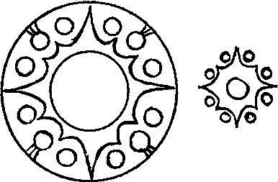

flat rim which indicates a later date. It closely resem­bles a mirror found in Ch'ang-sha in a tomb of the later part of the Western Han period.32 The knob is hemispherical although small in comparison with those on later mirrors. It is placed on a star-shaped base surrounded by twelve flat disks set between the b points. Such centre designs can be found on many

mirrors. They were especially popular in the later a part of the Western Han period (fig. i a and b) and will be called 'cogged or spiked wheel' patterns. These mirrors were in great demand from about 8o B.C. to the end of the century.

Figs. r a and b  
Design of centre and of nipple

A 'cog-wheel' centre of a little different construction is shown on on the mirror of **Pl. zz.** The main decoration is again an inscription. A new feature is the ring of arcs which, instead of surrounding the circumference of the mirror, merely encloses its inner section. Similar designs can be found on many mirrors of the later part of the Western Han period, and even during the first century A. D. The ring of arcs is connected with the inner circle again by curved and straight lines. They serve the same purpose as those on the simpler mirror, Pl. zo, although they imitate a slightly more complicated parasol cover. Another mirror similar to Pl. **22** was found in a tomb in Ch'ang-sha.33 Judging by the contents of this tomb it is safe to say that this mirror belongs to the later part of the first century B. C. It is interesting to compare this mirror with two other 'inscription mirrors' found in Ch'ang-sha34 in tombs of the later part of the Western Han period. On both, the type of script is more archaic than on those shown in Pl. **21** and **22,** and the crown of arcs encloses a simple centre design resembling the one of Pl. zo. These may represent an intermediate stage between Pl. **20** and 22. These mirrors were highly valued by Chinese scholars interested in ancient inscriptions, and they were copied in later periods es­pecially during the rule of the Sung Dynasty.

Mirrors with this inner circle of arcs are referred to in many publications as *`nei-hsiang lien bit'* 1'1 rii310, mirrors. The one on Pl. 23 was discovered in a tomb in Korea. It is one of the few early mirrors dated by an inscription and was made in 6 A.D. It differs from the two preceding ones by having a wide and heavy rim akin to TLV mirrors with an inscription referring to Wang Mang or the Hsin Dynasty. As is to be expected the script on this mirror is similar in style to those grouped together by Professor Karlgren in cat. L. *( H.& H.).* However, gone are the long needle-like endings on the quatrefoil of the knob-seat as shown on Pl. **12.** The sur­rounding zone decorated with a plain ring linked by lines radiating from the centre to the circle of arcs is not unlike that on Pl. **zz.** There are, however, slight variations in the details, *e.g.* the four groups of straight lines are crossed by another one. Other mirror centres suggest that these cross-lines often copied a square frame made of thin wire, bamboo sticks, or even of threads which was placed below the top of the parasol cover. It could not be seen from above except in places where it was not hidden by the arcs.35 None of the lines radiating from the inner ring on

**32** Ch'ang-sha report, Pl. 68 **(3).**

**33** Ch'ang-sha report, Pl. 67 **(3).**

**34** *Ibid.,* Pl. 68 (2) and 69 **(4).**

**35** Bulling, A., "Decoration of Some Mirrors", *op. cit.,* p. 33.

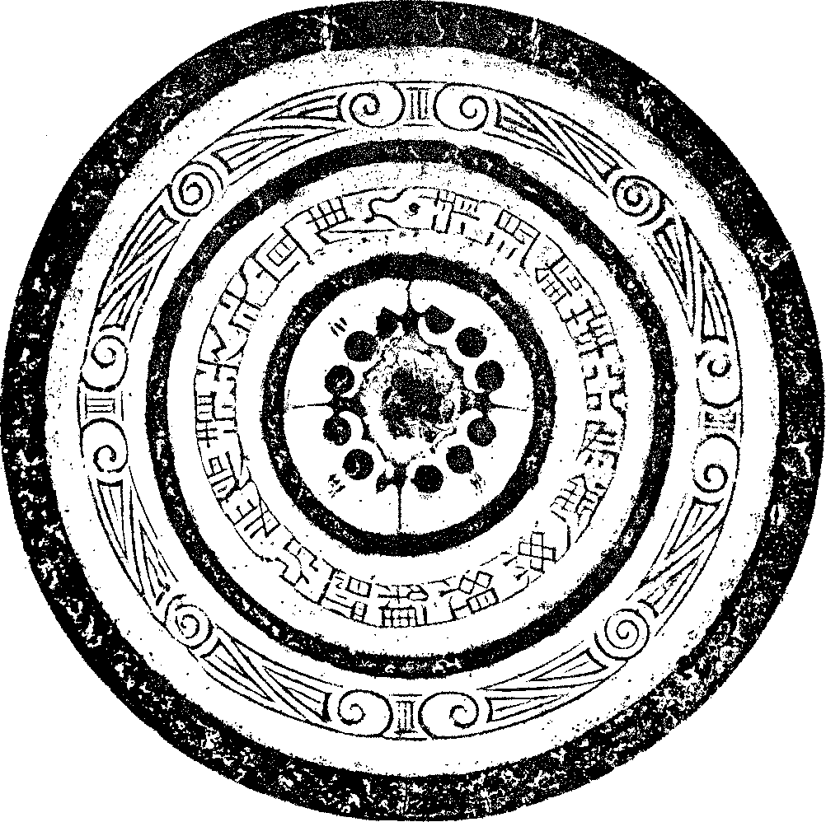

Fig. A  
Inscription mirror

this mirror are curved which confirms that no bent stays were used in the construction of the upper part of the parasol, and the square frame may well have helped to keep it stretched and in position. Whether the triangular motifs issuing from the inner ring imitate a structural part of the parasol or whether they were simply a decoration is difficult to say. They may have been pendants dangling from the upper ring. On all these mirrors (Pl. **20-22)** the bands carrying the inscriptions are placed on a striated background which suggests that the covers of the parasols were made of straw or light bamboo sticks and that the bands with inscriptions were fastened to them. The single and double line of saw- or teeth-patterns on the rim of this mirror (Pl. 23)

imitates two rows of festoons dangling from the edge of the parasol. Compared with earlier mir­rors *(e.g.* Pl. zo and zz) this one conveys an impression of greater smoothness and elegance, a typical development towards the end of the Western Han period.

A slightly different type of inscription mirror is shown in fig. A. It has a 'cog-wheel' centre with long spikes sticking out on all four sides, a small rim, and heavy rings typical of the first century B. C. The outer zone is adorned with four groups of spirals divided by signs looking like 'III'. They correspond to the small spirals *(e.g.* Pl. zo) or erb-like fru signs on early inscription mirrors. On this mirror the spirals are linked by a network of straight lines, some running obliquely from one spiral to another. The inscription on this mirror begins with the words : "I refine and work the flower of the copper to make the mirror .. ." AWN Calug,Mit

a phrase found on Wang Mang and on many Eastern Han mirrors. Various features suggest that this mirror belongs to the latter half of the first century B. C.

RELATED MIRRORS *(CHING-PAI OR MING-KUANG* MIRRORS)

The mirrors on Pl. 24 and 25 resemble the preceding ones but lack the special band carrying the inscription. Many of them were discovered in Shantung and it is sometimes believed that they were made in that province. Another mirror similar to Pl. 24 was discovered in the tomb of Wang Hsu in Korea36 which contained objects dated in the period between A.D. 42-69 The inscription on mirror Pl. z 5 proves that mirrors of this type were still being made in A. D. 64 *(yung ping ;1<,* seventh year). Sometimes the date can be deduced from the differences in the size of knobs and the fact that the one Pl. 24 is smaller than the knob of the mirror found in Wang Hsu's tomb can be taken as an indication for an earlier date going back to the beginning of the first century A.D. The centres of both mirrors (Pl. 24 and 25) are adorned with quatre­foils, an inner ring, and a circle of arcs connected by lines similar to those on Pl. 23 and other mirrors. Four characters are placed between the leaves of the quatrefoil, on Pl. 24 *Chang i kir sun* RA-T-V, Such an inscription can be found on many mirrors especially in the Eastern Han period and in some publications they are referred to as *`Chang i tzii sun'* mirrors. Because the words *`ch'ing pai'* or *'ming kuang' '* yE often occur in inscriptions on these and related types of mirrors they are sometimes described as *`Ch'ing* pai' or *'ming kuang'* mirrors. Moreover, some of them are so finely cast as to be translucent when held against the light. The main decoration on both mirrors (Pl. 24 and 25) consists, as in fig. A., of a band adorned with spirals or circles linked by straight and diagonal lines. This kind of pattern is very old. In China it can be traced back to neolithic times where we find it especially on painted pottery from Kansu. The dif­ferent coloured lines on these pottery vessels ending in spirals symbolize the ribbons which were wound on and off bobbins and posts. The whole pattern was a stylized picture of plays performed during ritual festivals.37 There is a wealth of evidence in myths, legends and cosmologies38 that at one time, all over the ancient world, these winding (or spinning) plays were part of celebra‑

36 Harada, Yoshito and others, *Lo-clang, a Report on the Excavation of Wang Has Tomb,* Tokyo 193o. Pl. 87.

37 Bulling, A., *The Meaning of China's Most Ancient Art, 2952,* p. 25.

38 Plato in *The Republic,* part it, Book 10 speaks about the "Spindle of Necessity" to give a picture of the working of the Universe, its rotation causing the stars and planets to move in their orbits.

tions symbolizing the flux of time.39 There are traces of their survival in to-day's folk art, in certain plays, and in the language of poetry. Vestiges can even be found in solemn rites. To mention one example : in Ceylon, in some Buddhist temple festivals, monks hold the 'sacred thread' wound all around the *Mavdapu* (a pavilion) during the recital of a special *siitra.40* Un­doubtedly, such plays survived in China although they underwent some changes and were reinterpreted in conformity with contemporary cosmological speculations. It is possible that in the Han period stylized symbols of these plays were painted on walls or ceilings of temples and served as models for the decoration of parasols and mirrors40a ; the spirals or circles standing for bobbins while the lines between them represent the winding strands.4. In the last part of the inscription nu. on fig. A. silk cords are actually mentioned. The phrase may not, as Karlgren thinks,42 refer to the tassels or silk strings attached to the knob but to the cords symbolized by the bands. These mirrors are cosmic mirrors.

*E.* g. the four large groups of spirals in fig. A divide the year into four periods. The sign III can either mark the two equinoxes and solstices, — then the three spirals in each group would correspond to three months —, or the four seasons, — then the spirals would symbolize the beginning, middle and end of each season. The eight spirals or circles on P1. 24 and 25 divide the year into eight periods; in addition to time each can be associated with one of the eight points of the compass and they may have been conceived also as symbols of rotating tops of the eight pillars of the sky controlling the orbit of stars and destiny43. In fact, the range of possible interpretations of such patterns can be extended in many directions. For example they may be held to depict a kind of net symbolizing 'the Net of Heaven' mentioned in *Kuan-t044* and in the *Shih-chi.* In later periods 'the Lucky Net of Heaven and Earth' is described as catching evil spirits. This would make a very suitable decoration for mirrors which according to many inscriptions were hoped 'to ward off evil influences'. In some parts of China and in neighbouring countries ghost-traps made of strands drawn in manifold patterns around all kind of objects have survived up to the present time. In Tibet they can often be found on roofs of houses or in lonely places. The popularity of this type of design is emphasized by the fact that similar patterns can be seen on other works of art, especially on lacquer bowls, dating back to the Western Han period.

39 About ancient winding plays see: C. Niessen, *Handbuch der Theaterwissenschaft,* 2952, Bd. I, Der Ursprung des asiatischen and antiken Dramas and des Totenkultes.

**40** Savatchanka, E. A., *Singhalese Folkways,* Ceylon 1953, p. 20.

40a That walls in the Han period were sometimes adorned with a network of cords running through rings is proved by a pattern which imitates such decoration and which can be found in the walls of many tombs and offering shrines. Al­though slightly different in arrangement such wall decorations must have been popular not only in China but in many other countries. *E. g.* S. D. Tolstov found the walls of a house in Toprak-Kala decorated with a pattern imitating intersecting bands of black, yellow and rosettes. (Kushan rulers 1-5th cent. A. D.) (William Watson, *Ancient Khorezm.)* (S. D. Tolstov's archaeological expedition in the Oxus Basin. 1945-47, p. Jo.)

**4'** On earlier mirrors the [-id signs are nothing else than representations of devices separating the strands.

42 Karlgren, B., 'Early Chinese Mirror Inscriptions', *BMFEA,* No. 6, p. 24 **(77).**

**43** The sky, like a canopy or tent, was imagined to be supported by cosmic pillars or poles. The most important one stood in the centre (reaching up to the pole star), it was believed to be the axis of the universe round which circulated the sky and the stars. Four, eight or more major pillars were held to support the sides of the tent of the sky. They stood in re­gions traversed by planets and stars which at regular intervals seemed to ascend or descend the vault of the sky.

**44** Erkes, Eduard, *Beitrage zur Geschichte des Chou kung.* Bericht fiber die Verhandlungen der Sachsischen Akademie der Wissenschaften zu Leipzig, Philosophisch Historische Klasse, Bd. fox, Heft 3.

HUNDRED NIPPLES MIRRORS

Though the inner circle of arcs on mirrors as shown on Pl. 26 and z7 is smaller than on most preceding ones they too belong to the large group of *`nei-hsiang lien hu'* mirrors. In addition, a circle of scallops follows the edge of the mirror. On both mirrors the knob is formed by nine rather high cones, the middle one rising above the others. Knob-seat decora­tions on this type of mirror include 'cog-wheel' (fig. 1) centres and other designs found on mirrors of the first century B. C. The small bosses or nipples of the four rosettes on the main zone of decoration are often placed on a seat shaped similarly (Pl. 26 and 27) (fig. i b); the long spikes extending towards all four sides also confirm a Western Han date. In rare cases animal-shaped knobs decorate this type of mirror. The curved lines connecting the knob with an inner ring (Pl. 26) resemble those on P1. 20 and imitate a similar construction. Such mirrors have been found in fairly large numbers in tombs of the later part of the Western Han period.45 They flourished, in particular, in the first century B. C. and appear to have been made first towards the end of Wu ti's reign. The two circles or arcs suggest that the parasol copied by these mirrors must have been convex so that the main zone of decoration as well as the apex could still be seen. The knob-seat on the other mirror (Pl. 27) has a different design; the striated zone encircling the central part imitates the lower cover.

On both mirrors, the main zone of decoration is divided into four sections by nipples set on a 'cog-wheel' base surrounded by eight flat disks. The main decoration consists of a number of pointed cones joined by thread-lines and scrolls. Scrolls similar to P1.26 can be found on a TLV mirror which will be discussed later. (P1. 29). This is another example of the popular appeal of high relief similar to the mirror on P1. 18. However, the smoother and more elegant design suggests a slightly later date towards the middle of the first century B. C. This type of mirror was still in demand at the end of the Western Han period and patterns resembling those on the main zone of decoration are found on other works of art although in paintings the cones are represented by round dots. In Chinese publications these mirrors are referred to under various names. They are sometimes called *pai ju* "qt, (hundred nipples) or *hying yiin* ag (star and cloud) mirrors, or else the pattern is described as *lien chu* alt (strung pearls). All these names reveal the original meaning of the decoration. The cones represent stars grouped together in clusters or constellations, and each one is shown four times symbolizing its orbit during the four seasons. In accordance with space-time speculations of ancient China the four rosettes would correspond to the four corners of the world representing the pillars of the sky in the nor­thern, southern, eastern, and western parts of the universe. It is important to realize the dif­ference between these fairly realistic pictures of constellations resembling maps of the sky and the more indirect dragon or bird arabesques of previous periods. The rational representation of stars is symptomatic of the change in the intellectual atmosphere which took place in the course of the Western Han period.

The other name given to these patterns, 'strung pearls', refers to a different aspect of the design. Long before the Han period pearls and semi-precious stones had been used as signs of heavenly bodies and references to such star-pictures can be found in various texts. An accurate

**45** Ch'ang-slia report, P1. 67 (z); *K'ao-ku t'ung, 1958,* **2,** p. z3 (M).

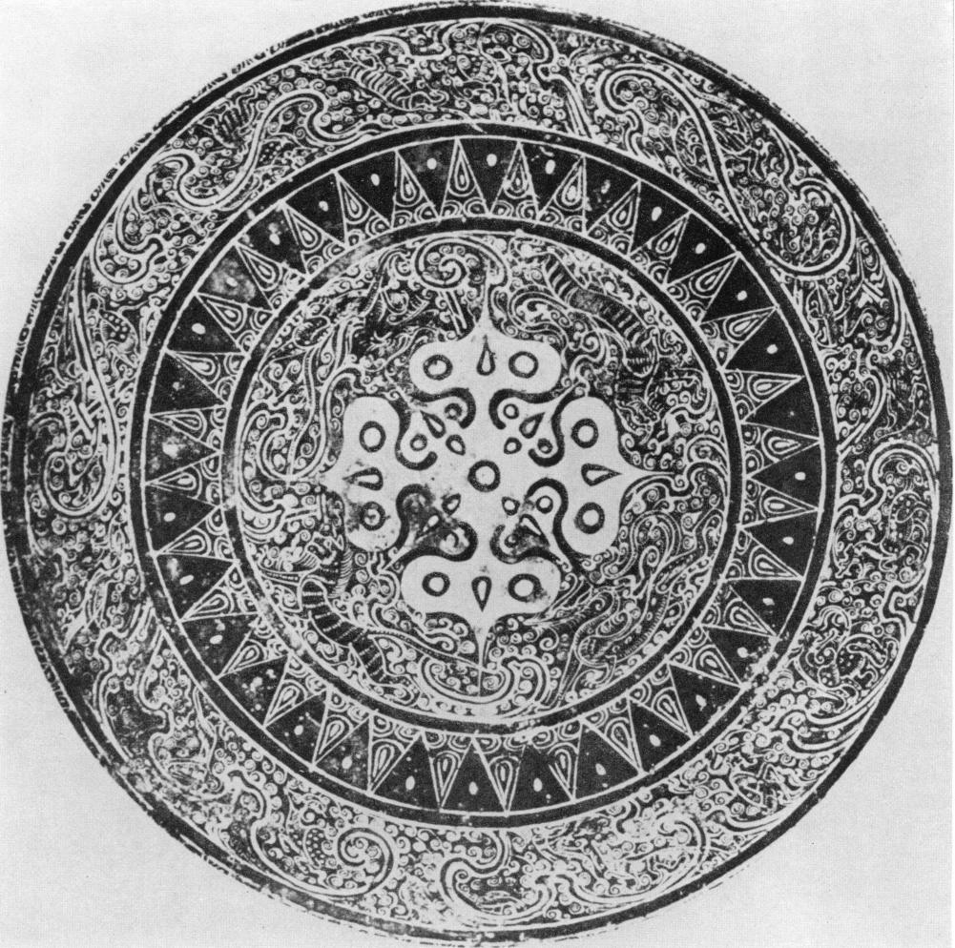

Fig. B  
Inlaid bronzc bowl

description of such configurations is given in the Bamboo Annals46, although its direct meaning often escapes our understanding. Legge translates "Sun and moon appeared like a pair of gems and the five planets like threaded pearls", yet this is a true description of configurations in which gems and threaded pearls were used to represent celestial bodies. They may have been sewn to cloth adorning the walls of temples or palaces, or else to the garments of the ruler or high officials.

On some of these mirrors each of the cones is set in a small mount or cup, and it is possible that the parasols were adorned with semi-precious stones or with less costly substitutes such as glass or coloured stones. They have no background patterns which indicates that the star-pic­tures were placed on a cover made of plain silk or of some other undecorated material.

These mirrors, no less than the better known and more often discussed TLV mirrors, are meant to give a picture of the entire universe. The outer ring of arcs symbolizes the mountain range believed to circumscribe the world bordering the sky, whereas the main zone of decora­tion represents that section of the sky traversed by the great lunar and solar constellations; while the centre stands for the circumpolar sky with the pole-star in the middle. A range of mountains (inner circle of arcs) separates it from the part of the sky in which stars and planets rise and set (stars on the circumpolar sky are visible all year round). Cosmological speculations occupied the mind of the people of the Han Dynasty especially during the Western Han period, and their be­lief in the identity of macrocosm and microcosm enabled them to interpret the signs on these mirrors in terms of time, space, order of society, moral commands, life and death of human beings, and so on.

MISCELLANEOUS MIRRORS

A rare and precious mirror is shown on Pl. 28. It is said to have been found in a lacquer toilet box though it fits only into the lid.47 The hemispherical knob and the quatrefoil indicate that this mirror cannot have been made during the earlier part of the Western Han period. It is divided into sections by heavy concentric rings and belongs, therefore, to the group called *`chung ch' iian ', (cf.* Pl. zi and fig. A.). The pattern is worked in gold leaf applied to the flat surface. Such costly mirrors could not have been produced in great numbers. Unfortunately, the painting has worn off and is difficult to discern. A close examination shows that the outer part of the main zone of decoration has a large scroll consisting of irregular C-shaped curls. It is painted in double lines while the small regular S-spirals in the inner zone are drawn in a single line. It is typical of this kind of pattern that the two ends of the S-spiral are alternately linked by straight lines to the outer and inner border of the pattern. S-spirals with similar 'bars' can be found on many mirrors some carrying an inscription mentioning Wang Mang, or more pre­cisely, the Hsin Dynasty *(e. g. H. & H.* cat. L. 6). On many Eastern Han mirrors an often simpli­fied variant of such a pattern decorates a small ring separating the centre field from the main zone of decoration *(e.* g. Pl. 46). This illustrates a typical development; the established pattern is not altogether abandoned when new designs become popular but is shifted to a secondary place. The mirror, Pl. 28, resembles in its workmanship and decoration the famous inlaid

46 Legge, J., *The Bamboo Annals,* The Chinese Classics, Vol. III, Part 1, p. 113.

47 Gray, Basil, "The Eumorfopoulos Lacquer Toilet Box and Blue T'ang Horse", *British Museum Quarterly,* 1940, PP. 49-53.

**48** For a more detailed description see: Bulling, A., "Late Chou and Han Art in the British Museum", *Burlington Magazine,* May 1951.

bronze basin in the Hosokawa collection49 (fig. B). On both, the space between the leading lines is covered with masses of small and rather tightly wound scrolls. The decoration of the beautiful basin includes figures of immortals, animals, and fanciful creatures drawn in a style and manner found on TLV mirrors up to Wang Mang's time of reign. It seems therefore, that this bowl can hardly antedate Wang Mang mirrors by more than sixty to seventy years. In conclusion: the various features on this mirror (Pl. 28) allow us to say that it cannot be much earlier than the end of the Middle Western Han period and not later than the last decades of the first century B. C. The decoration of the zone inside the rim consists of a single row of chevrons which differ, however, from those on Pl. 23 because a dot is placed in the dark spaces between the light triangles. These dots are meant to represent tassels placed between the festoons which dangled from the rim of the parasols. In fact, this decoration closely resembles painted canopies with festoons and tassels such as can still be seen in a cave of the sixth century A.D. in Tunhuang.50

THE DEVELOPMENT OF TLV MIRRORS

Certainly the most important change which took place in the later part of the Western Han period is the replacement of dragon or other arabesques on TLV and other mirrors by figures of winged animals, strange monsters, or immortals in anthropomorphic shape. All of these creatures are shown in action, some chasing each other or fighting. Others are engaged in amusing tricks or in deep conversation. The problem is : when were these mirrors first made? Although we agree with Professor Karlgreen that they originated in the first century B. C. we cannot fol­low his argument in all parts.s' His assumption that these mirrors were first made in about ioo B. C. is based on an inscription still found on TLV mirrors made during Wang Mang's rule and in the Eastern Han period. He rests his argument on the following phrases : "the Barbarians of the Four Directions have submitted... I congratulate the House of Hsin (other mirrors refer to the Han Dynasty), the people have got rest; the *Hu* slaves (northern barbarians) are exterminated and destroyed; wind and rain come at their times, the five grains ripen... N AN tuf*AxE141

iyIKTAgyffin-afi ". Though the phrases vary slightly this is a typical example *(e.g.H.& H.* L. ; similar fig. E). Professor Karlgren holds that sentences proclaiming victory over these enemies could not have been invented during Wang Mang's rule because at that time China was powerless and helplessly exposed to the attacks of northern (and north-western) barbarians and the monumental empire built by Wu ti in the Western Han period had disintegrated. These "lauda­tory formulae", he believes, would have been tantamount to defamation at the time of Wang Mang. For this reason Professor Karlgren assumes that the large and heavy TLV mirrors in his cat. L *(H. & H.)* carrying similar inscriptions must have been designed much earlier, that is, at a time when historical conditions justified such eulogies. During Wang Mang's rule, he holds, they had become "mere meaningless phrases" repeated ad infinitum because by tradition they were linked with these mirrors and copied over and over again for nearly a century. He concludes that these mirrors originated at a time when the barbarians had been driven back and the *Hsiung-nu (Hu)* brought to submission, that is roughly at the beginning of the first century B. C. during the

49 Rostovtzeff, M., *Inlaid Bronzes of the Han Dynasty in the Collection of C. T. Loo,* Paris and Brussels, 1927, Pl. V—XII.

50 P. Pelliot, *Les Grottes de Touen Houang,* Cave tzo N, P1. CCLVII.

5' Karlgren, *H. & H.,* p. zo.

later part of Wu ti's reign. It is perhaps typical of our rational age that without any question such phrases are taken as referring to historical or political events. Such an interpretation has, however, little bearing on their true meaning. In fact, similar inscriptions can be found on late Han and even post-Han mirrors when historical events made them seem even more blatant distortions of the truth than at Wang Mang's time. Hence, it seems safe to say that the inscription has no bearing on political events but refers to rites and sacrifices which were believed to be im­bued with invisible powers, especially in regard to the destruction of evil spirits. 'The Pacifica­tion of the Four Barbarians' is a rite mentioned in the literature of the Chou and Han periods. It is related to the ancient 'Dance of the Four Quarters of the World' and the statement "the Barbarians of the Four Directions have submitted" means that this rite had been performed and the evil spirits residing in all four directions of the compass been driven back or destroyed. The *Hu,* in this case, are identified with those living in the northern part of the universe and are held to be particularly obnoxious because they were connected with the powers of darkness, cold, death, and other dangerous forces. That the same name was used for the *Hsiung-nu,* the most dangerous enemies of the Han people, is not surprising; in fact, identifying enemies with evil spirits is a human folly not unknown even in our more enlightened age. That the mirrors and their decorations were supposed to have protective powers is born out by many inscriptions which claim that magic power of the mirror helped to "eliminate what is baleful", or that the *sru-shin IN#,* 'the four spirits' symbolizing the four constellations of the seasons acted as guar­dians against the onslaught of evil spirits. In the light of all this it is not surprising to find in­scriptions on mirrors referring to rites or sacrifices ensuring protection.

The other phrase "the people have got rest" is the direct consequence of the successfully performed rite. Praise of the Imperial or Ruling House, be it the Hsin or Han Dynasty or merely "the House of the Prince", is based on its supreme position as apex of the social and religious hierarchy. As 'Son of Heaven' the Emperor was not only the intermediary between the world of mortal and supernatural forces but he was also directly responsible for the carrying out of the great rites and sacrifices on which depended not only the welfare of the people but also the order of the universe, the changes of the seasons, the weather, and the ripening of the five grains. The most important rites and sacrifices of the year took place at the time of the New Year and during this festival the Great No was performed in which all the evil spirits of the old year were banished or destroyed.

An additional reason for interpreting the inscription in terms of annual rites is the fact that many of these mirrors are decorated with the sign of the constellations of the four seasons or inscribed with the names of the twelve zodiacal constellations. In each case their sum total covers the period of one year, although in an extended sense, they symbolize the eternal revo­lution of time. At the New Year's festival both the death of the old and the birth of the new year were celebrated symbolizing the annual victory of life over death, and the perennial renewal of the powers of life. Numerous inscriptions confirm that such ideas were implicitly connected with these mirrors and either expressed as a simple wish for longevity, for ten thousand years, for many sons and grandsons, or in more intricate metaphysical terms, as the hope that the soul of the dead may "revert to the beginning after a completed life circle".

The assumption that these mirrors originated in the beginning of the first century B. C. might be called in question on account of the religious character of the inscription which dimin‑

ishes its value as a reliable guide for dating. Moreover, it seems at least debatable that by the time of Wang Mang it had become a "mere meaningless metaphor". On the contrary, Wang Mang's character and preoccupation with ancient rites and his firm belief in their magical powers make it more likely that he not only supported but encouraged the use of such phrases. This type of inscription does not occur on early Western Han mirrors nor on any which can, with any degreee of certainty, be attributed to the earliest part of the first century B. C. But it is very common on Eastern Han mirrors. Its beginning may not antedate Wang Mang's lifetime by more than a few decades, gaining increasing popularity during the end of the first century B. C. and the time of Wang Mang's rule.

Excavations and detailed analysis of a number of mirrors allow us to follow the slow emergence of this new type of TLV mirror. A good example of the formative stage is the mirror, Pl. 29. The heavy ring which divides the main zone of decoration into two parts shows that it belongs to the 'heavy ring' or *chung ch' iian* group of mirrors which flourished in the later part of the Western Han period *(c f.* P1. 21,28 and fig. A). The TLV signs are all placed in the inner part of the main zone and the space between them is filled with scrolls reminiscent of the arrangement on Shou-chou mirrors and ancient dragon arabesques. For a more exact dating it is important to note — as has already been pointed out — that the scrolls resemble in workmanship and type those on Pl. 26. They run in single or double lines. Some interlace like plaits and others end in fork or trident-shaped signs. The new type of decoration is placed into the outer zone; we see 'the four spirits', the animals symbolizing the constellations of the four seasons, pursuing each other among the clouds. However, the winding lines of the wafting clouds with their long hook­like endings are closely related to those on earlier mirrors and differ from those on the Hosokawa basin (fig. B.) or on Wang Mang mirrors. The hemispherical knob is set in a square frame filled with scattered spirals and scrolls. The large, flat rim has been left undecorated as on many mir­rors from the later part of the Western Han period. The various stylistic features of this mirror suggest a date between the end of the second and the middle of the first century B. C. According to Professor Umehara52 the mirror has an inscription in the old style script placed towards the centre which cannot be seen on this photograph. It is an inscription often found on mirrors of the Western Han period which, according to Professor Umehara's translation reads : "the bril­liancy is like that of the sun and moon; posterity ever continuing".

Another stage in the development is illustrated by a mirror excavated in Ch'ang-sha53 (fig. C.). It was found in a tomb from the later part of the Western Han period. The main zone of deco­ration is still divided by a ring into two parts, yet it is neither convex as on second century B. C. mirrors nor a plain band but consists of two thin threads divided into four parts by small con­cave, round disks. Unlike the mirror of Pl. 29 the L,and V signs are placed into the outer and the T signs into the inner ring. The ring dividing the two zones has, however, lost its structural function. It no longer divides the surface into two parts covered with different types of decor­ations but it is merely placed above it. Now the pattern spreads all over the zone. In some cases animals are cut into two parts, their bodies showing in the exterior and their heads in the in­terior section of the main zone of decoration. In style the animals, immortals, and monkey-like creatures resemble those on the Hosokawa basin (fig. B). The knob is small and hemispherical

52 Umehara, Sueji, "Mr. Moriya's Collection of Ancient Chinese Mirrors", *Artibus Asiae,* Vol. 18, No. 3/4, 1955, p.248.

53 Ch'ang-sha report, Pl. 63 (2), Tomb att.

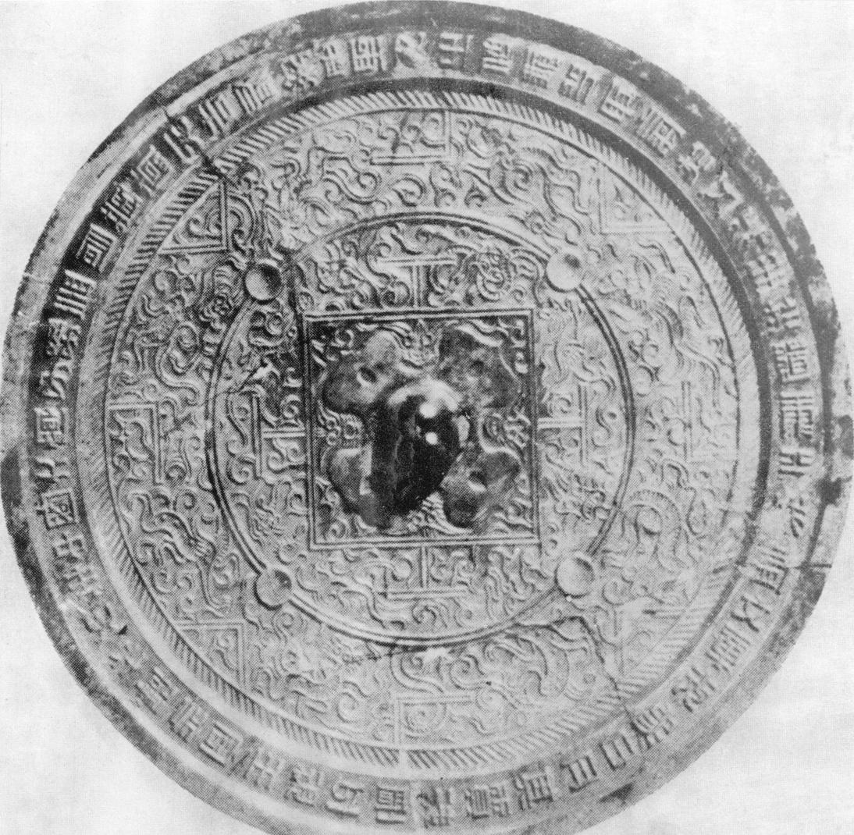

Fig. C  
TLV mirror found in Ch'ang-sha in a tomb of the  
later part of the Western Han period

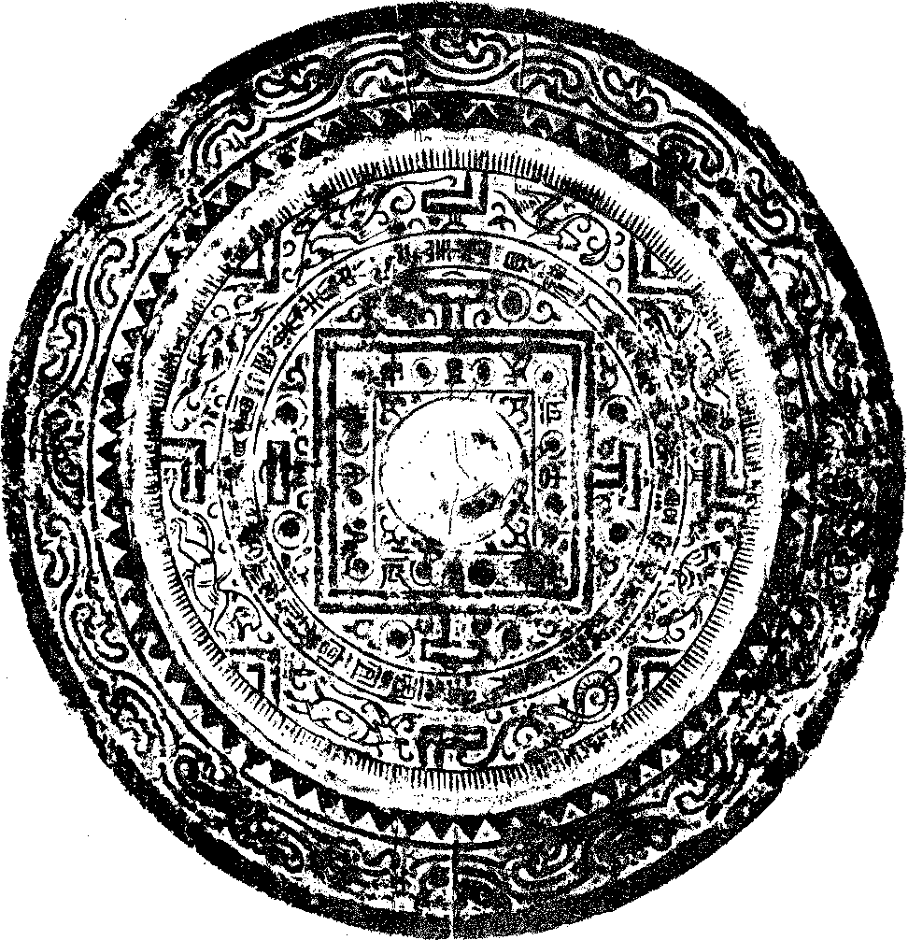

Fig. D  
TLV mirror

and the knob-seat is decorated with a quatrefoil. The corners and sides of the inner square are filled with scrolls and face-like motifs. The same tomb in which this mirror was found con­tained another one resembling Pl. 23 (dated 6 A. D.) exept that it had a 'cog-wheel' centre and may date back to about the middle of the first century B. C. The mirror, fig. C, provides another example of the transformation of TLV mirrors during the course of the first century B. C. Its most likely date lies between the end of Wu ti's reign and the last quarter of the first century B. C. The inscription placed on the rim is interesting because, in addition to some standardized phrases, it refers to the Five Elements and to Huang ti mentioned on many mirrors in the later

part of the Eastern Han period but rarely on early mirrors. The inscription begins not with a  
family name or the Imperial Department but with *Sengrien,* a wise man or sage, as the one who  
had the mirror made. H ANAPP11%."-

11:1121*-T-4'11- EMS5E-NAlE1411.

The division of the main zone of decoration into two concentric sections was not altogether abandoned during the later part of the first century B. C. or even in the beginning of the follow­ing century. (Pl. 3o.; fig. D.) On both mirrors the inscription is set into the band dividing the main zone of decoration. As on Pl. 29 the two zones are decorated with different patterns. The inner one contains scrolls, the outer one a row of animals, birds and immortals. The band around the centre square, (fig. D), is inscribed with the names of the twelve signs of the zodiac alternating with nipples, a feature to be found on many mirrors which according to their inscrip­tion were made during Wang Mang's reign. The knob appears to be bigger than the one on Pl. 3o, and the rim is wide and heavy as on many Wang Mang mirrors. The mirror on Pl. 3o differs slightly not only in its centre section but also in the flat rim which is similar to those on late Western Han mirrors. It may well be slightly earlier than fig. D. The dates of these two mirrors lie between the later part of the first century B. C. and the beginning of the Eastern Han period. This assumption is supported by the inscription of fig. D. which begins with a phrase found on mirrors of Wang Mang's time and of the Eastern Han period. It starts : "On top of the Hua Shan (mountain) *hsien-jen* (immortals) can be seen..." and closes with the usual wish for "posterity and joy without end" ±*L11 f[ti

The development of TLV mirrors in the later part of the Western Han and Wang Mang periods (time of transition) will be dealt with in the next chapter. It is to be hoped that the fore­going discussion of some TLV mirrors has shown that the type and style of mirrors inscribed with a date pertaining to Wang Mang's reign are not merely relics of the past but developed in the course of the first century B. C.

SHOU-CHOU MIRRORS DECORATED WITH FIGURES OF HUMAN BEINGS

During the Eastern Han period the popularity of mirrors decorated mainly with human figures or divinities in anthropomorphic form increased considerably. Yet already in the first half of the Western Han period we find figures of human beings on some Shou-chou mirrors. The knob-seat of one published by Professor Karlgren *(H. & H.* cat. F. 1 6) is decorated with figures of three running men (fig. 2). It is interesting to compare this figure with one cut out of thin gold foil (fig. 4c). It was found in the same tomb as the mirror in fig. C. together with a great number of other figures, all of them probably fallen off some objects made of lacquer. That lacquer boxes were often inlaid with figures cut out of silver or gold foil is well doc­umented *e.g.* by fragments of toilet boxes found in Noin-U1a54 and one in the British Muse­um55. The main zone of the mirror (F. i 6) is divided into four sections by 'brush-like petals', *(cf.* Pl. 8 and 9) and a sweeping line depicting mountains, swirling waves or flames is now re­placing the ancient dragon arabesques. Small human figures are represented as if walking on

**54** Trever, Camilla, *Excavations in Northern Mongolia 1924/2/.* Leningrad 1932.

**55** Gray, B., *op. cit.*

the mountains or resting on the peaks. Cloud mountains on figured silks found in Noin-U1a56 and Lou-lan57 present a similar picture of winged spirits or men riding on horseback. The style of the mountains on the mirror shown in F. 16 points to a date somewhere between the later part of the second and the middle of the first century B. C. An even more in­teresting example is the mirror on Pl. 31 because it demonstrates that the ancient mirror makers did not hesitate to break with traditions but ventured forth into new fields of decoration. The four dragons placed

Fig. **2**  
Running man (from Shou‑  
chou mirror, Karlgren  
*H. & H.,* Pl. 56, F. 16)

around the knob in the centre field do not resemble those on Pl. 3 and can hardly be attributed to the first part of the second century B. C. The main zone is divided into four sections by mush­room-or plant-like motifs not unlike a design on a figured silk found in Noin Ula.58 The dragons or arabesques are replaced by a pictorial decoration. In each section we see the same scene : two men playing musical instruments attended by a third standing at their left side who may have accompanied their music with recitals or songs. On the other side two men are engaged in con­versation. That this scene is meant to portray a spectacle or ritual performance is revealed by the presence of some animal trainers or magicians. One is shown riding a tiger alternating with one who apparently tries to coax an animal to perform. The most probable time for the appearance of such new and more or less 'realistic' types of decoration is the later part of the second century although they may still have been produced in the beginning of the first century B. C. From an aesthetic point of view such a decoration is not very satisfying and the artists of the first century B. C. were justified in abandoning this type of pattern and prefering the more graceful and imaginative decorations as are seen on TLV mirrors. Although the mirrors discussed in this part of the study do not include all variants of each type it is hoped that the survey can be used as a kind of framework in which stylistic features, such as have been dealt with, will serve as a guide for the dating of other specimens.

THE DEVELOPMENT OF BIRD MIRRORS

In summarizing the general line of development the following mirrors decorated with birds will serve as examples. The wonderful mirror on Pl. 3 2 from the period of the Warring States (approximately the fourth century B. C.) is a good illustration of the solemnity of that age; the four birds placed between the stalks on a background of

`curl and feather' pattern walk in stately procession. They are solidly worked, powerful birds resembling geese. However, it is impossible to attach the name of any species to the elegant birds with dragon-like tails (fig. 3) seen on mirrors of the third century B. C. They are creatures of fantasy, and the gracefulness of their sweeping lines set on a finely patterned background reflects the refined taste and sophistication of a feudal aristocracy declining in power. The birds

Fig. 3  
Dragon-bird on third cent. **B.** C. mirror

56 Andrew, F. H., "Ancient Chinese Figured Silks", *Burlington Magazine,* April 1926, fig. i.

***57*** Trever, C., *op. cit.,* Pl. 17 (tomb 6).

58 Trever, C., *ibid.*

on mirror Pl. 33 have regained some of their bird-like features although they are still highly styl­ized. The arabesques, which have lost all semblance of dragons, wind through open lozenges and through the wings of the birds. Hook-like endings branch off the main lines. Birds of a similar style are represented on a mirror found in one of the thirty tombs excavated near Canton in 1955.59 Coins discovered in the same place suggest that this burial place was used in the later part of the second and also in the first century B. C. This mirror is another example of the transformation of the traditional dragon pattern into a mere arabesque, a movement which, as has been pointed out, gained momen­tum in the Middle Western Han period. The mirror, Pl. 34, illustrates another stage in the general development of style. The small hemispherical knob, the 'cog-wheel' centre, and the rosettes in the main zone of decoration leave no doubt that this mirror belongs to the first century B. C. The circle of arcs surrounding the inner field is rather small, a feature more common on mir­rors of the early and middle part of the first century B. C. than on those of the end of the Western Han period. Four groups of three birds are placed between the rosettes. Two large birds facing each other across the rosettes with a small bird between them. All of them are long-legged water birds (probably cranes), realistic in their running movement or in their resting position on one leg. Yet they are highly stylized, and their slender bodies are drawn in an elegant curve. They resemble in style birds stamped on tiles found in Ch'in tsun near Lo-yang in Honan which according to Bishop White60 date back to the third century B. C. This mirror is said to have been found in the same locality and its date might be a clue for a more exact dating of these tiles. The birds on this mirror are drawn in a single line as if copied from a simple drawing. This mirror and one on P1. 32 reflect completely different mental attitudes. There is nothing left on P1. 34 of the awe-inspiring solemnity or the patterned beauty of the birds on P1. 33 ; on the con­trary, the design on Pl. 34 is humorous, a state of mind totally absent in earlier types. That such decorations are meant to amuse is corroborated by the grotesque shapes and funny faces of some of the fancy creatures shown on TLV and related mirrors of the first century B. C. The implications of this change are quite revealing and confirm that the decoration of mirrors has now assumed a new function. It should not only enrich life by its beauty, or deepen the under­standing of life by its symbolism, but it should also entertain and amuse the onlooker. The pur­suing and playing animals and immortals on mirrors and other works of art of this period provide a kind of picture book which can be enjoyed even by those who do not understand the complicated meaning of all the various signs and symbols.

This trend is certainly characteristic of the mentality of the wealthy and urban society which developed in the first century B. C. They finally broke with the ancient feudal traditions and were building up a new type of ruling class. It is, therefore, understandable that they felt increasingly free to change the ancient signs and symbols and to replace them by new ones which had a more immediate appeal to the people of their time. Especially after the country had recovered from the exhaustion of the war years at the end of Wu ti's rule people began to enjoy the benefits of the expanded and powerful empire, and the mirrors reflect the pleasure found in elegant compositions, refinement, and smoothness of surface. Although the turbulent years of the middle Western Han period produced perhaps the greatest number of new mirror types, the first century B. C. may well prove one day to have been one of China's most creative periods.

59 *'Veil-mu,* 1956, No. 5, p. 3o (B).

6° White, W. C., *Tomb Tile Pictures of Ancient China,* Toronto 1939; *(e. g.* P1. CVII and XCV).

TIME OF TRANSITION AND THE EASTERN HAN PERIOD

ot only the style of decoration but also the phrases used in inscriptions on mirrors changed in the course of the Han Dynasty. Professor Karlgren's excellent study" provides us

**N**

with a great number of inscriptions which can be found on mirrors of the Han period. Here the subject can be dealt with only in passing, but it should be stated that some of the standard phra­ses on earlier Western Han mirrors went out of fashion towards the end of that period especially during the second part of the first century B. C., although others such as wishes for "poster­ity", "joy without end", or for longevity and other blessings continued to be used all through the Eastern Han period. Typical inscriptions on TLV and other mirrors from the latest part of the Western Han period onwards are those in which some motifs of the decoration and their functions are described: "the dragon on the right, the tiger on the left control the four sides" ft t bt 'SEEM *(i. e.* the four directions of the compass), "The Red Bird and the Dark Warrior follow *yin* and *yang* *A-Al-itimir, and so forth. The little winged immortals (or spirits) are qualified as "not knowing age" tilAy;Fi, "drinking from the jade spring" vgl, or "wandering through the universe travelling between the Four Seas" g-F-gz F1. They are apparently able to ride clouds and to visit stars. On mirrors of the later part of the Eastern Han period Tung-wang-kung (the Lord of the East) and Hsi-wang-mu (the Queen-mother of the West) are frequently mentioned. They are also described as eternal beings who "do not know age" and they are often mentioned together with "the Green Dragon on the left and the White Tiger on the right" *Ii:LyNI-fililian At which likewise reside in the eastern and western parts of the sky.

Many inscriptions mention the *Shang fang* as the place where the mirror was made} ( n=lf ) . This is the name of an Imperial Department which existed already at the beginning of the Western Han period or even earlier. However, during the Western Han period it had primarily been engaged in making drugs and medicines although it also supervised the produc­tion of precious objects and utensils. The *Shang fang* continued to work during Wang Mang's time and during the Eastern Han period. From the inscriptions on Wang Mang and Eastern Han mirrors it can be deduced that from the end of the Western Han period the making of mirrors became one of the department's main lines of production. In the later part of the Eastern Han period the *Shang fang* was divided into three sections : the *Shang-fang* of the right, left and centre, the latter being exclusively concerned with paintings. Many inscriptions refer to processes in the manufacture of mirrors, *e. g.* the selection of fine bronze ggif, ird, the refinement of "the three auspicious metals" -=_L-.-__fpit, (copper, lead and silver), or "the methods employed in its

**61** Karlgren, B., Mirror Inscriptions, *op. cit.*

casting" ME. Tan-yang ffltg is often named as the place where the metal was mined,  
although other names such as Tung-liang Om are occasionally mentioned. Yet the aim was  
not only to produce a beautiful mirror but one that was magically effective and could "eliminate

what is not auspicious" or what "was baleful". Mirrors were even hoped "to in‑

crease people's span of life and to cause them not to know old age" Lii-ARtf(14\ This meant

that much more than mere skill was necessary for the making of these mirrors. The craft de­manded a wide knowledge of symbols and their correct position on the mirror. The masters of the *Shang-fang* were certainly not mere artisans but men of great learning who held superior positions. They were not engaged in making the mirrors but merely supervised their manufact­ure. Families such as the Wang, Wu, Lung, 1 ; ; IlMfF-A- and others are mentioned as having mirrors made for them and in some cases the inscription says "I made this mirror" E.frA . One of the holy mountains, the Hua Shan, has already been mentioned as part of an in­scription but the T'ai Shan was no less popular. Space as represented by the decoration on these mirrors is aptly expressed in phrases such as "I had engraved (on it) the ten-thousand regions" RA-tiX N, that is the entire world. Time is no less all-inclusive and universal; it refers to "the primeval beginning" Fl Tc, the very act of first creation.

TLV MIRRORS

Many mirror inscriptions mention the Hsin-, the new dynasty founded by Wang Mang. These dated mirrors can serve as a basis for a chronology of mirrors, allowing us to differen­tiate between mirrors popular before or after this time. These inscriptions are especially nu­merous on TLV mirrors which, during this time, reached a somewhat final stage in their develop­ment. Their designs may be called classic, if the word is understood in the sense that this par­ticular type and style was copied in parts or as a whole not only during the Han period but even later. A number of forgeries, including copies of dated inscriptions, testify to the value placed on such mirrors. Later, during the Sung period, there was a revival of interest in these and other more ancient types of mirrors. But many copies made then can be identified fairly easily not only by their workmanship, which is mostly below the standard of genuine Han mirrors, but also by their use of a different type of inscription. That TLV mirrors continued to be popular all through the Eastern Han period is confirmed by their prevalence in numerous Eastern Han tombs.

The fact that a rather substantial number of TLV mirrors have inscriptions mentioning the Hsin Dynasty suggests that Wang Mang had a certain interest in them and perhaps encouraged their production. No doubt, the fanciful decorations and the wide cosmological implications appealed to this vivid imagination and speculative mind. Though he did not ascend the throne until 9 A. D. he had been a most powerful influence in the country for some time and the name Wang, often inscribed on mirrors which, according to their style, were made towards the close of the Western Han period, may well refer to his family. Professor Karlgren assumes that the family names mentioned on mirrors refer to the craftman who actually made the mirror and translates "Mr. ... made the mirror". However, there is no reason why the word *`shih'* fp ; ; J:uF should not be taken in its usual sense — family or clan — and the sentence translated 'Family Wang (or other names) had this mirror made'. That neither the Master of the *Shang-fang* nor

Fig. E  
TLV mirror  
(Inscription referring to Wang family and Hsin dynasty)

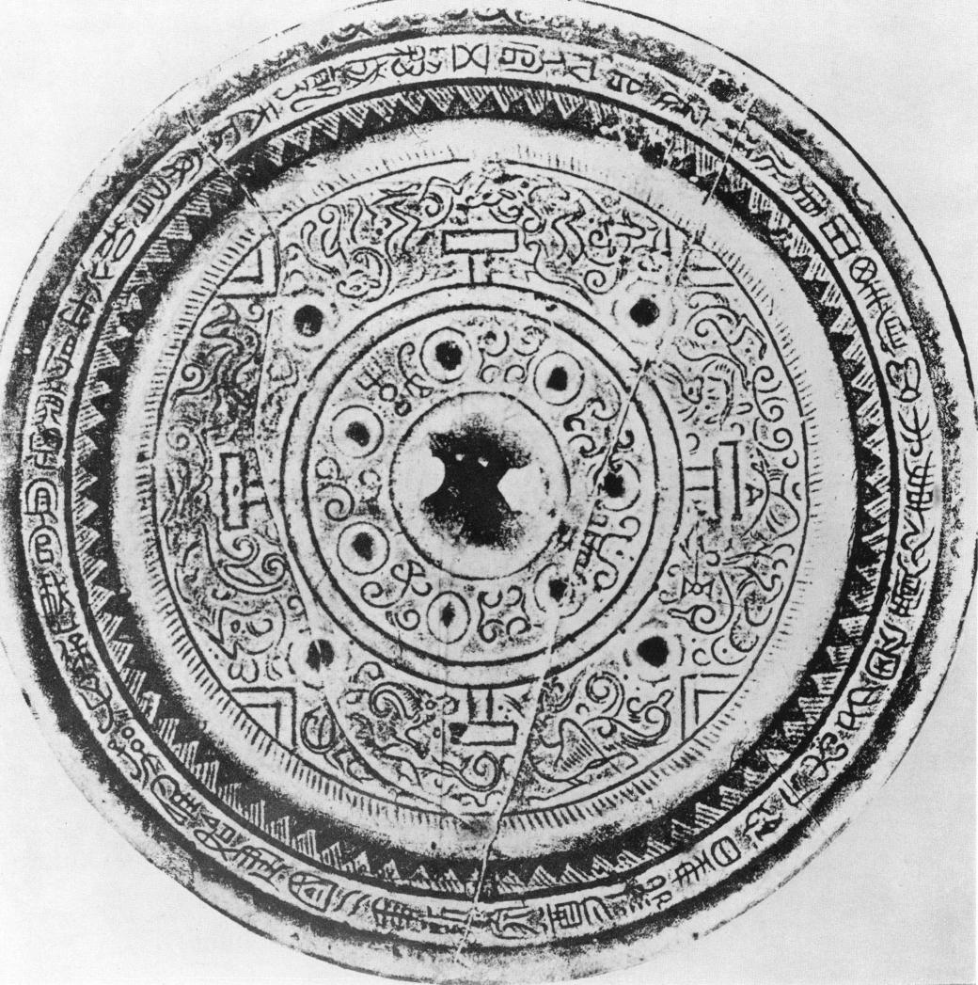

Fig. F  
TV mirror, dated A. D. io

the family names are those of the artisan is corroborated by other inscriptions in which in addition to the *Shang-fang* the "skillful workman who engraved the decoration" is especially mentioned (see: Pl. 3 5). Moreover, the wishes for good luck, for posterity and so forth, are directed towards the family who had ordered, or owned, the mirror and are not meant for the artisan who actually made it. Wang is certainly a very common clan name. However, during the period in which Wang Mang's family held the reigns of power in their hands it is safe to assume that in many cases where the *Wang* family is mentioned in the inscription, the mirror had been made for members of Wang Mang's family. Their rise to power dates back to the marriage of Wang Mang's aunt to the Emperor, and their influence increased continuously after the death of Yuan ti in 33 B. C. Wang Mang was actually appointed to the highest position in the country after the death of his uncle Wang Feng in 22 B. C. The numerous inscriptions in which the Wang family, or the Hsin Dynasty (or both together as on fig. E) are mentioned can be taken as a sign that not only Wang Mang but the Wang family was interested in this type of mirror. Their patronage was bound to have an influence on the production of these mirrors and inspired the artists to per­fect their designs. The closing years of the Western Han period (roughly from about 4o B. C. onwards) can, therefore, be expected to be the time in which TLV mirrors underwent their final change, reaching their stage of perfection during Wang Mang's actual reign *(e. g.* Pl. 3 5, fig. E and F).

The most common designation given to TLV and other mirrors with a hemispherical knob set into a square frame is *kuei-chii* VM, circle- and square-mirrors, though TLV mirrors are also grouped under the heading of *ssu -shen* NT-0, or its equivalent, *ssu-ling Fill* mirrors, especially when the Four Spirits are mentioned in the inscription. When the square band contains the characters of the so-called Twelve Earthly Branches (signs of the zodiac and of the hours of a day) they are sometimes described as *shih erh ti chi* mirrors.

A very typical example of a mirror referring to the Hsin Dynasty in the inscription is shown on Pl. 3 5 . The main zone of decoration is completely filled with figures of winged animals, immortals, and cloud scrolls, all outlined in a thin and slightly raised thread. Typical of the style of this time is the snake-like curved chest of the tiger, the shape of the quatrefoil in the centre, and other features which will be discussed later. Another mirror mentioning the Hsin dynasty in its inscription (fig. E) shows the same stylistic signs of the mature Wang Mang style.

The mirror in fig. F was cast, according to the inscription, in the year A. D. o.

that is shortly after Wang Mang's usurpation of power. To a certain extent this mirror seems more akin to Western than to Eastern Han mirrors insofar as the centre field is rather wide and the heavy band which divides it from the main zone resembles those on mirrors of the *chung­ch'iian,* the 'heavy rings' type. The rather narrow main zone may be compared with the outer zone of the mirror fig. D. It does not allow for the display of all three letters and the L's are left out altogether. The main inscription is written on the rim, a place more common to Western than to Eastern Han mirrors *(cf.* fig. C). Seven nipples are placed inside the inner circle alter­nating with characters expressing wishes for posterity. This again links the mirror to late West­ern Han specimens in particular to one found in tomb No. 245 in Ch'ang-sha62. Although this has nine nipples in the central ring alternating with characters. The mirror in fig. F, is especially

62 Ch'ang-sha report, P1. 69 (3).

interesting for another reason. It includes in its decoration some figures which are not commonly found on early TLV mirrors. On the right side Hsi-wang-mu is shown recognisable by her head­gear, with the hare of the moon pounding the elixir of life at her side; while the other one shows a running man confronted with a kneeling stag, a fierce creature drawn rather realistically. The fancy animal on the side below resembles a wild boar although it has apparently been fitted out with curved horns. The inscription in the centre is unusual insofar as it contains only three, and not four, characters.

Vestiges of Western Han mirror designs can be found on other mirrors with a Hsin Dynasty inscription. For example, a mirror published by Karlgren *(H. & H.* cat. L. 6) has retained scrolls as the only decoration of the main zone. Yet they resemble those in the inner section of the main zone of fig. D. and not those on earlier mirrors *(e. g.* Pl. 29). Moreover, like the mirror in fig. F it is incomplete insofar as it lacks the V and L signs, merely displaying the T signs although it has a square centre and a quatrefoil resembling fig. E and Pl. 3 5 and eight nipples in the main zone of decoration. The rim is decorated with a row of S-spirals with bars, a simplified variant of the elegant pattern on the inner ring of the mirror, Pl. 28. That the ancient division of the main zone of decoration into two rings was still used during Wang Mang's reign is corroborated by a mirror dated A. D. 1063. Its rim was left undecorated and the outer ring of the main zone of decoration filled with a tendril pattern similar to those on the rim of Pl. 3 5 and fig. E. A remnant of this division is the small band of spirals at the inner side of the main zone around the centre field which was popular in the Eastern Han period *(e.* g. Pl. 46).

The centre of the mirror Pl. 36 is decorated in a different manner: the space between the knob-seat and the square frame is covered with thin, single and double lines, forming rectangles linked by short, curved and straight signs which, as has been explained previously, imitate parts of the construction of a parasol. The double thread lines of the two rectangles (forming a cross) resemble those used on the mirror, fig. C from Ch'ang-sha. The winged immortals are, however, of a type which was still popular at Wang Mang's time. The tiger on Pl. 36 lacks the powerfully curved or snakelike neck typical of the mature Wang Mang style *(e.g.* Pl. 3 5 and fig. E) resembling more closely the truly feline tigers on the Hosokawa basin (fig. 9), or even more the one on fig. D. This mirror dates from a time between the later part of the first century B. C. and Wang Mang's usurpation of the throne. It is unusual in that the centre part imitates a parasol or canopy in the shape of a lantern ceiling64, a form of roof construction which, according to the literature of the Han period, was frequently used in buildings such as temples, main palace-halls or towers. Wang Mang is known to have been interested in ancient types of buildings, and he petitioned the throne in 4 A. D., before he usurped the imperial power, to build a *Ming-Pang,* a *Pi -yang,* and a *Ling-I ai,* a magic tower65 ; his preoccupation with these buildings goes probably back to his

63 *e. g.* 1957, No. 8, p. 35 — gilded mirror — (C).

64 Bulling, A., "Some Decorations of Mirrors", *op. cit.,* p. 28.

6s *Ming-t'ang, i.* e. bright hall is the name given to an ancient type of building, sometimes called a 'calendar house'. It was a place in which special rites were performed by the kings coinciding with the orbit of sun and moon and monthly and seasonal changes during the course of a year (simple kinds of such calendar houses are still known to-day, *e. g.* in Ma­dagascar). The original form of the building had already long been forgotten in the Han period and had become the subject of speculation (see: Laurence Sickman, Alexander Soper, *Art and Architecture of China, 1956,* pp. 2 12 ff. and 226ff.). The *Pi Yung*is believed to have developed from a primitive House of Men. In the Han period it became the centre for the study of sacred books especially the Confucian classics. In Chang Heng's description of the capitals *(op. cit.)* and in other poems towers like the *Ling-t'ai* are often described; they apparently served as observation towers, especially

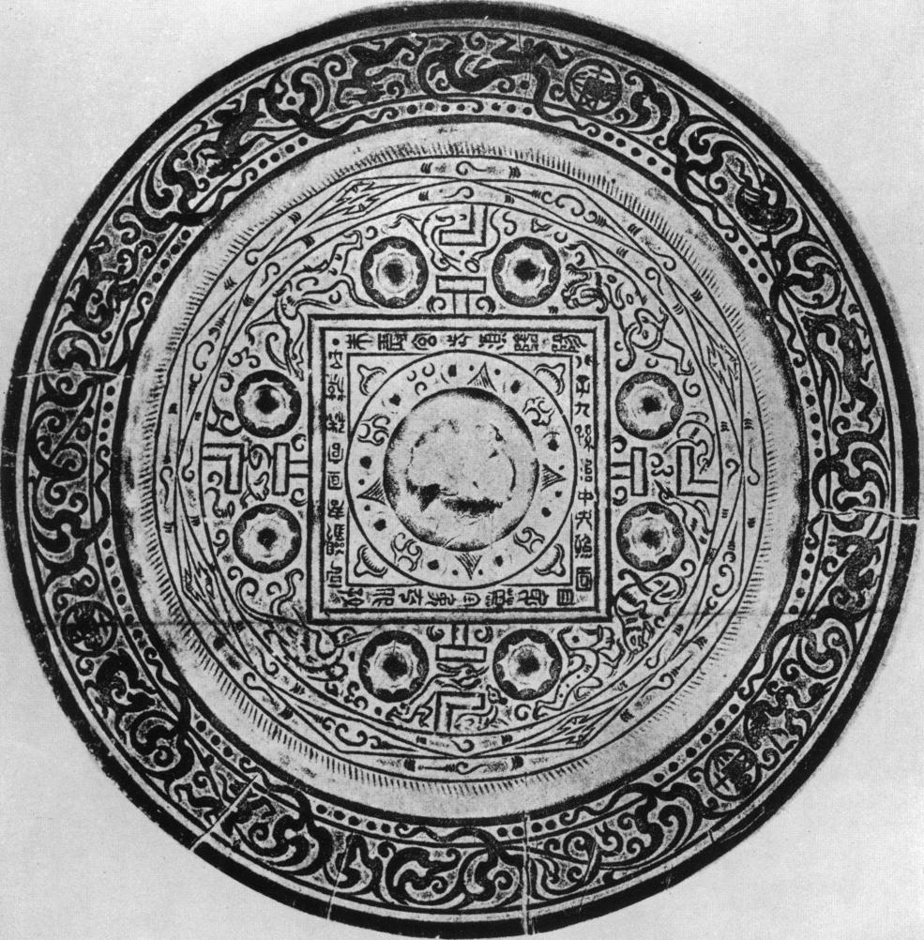

Fig.

TLV mirror

earlier years. When he ascended the throne his interest did not wane and inscriptions on mir­rors, *e.g.* "the Hsin Dynasty has erected a *Pi-yung* and built a *Ming-fang* ERrA2" suggest a connection between the decoration of mirrors and these buildings.

The bands running between the four V signs on mirror (Pl. 37) can similarly be interpreted as images of beams that form the framework of a roof. They are decorated with a row of diamond patterns which suggest that the beams were painted as in Chinese buildings of a much later date. The fact that a similar design can be found on a *chung-ch'fian* mirror66 suggests that such patterns were popular in the later part of the first century B. C. A similar mirror, found in an Eastern Han tomb, was said to be gilded.67 The rim is decorated with a double zigzag line with dots in between *(cf.* Pl. 28) and the inscription is written in a very artificial style. We may con­clude, therefore, that this mirror belongs to the time of transition, i. *e.* roughly from the middle of the first century to the end of Wang Mang's reign.

A single zigzag line interspersed with dots circles the main zone of decoration of the gilded mirror, Pl. 38. The lithe immortals on this mirror are akin in style to those on the Hosokawa basin (fig. 1o) and none of the animals, especially not the tiger, have the long neck and curved chest of the mature Wang Mang style. Moreover, the shape of the scrolls between the figures, and the style and movement of the animals resemble those in fig. C. Although none of the in­dividual stylistic features would be sufficient for the dating of this mirror, the fact that they appear together on the same mirror justifies the conclusion that a style is represented which flourished in the middle of the first century B. C. but had already been abandoned at the beginning of Wang Mang's reign. The division of the flat rim into two zones supports this date. The border pattern consists of a band running in broad zigzag lines inside the rim. Although this is an unusual design for a mirror it can often be found on other works of art of this period.

A rare type of TLV mirror is shown on Pl. 39. The meaning of the figures in the main zone of decoration will be discussed later. However, the leaves of the quatrefoil with their long needle-like endings still reflect the late Western Han style. The fact that there are only four and not eight nipples in the main zone of decoration can be interpreted as an additional proof of its relatively early date, the more so as their simple shape and their distribution can be related to the four disks in fig. C and to the four nipples on the mirror dated io A. D. (fig. F). This mirror belongs to a period between the last decade of the first century B. C. and the beginning of the Middle Eastern Han [period. ca](http://period.ca/). A. D. 80.

The mirror in fig. G is of particular interest because it includes the pictures of three coins in the decoration of its rim. They are exact copies of the *ta-chfian wu-chu tREtt,* a small coin issued by Wang Mang in A. D. 8 gt-AL.-,- if. This shows that the mirror cannot be earlier than the beginning of Wang Mang's usurpation of the throne in A.D. 9 although these coins were used for centuries and specimens have been found in many late Eastern Han tombs68. Yet the animals and other features conform more to the style of the earlier than to that of the later

for viewing the stars and the clouds and they were called 'magic towers' because it was believed that they could ward off evil influences. Clay images of such towers are often manned by archers shooting arrows in all four directions; they aim at the birds of ill omen or other inauspicious intruders from the world of spirits.

**66** Umehara, S., *Kokyd no kenkfi,* Pl. 19.

**67** *Ch'iian-kuo chi-pen chien-.the kung cb'ing chung ch'u-eu win-wu,* Peking 1955, Vol. II, Pl. 161 (r), excaveted near Lo-yang in Honan province.

**68** *e. g.* together with coins cast during Ling ti's reign (168-1 89 A. D.), *K'ao ku t'ung, 1957,* No. 5, p. 73 (L).

Fig. 4 from border patterns

a

Fig. 4a mirror publ. by Umehara. Fig. 4b mirror publ. by Karlbeck Fig. 4c figure cut out of gold-foil *Kokyo no Kenkyfi,* Pl. 27 Syndicate 1931/32, No. 198 (Ch'ang-sha report, Pl. 83)

Eastern Han period, and the division of the main zone into two sections with the border pattern running around the outer side is more common on early than on late mirrors. It shows diamond-shaped motifs alternately filled with C-shaped scrolls and so-called 'zigzag or compound lozen­ges'. This border restricts the space of the main decoration and instead of the L-signs *(cf.* fig. F) the V signs have been omitted. None of the animals has the curved chest so characteristic of the mature Wang Mang style. A motif on this mirror can be related to one on the mirror dated A. D. io (fig. F). On both, an animal is shown kneeling in front of a man who hurries towards it. The centre field is decorated with a ring inside a square frame not unlike that on Pl. 3o. It is adorn­ed with striated triangles alternating with scrolls which in style are akin to those in fig. F. The four corners of the square are decorated with rather stylized trefoil motifs which have lost their gracefulness when compared to others, *e.g.* Pl. 3o or fig. D. As on so many Wang Mang mir­rors the inscription is set in the band surrounding the centre square. It begins with the well-known phrase "the Red Bird and the Dark Warrior follow the *in and yang"* and finally expresses the hope that "the eight sons and nine grandsons may govern the centre" A-T-J-1,Wt,r11, a phrase which has a cosmic and metaphysical meaning. This mirror has a very elaborate border decora­tion. Its main features are S-spirals turning into flame-like cloud signs which penetrate an inner ring studded with small dots. Similar patterns can be found on a number of other mirrors *(e.g.* Pl. 4o and 42) though the figures between the spirals differ widely. Those in fig. G. include a dancing bear, a stag with huge antlers, dragons, and a charging buffalo- or goat-like creature. The style of the various motifs, including the border pattern, suggests a first century A. D. date lying between Wang Mang's time and the beginning of the Middle Eastern Han period.

The border on Pl. 4o is perhaps even more elaborate than the previous one. The charging buffalo, although no less stylized than its counterpart on the previous mirror, is nevertheless more realistic in its movements. He is attacking a queer-looking monster which is drawn facing the onlooker. On other mirrors he is attacking the hare of the moon (fig. 4a). Some running men are shown on the other side of the border (fig. 4b), a motif going back to Shou-chou mirrors (fig. 2). Those on this mirror differ from the earlier ones insofar as their trousers widen beneath the knee. They resemble some of the figures (fig. 4c) cut out of gold foil found in tomb 211 in Ch'ang-sha. The main zone has four nipples only and lacks the V-signs *(cf.* fig. G). Some figures in the main zone of decoration are worked in slight relief, a difference in technique not previously encountered. The scenes represented on this and on other mirrors (Pl. 39, fig. F and G) illustrate various episodes connected with Hsi-wang-mu and the archer Hou-i. They will be interpreted when discussing a later type mirror. The plain knob is surroun­ded by a square inscribed with the names of the Twelve Earthly Branches alternating with twelve

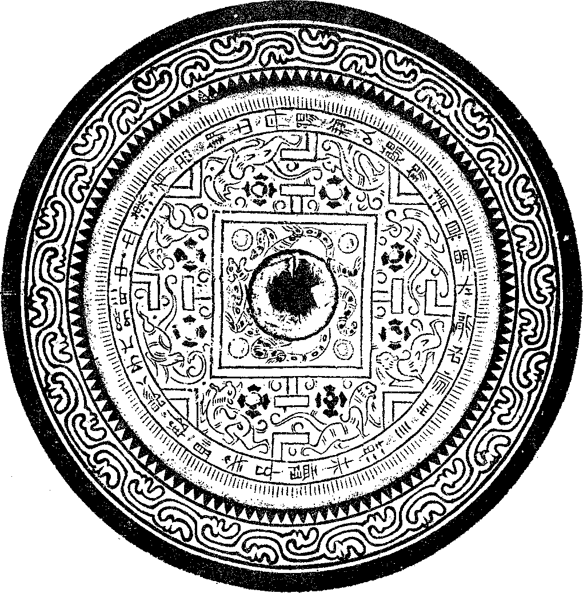

Fig. H  
TLV mirror

nipples. The trefoil motifs which fill the four corners of the central square resemble those on the previous mirror, a fact which is an important help for assessing its date. This mirror is a good example of the manifoldness and vitality of TLV mirror decorations which flourished from the end of the first century B. C. to the middle Eastern Han period.

It may be permissible to refer to the mirror on P1.41 as a standard type because its style and decorative pattern were copied over and over again. Although the neck of the tiger is not so powerfully curved and snake-like as those on Pl. 3 5 and fig. E, this mirror could hardly have been

made before the end of the first century B. C. The straight backed immortal in his feather dress was popular for quite a time, even after the time of transition. The quatrefoil is different from those on Pl. 35 and fig. E which are seen on many mirrors with a Hsin Dynasty inscription. Yet, this is not at all a sign of a post-Wang Mang date, the less so since it is surrounded by an elaborate network of scrolls such as were more popular in the pre-Wang Mang than in the post­Wang-Mang era. However, though the style of this mirror suggests that it was first made during the time of transition, such mirrors were made for a long time and retained their popularity, all through the first part of the Eastern Han period.

Although the main motifs on TLV mirrors of the transitional period were copied over and over again, there are certain general trends of development and certain individual features which sometimes allow us to discriminate between mirrors of this and the following periods. The shape and design of the nipples in the main zone of decoration can sometimes indicate the date, but they should not be taken as reliable guides as earlier shapes were copied during later periods. Typical of Wang Mang mirrors are nipples surrounded by scallops *(cf.* Pl. 35, 41, 47; figs. E. G.). However, they were sometimes copied on later mirrors. Perhaps as a reaction against the very elaborate designs of the mature Wang Mang style, mirrors tended to become simpler in the course of the first century A. D. The main zone of decoration on fig. H has only four pairs of figures. Although there are a number of TLV mirrors with a Hsin Dynasty in­scription showing not more than eight figures, the mirrors of the mature Wang Mang style abound in a great number of birds, small animals, and immortals. The animals on fig. H are less ornate than on Pl. 35 and fig. E. The nipples surrounded by four leaves are of a type particularly popular during the Eastern Han period in the late first and ,second century A. D. The most im­portant change can be found in the design of the centre square. The quatrefoil has been replaced by a dragon and a tiger. The main part of their bodies is hidden behind the knob but their extremities are protruding on all sides. The root of this decoration can be traced to Western Han mirrors which freqently displayed an arrangement of animal figures around the knob. They became very popular in the Eastern Han period and finally gave rise to a new type of mirror. The inscription is typical and says that good copper is mined at Tan-yang, and it continues with the usual reference to the *ssu then,* to eight sons and grandsons, and concludes with the wish that they may govern the centre. It is placed on a band around the main zone of decoration which was the most common position for inscriptions, at least, from the beginning of Wang Mang's rule on and later. Mirrors like this one flourished in the first century A. D. after the end of Wang Mang's rule and in the Middle Eastern Han period.

The mirror, Pl. 42, is a good example of the conservatism as well as of the changes which took place in the decoration of mirrors in the course of the Eastern Han period. The border pattern is a continuation of those on Pl. 4o and fig. G, yet the figures interspersed between the flame-cloud spirals differ from earlier ones. First of all, being larger in size, they no longer fit into the main zone but occupy the space above the inner ring, thus breaking the continuity of the row of dots. Secondly, the style of the animals has changed; their movements are less fluid and graceful but often quite stiff and angular. The charging buffalo has disappeared altogether and has given place to a rather strange figure, i. *e.* a man apparently crawling out of a large shell. In addition, the little gay sprite (fig. G) has been replaced by a rather sad-looking and emaciated man with a long body. Unlike immortals on earlier mirrors he is neither dressed in a feather

garment nor has he wings attached to his shoulders. Taken altogether the differences between the two border patterns indicate a considerable time lag. In fact, border patterns like the one on Pl. 42 were favoured in the later part of the second century A. D. The eclecticism in the stylistic rendering of some of the motifs in the main zone of decoration is another sign of its late date. The tiger has the curved chest found on Wang Mang mirrors and later periods. There are two types of sprites or immortals, one seated on an animal riding backwards, the other coaxing a dragon. Both lack feather dresses and wings though the latter is akin to earlier types. Inter­esting is the dancing monster which, like the one on the border of Pl. 40, turns its face towards the onlooker. This one has a serpent in its paws. In place of the simplified trefoil (Pl. 4o and fig. G) the corners of the inner square are filled with a motif reminiscent of Western Han mirrors. That this design was still popular in the later part of the first century is confirmed by the mirror dated A. D. 64 (Pl. 25). The main determinant of the date of this and many other mirrors is border patterns because they tend to be less conservative in style than the decoration of the main zone.

An example of the deterioration of the classic design is shown on Pl. 4z A. The figures are reduced to a few rather crude lines while the animal border has gained in importance. This mir­ror cannot have been made before the end of the Eastern Han period, and the decoration of the four corners of the square suggests that it was made in the Six Dynasties and not even in the San Kuo period.

From about the middle of the Eastern Han period onward interest shifted to other types of mirrors although the TLV mirrors were still produced in considerable numbers. Pl. 43 illustrates a complete deviation from the accepted type. It lacks the charm of the earlier mirrors but the dragon riders and the dragons resemble those on stone reliefs from the later part of the Eastern Han period, especially from the middle of the second century onwards. The earliest possible date for this mirror is the third century A. D. as indicated by the large and fiat knob and the ill-defined lines of its design. It was most probably made after the close of the Han Dynasty and not before the middle of the century. The main zone of the mirror is divided into two parts, the outer one being filled with S-spirals reminiscent of Western Han mirrors. The revival of ancient motifs is typical of this period and started already in the later part of the second century A. D. Although this survey cannot offer examples of all variations of TLV mirrors it is hoped that the foregoing selection will facilitate the chronological grouping of mirrors.

GUIDE FOR DATING

To supplement the survey some features of the decoration typical of the style of one period will be dealt with separately. This guide should, however, be used with caution. Only if the centre design and border pattern conform in style to those of the animals, immortals, and other features, can we be sure that the mirror belongs to a particular period. An eclectic combination of ill-assorted motifs can mean that the mirror was either made in the later part of the Han period or in the third or fourth century A. D. The selection of drawings is restricted to the most common types and is not meant to be anything like a complete list of all existing types.

*tWO*

**,0•• 7mw oteMi. .10W.**

**.nnn .womme osIm. oreme *emme* omme orommo *arawar* .rovro owewo .swoor**

Fig. 5 a  
fragment of a TLV mirror (the ground is gilt)  
(W. P. Yetts, *The Eumorfopoulos Collection,* Vol. II, B. 9)

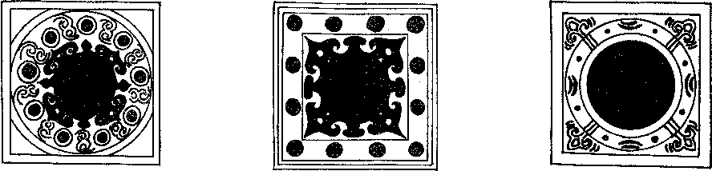

Fig. 5 b Fig. 5 c Fig. 5 d

TLV mirror (Umehara, *Shina* TLV mirror TLV mirror

*Kodo Seika* Vol. IV, Pl. 66) *(ibid.,* Vol. IV, Pl. 6z) *(ibid.,* Pl. 64)

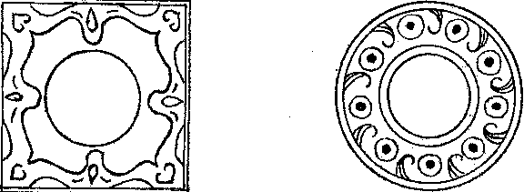

Fig. 5 e Fig. 5f

TLV mirror (Umehara, TLV and other mirrors *(e. g.* Pl. 3o

*Tokan Kokyo Zuroka,* and Umehara, *Shina Kodo*

Pl. XXII) *Seika,* Vol. IV, Pl. 69)

*Centre fields*

A number of designs filling the square framework of TLV mirrors during the time of tran­sition and during the early Eastern Han period have already been discussed. Fig. 5 a seems to be an exception. It is from a large fragment of a TLV mirror formerly in the Eumorfopoulos col­lection, and Professor Yetts69 estimated that the whole mirror measured 30.5 cm. in diameter. Yet, the main zone of decoration and the rim may well have been smaller than on the more com­mon type of mirror. It should be noted that a separate zone, like a belt, surrounds the quatrefoil resembling the heavy rings on *chung-th' I:jun* mirrors of the first century B. C. while on most mirrors made during the time of transition the quatrefoils, scrolls and nipples are enclosed by a single line only (fig. 5 b). Although the quatrefoil is basically the same as that on Wang Mang mirrors (fig. 5 c) it is slightly more elaborate and therefore suggests an earlier date. In general, there is a growing tendency in the course of the later part of the first century B. C. and A. D. to simplify the designs of the central fields. And yet the design on fig. 5 a is not nearly as elegant and graceful as the quatrefoil on the Hosokawa basin (fig. B.) where the small leaves fit perfectly into the hollow formed by the larger ones. This is certainly partly due to the fact that in fig. 5 a the quatrefoil is placed into a narrow circle which does not allow for leaves with long needle-like endings. The mirror fragment is thin and the similarities as well as the differences between it and other mirrors suggest that it was made prior to the time of transition or, at least, in its early part. It is partly gilded like the mirror on Pl. 3 8 ; and although the first century had a marked prefer­ence for precious and expensively worked mirrors this does not necessarily indicate the date of its origin as the practice of gilding was popular from the first century B. C. onwards and all through the Eastern Han period.70

A comparison between fig. 5 c and the centre of a Western Han mirror (Pl. 15) is no less characteristic of the development. On the earlier mirrors the leaves with their long needle-like endings are not only more graceful but their forms express a certain dynamic tension which is missing in the short leaves of the quatrefoil in fig. 5 c. The sharp teeth-like signs between the leaves on Pl. 15 are turned in fig. 5 c into T-shaped or mushroom-like motifs. These quatrefoils are often referred to as *pien-fu tg-ttTi* although they have nothing to do with bats. They are only one of the many designs of the centre field. Often the knob is simply placed into a decorated ring (fig. 5 d) and the corners of the square filled with trefoils or other motifs. Simple quatrefoils

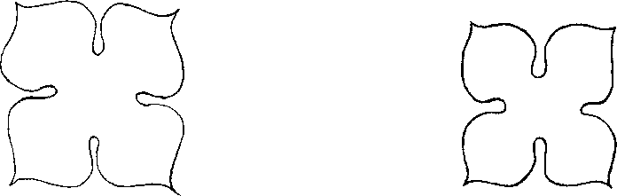

Fig. 6 a

centre of toilet box in the British Museum  
(B. Gray, The Eumorfopoulos Lacquer Toilet Box)

Fig. 6 b

centre of toilet box found in Wang Hsii's tomb in Korea  
(Pl. LXXXV)

69 Yetts, W. P., *The Eumorfopoulos Collection,* Vol. II, B. 9, p. 51.

70 Umehara, Sueji, `Ityukin no kan rikucho kyo', *Yamato Bunka,* No. 6, April 195z.

are not less popular. They are often called *siu pa* IA M or *ling-hua VA-L, i. e.* 'four plantain leaves' or 'water-chestnut flowers' patterns. The one in fig. 5 e is surrounded by scrolls typical of this period; without such additional motifs no date can be reliably deduced from the quatre­foil as such. The slight differences in the shape of leaves *(e. g.* Pl. 19, 25, z8) have no relevance to the date of the mirror. Similarly shaped quatrefoils have been used as decoration of other works of art for long periods. For example, the two shown in fig. 6a and b adorn toilet boxes, one dating back to the later part of the first century B. C., and the other to the middle or later part of the first century A. D. Although there is a difference in the shape of the leaves the exami­nation of a great number of similar motifs has shown that whether the leaves are stumpy or slim has no bearing on their dates. The design of fig. 5 f fills the square frame on TLV mirrors and is also used as a centre field design on other types of mirrors.

*Border patterns*

Another great innovation of the first century B. C. is the introduction of special patterns decorating the rims of mirrors. The changing motifs and styles of these patterns are in most cases a clue to the date of the mirrors. The development of special border patterns is the logical con­sequence of the new type of more pictorial decoration. The arabesques and scroll patterns sym­bolizing clouds had hitherto been an essential part of the decoration which could not be omitted. Yet the division of the mirror into two zones, one of them reserved for cloud scrolls *(e. g.* Pl. 29) proved unsatisfactory as it confined the display of the animals and immortals to a rather narrow zone. To move the cloud signs to the rim of the mirror seemed the most convenient and pleasing solution. It promoted the development of new cloud signs especially suited for display on a narrow border. Plant-like motifs, resembling winding creepers with buds and leaves seemed to answer this problem. The most realistic flower patterns on TLV and other mirrors are those shown in fig. 7a, b, c. They became a favourite decoration during the later part of the first cen­tury B. C. and only lost their popularity in the course of the first century A. D. However, a pattern as in fig. 7 c can again be found on mirrors in the later part of the Eastern Han and post-Han era (Pl. 59). Fairly rare and certainly Western Han are border patterns such as the one in fig. 7 d (Pl. 3o and Pl. 38). Those on fig. 7 e differ from previous creeper patterns insofar as they are more geometrical and buds and leaves merely adorn the ends of S-spirals. The decorations in fig. 7f and *g* have lost their creeper-like appearance. This is even more pronounced in the small patterns of fig. 7h and i which are not border patterns but those of rings circling the inner section of the mirrors, *e. g.* Pl. 46 and 47. They became very popular in the first century A. D. and in the Middle Eastern Han period. The changes in the style of these border patterns show that the more floral and elegant designs were replaced in the course of the first century A. D. by simpler and more geometrical patterns. This development reflects the difference in the intellec­tual and social atmosphere of the later part of the Western and the Eastern Han period.

The most common border pattern on Wang Mang mirrors is the one shown in fig. 7 k; it is called *liu-yfin* or 'drifting cloud' pattern. Unfortunately, it cannot be used for dating as it remained unchanged for centuries and can still be found in the time of the Six Dynasties. Equally difficult to date are borders with zigzag or sawtooth patterns except where the pattern is in­terspersed with dots as previously mentioned *(e. g.* Pl. 37, Pl. z8 and 38). These zigzag patterns,

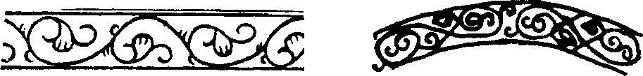

Fig. 7 a Fig. 7 *f*

Umehara, *Tokan Kokyo Zuroku,* Pl. XII *ibid.,* Vol. III, p. 20

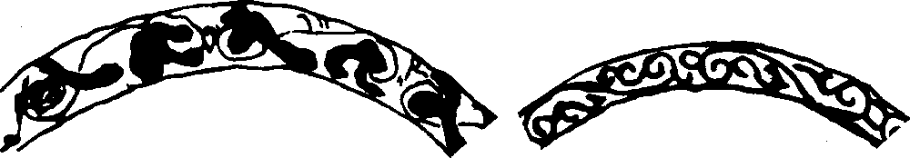

|  |  |
| --- | --- |
| Fig. *7* b Liang Shang-ch'un, *Yen k'u ts'ang ching,* Vol. II, P. 43 | Fig. 7 g Umehara, *Tokan, op. cit.,* Pl. XIII  Oz*  Fig. 7 h interior belt (Liang Shang-ch'un, *op. cit.,* Vol. III, p. 75 |
|  |
| Fig. 7 c *ibid.,* Vol. III, p. 48 |

Fig. *7* e Fig. 7 k

Fig. 7 d  
see Pl. 30

Fig. *7* i  
interior belt, *ibid.,* Pl. 64

Liang Shang-ch'un, *op. cit.,* Vol. III, p. 18 on a great number of mirrors

Fig. *7* Border patterns on mirrors

*san-chio =* Ai, are sometimes arranged in three concentric circles, of which the middle one is often drawn in double lines *(e. g.* Pl. 36, Pl. 46, Pl. 47), or in a solid band *(e. g.* Pl. 48). Whenever the sawtooth patterns decorate the rim of mirrors they symbolize cosmic mountains' *(e.g.* Pl. 43, Pl. 5 8. Pl. 49, Pl. 6i, and so forth), believed to surround the sky along the edges of the universe. When three concentric zigzag lines are shown the middle one represents a river mean­dering between two mountain ranges surrounding the universe. On late Eastern Han and third century mirrors the double line, symbolizing the river, is often set in a very narrow band *(e. g.*

**7'** Bulling, A., *The Meaning of China's Most Ancient Art,* **1952,** pp. 5 6 ff.

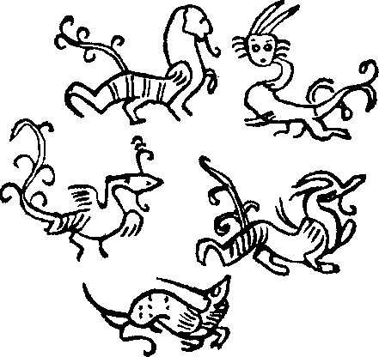

Fig. 8.a  
from TLV mirror (Umehara, *Shina Kodo Seika,* Vol IV, P1. 65)

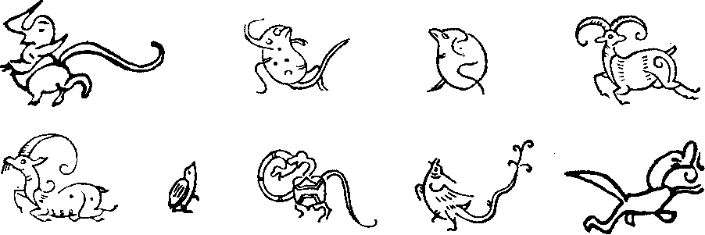

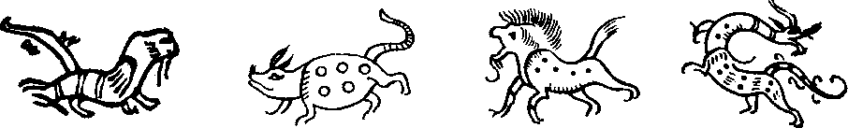

Fig. 8 b  
from different mirrors

Pl. 58 and P1. 43), whereas on earlier mirrors it is mostly the dominant pattern *(e. g.* Pl. 36, 47, Pl. 23, 37) while on the mirror Pl. 48 all three lines are of equal dimensions.

An undecorated flat rim is typical of the first century B. C. *(e. g.* Pl. 19, 29, 34 and 44) al­though it can also be found on late Eastern Han mirrors as illustrated by fig. L.

*Animal figures*

The amazing array of animals on the main zone of TLV and other mirrors includes tigers, goats, rhinoceros, monkeys, hares and birds as well as fantastic creatures such as dragons, three-legged birds, or dancing monsters *(e.g. fig.* 8 a. b). The animals on first century B. C. mirrors

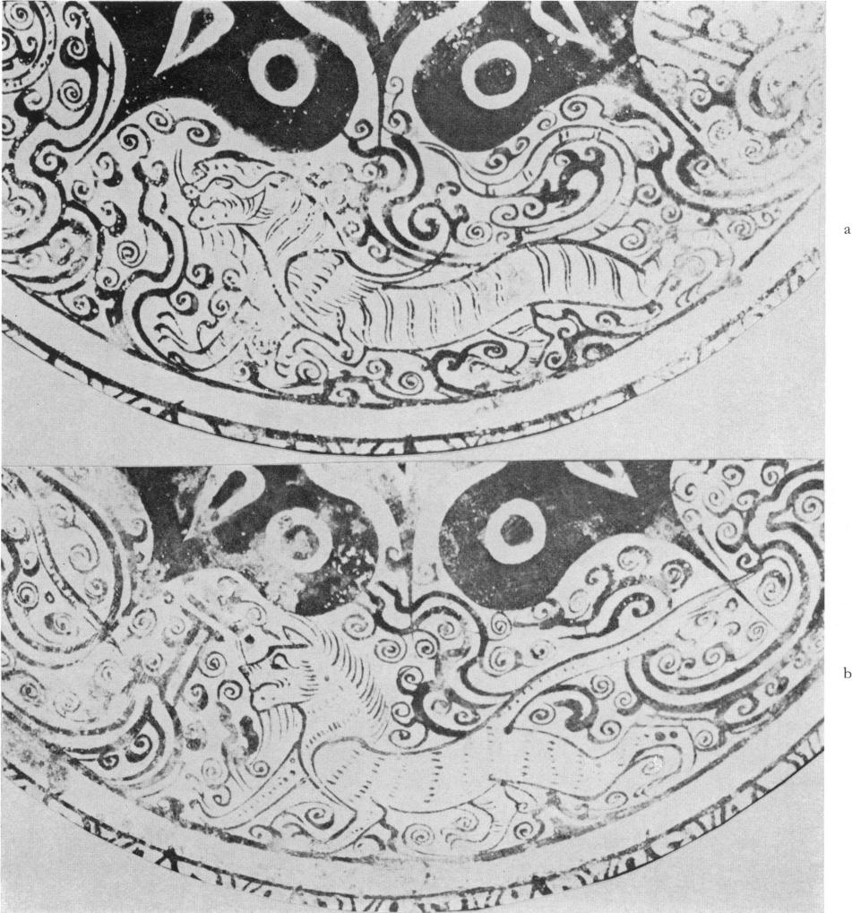

Fig. 9  
details of fig. B

are drawn in a florid style. Some of the hybrid creatures (Pl. 38, 44 and fig. C) seem of an amazing vitality and mobility. Typical of the eccentricity of these creatures is, for instance, an appalling monster with a square head walking on two legs which is shown in fig. C and Pl. 44. The rather gruesome imagination of the artists of this period has not been surpassed by later generations. Monsters with square heads on late Western Han and Wang Mang mirrors are not quite so grotesque and look a little less fierce. Other animals are drawn more realistically such as the lion-like animal with the flowing mane on Pl. 44 which closely resembles one on the Hosokawa basin (fig. 9 b). Animals on mirrors of the mature Wang Mang style differ considerably. On all these mirrors the Four Spirit Animals play the dominant part in the decoration and a comparison of the tigers on various mirrors provides a basis for dating. When compared with the highly stylized tigers of the mature Wang Mang style (Pl. 35, 41, fig. E and fig. 8 a) those on fig. D and Pl. 29 look more realistic, if such a word can be used at all. This shows that although the winged tiger was a denizen of the sky the artists were keenly interested in the shape and movements of the real animal. That they studied animals carefully is perhaps best demonstrated by the various tigers on the inlaid basin (fig. B and fig. 9a) where the animals are shown prowling, stalking their victims, or walking with true feline movements along their paths. The tigers on Wang Mang mirrors have lost the realism of the earlier beasts. Typical of them is the powerful, curved chest or snake-like neck (Pl. 35, fig. E, Pl. 41, fig. 8 a). Wherever there are animals with such features the date of the mirror can only be Wang Mang or later. Although already less pro­nounced than on Wang Mang mirrors the long necks of the tigers on Pl. 48 and fig. H and J indi­cate that they cannot have been made prior to Wang Mang's era. The animals on these mirrors are less stylized and less ornate; some lack, for instance, the highly elaborate tails with their tendril-like endings seen on most mirrors from the first century B. C. onwards. This simpli­fication is typical of the general trend of the Eastern Han period. Towards the end of the time of transition the power of imagination which had created a wealth of animal patterns seems to have declined, and the following generations frequently copied existing designs.

*Immortals*

*Hsien* or *shan-jen qj A:* iLIA are the names given in inscriptions to the little fairies or genii in anthropomorphic forms which roam amongst the spirit-animals. They are one of the constantly recurring motifs on mirrors and their changing appearance is a valuable guide to the dating of mirrors. Many wear a kind of feather dress or have wings attached to their shoulders. Similar figures are depicted on other works

of art and those on the Hosokawa basin, fig. 1o, provide a good ex­ample of the type popular in the middle and later part of the first century B. C. They resemble those on Pl. 38 and fig. D, F and fig. 11 a but are different from those in fig. C. Other variants are those on Pl. 41, 45, 46, and Pl. 47; they are

Fig. ix f Fig. i z g Fig. i r h

Fig. II a  
Umehara, *Tokan, op.*  
*cit.,* Pl. XVI

Fig. i i c  
*ibid.,* Pl. XI

Fig. i i d

Mirror found in Lo-lang in Wang Hsti's tomb Umehara, *Shina Kodo Seika,* Vol. IV, Pl. 7o

Fig. II Immortals from mirrors

smaller and seem to have lost some of the elegance associated with the previous examples. An­other small and more imp-like immortal is shown on Pl. 36. Many Wang Mang mirrors have spirits like those in fig. i i, b, c, d, e, some resembling old men or hunchbacks. Immortals like those on Pl. 42 and fig. H. became popular especially from the Middle Eastern Han period on­wards. The immortal with an animal head in fig. i i f is from a mirror found in the tomb of Wang Hsu in Korea and suggests an Eastern Han date between 4o-7o A. D. This type was still popular in the Middle Eastern Han period. The rather sketchily drawn spirit with a large head in fig. i i *g* and on Pl. 47 can be found on mirrors in the first century A. D. ; a similar date can be assigned to immortals resembling fig. i i h. Although certain types of immortals were especially popular during one period or the other, this alone is not a safe basis for dating; the less so as in the Eastern Han period the artist had a choice of a number of well established types which he could use freely in conjunction with later designs on mirrors, and the combination of a mixed assortment of immortals belonging to different styles proves that the mirror can only be of a later date.

*SHOU-TAI* "am, "ANIMAL BELT" MIRRORS

In a general sense all mirrors decorated with a belt of animals can be described as *shou-tai* mirrors; yet this name is given especially to mirrors which differ from TLV mirrors insofar as they lack the three letters. Typical of this group are the nipples which are interspersed between the animals. Their numbers vary; there can be as few as four or as many as nine nipples, and in many publications they are grouped together according to their number of nipples. Knobs, central field designs, and border patterns are very often the same as on TLV mirrors. That the first specimens were produced in the later part of the Western Han period is confirmed by the discovery of an interesting mirror in tomb 245 in Ch'ang-sha.72Unfortunately, the illustration is not clear enough to show all the details of the decoration. It has an hemispherical knob sur­rounded by a zone filled with nine small nipples all set into richly decorated rings. Characters are placed between the nipples not unlike those in fig. F. A plain broad ring like those on on Pl. 44, 45, surrounds the centre. Each of the seven nipples in the main zone is set in an equally

72 Ch'ang-sha report, Pl. 69 (3).

decorated ring similar to those in the centre field. The various creatures are placed between the nipples as on Pl. 45-48. They include the Dark Warrior (tortoise and serpent), tigers, drag­ons (one turning its head as if bellowing at the one behind him), and — rather indistinctly — the figure of a running man. The animals are shown in violent motion and are surrounded by scrolls not unlike those on Pl. 38. The rim is divided into three belts *(cf.* Pl. 3o, 38, fig. C), of which the middle one holds a row of animals including birds and serpents with split, tendril-like tails.

The most common centre design on *Shou-tai* mirrors of the late Western Han period and early first century A. D. is quatrefoils like those on Pl. 44 and 45. The difference between the two is that the scrolls in the later one are simpler than in the earlier one (Pl. 44). The animals on Pl. 44 are extremely lively in their movements and expressions; they excel in contorting their bodies and grotesque grimacing. Some look as if they were roaring and bellowing loudly. They resemble animals on Western Han mirrors and are not too different from some on the Hosokawa basin or on fig. C, especially the lion-like animal with the flowing mane, and the creature with the square head walking on two legs. As none of the animals exhibits any stylistic features of the mature Wang Mang style, it is safe to say that this mirror provides an example of *show-tai* mirrors such as were popular in the first century B. C. preceding the types which flourished during Wang Mang's lifetime.

Seven-nipples mirrors as shown on Pl. 45 are sometimes called 'seven stars' -Lm_ mirrors or else *His-ling san-jui* , 'Four Spirits and Three Happy Omen' mirrors. The animals on this mirror are of a relatively subdued type. The curved chest of the tiger of the mature Wang Mang style is missing, and the little immortal jumping over the back of an animal can best be compared to the one on Pl. 41. It is more than likely that this mirror was in popular demand especially from the end of the first century B. C. to the middle of the first century A. D.

Another 'seven planets' mirror is shown on Pl. 46. The knob is surrounded by a ring with nine small nipples alternating with characters. Instead of a plain band, a belt with S-spirals surrounds the centre field. The style of the tiger in the main zone of decoration suggests that the mirror could not have been made before Wang Mang's time of rule. The immortal resembles one on a mirror found in the tomb of Wang Hsu in Korea. All these features indicate a date some time between Wang Mang's era and the end of the first century A. D.

The design of the centre field on Pl. 47 differs from the previous one insofar as scrolls alternate with nipples. The S-spirals in the intermediate zone on this mirror like those on Pl. 46 and fig. J are rather geometrical and lack all plant-like endings. The nipples in the main zone on this mirror and on Pl. 46 are surrounded by a belt of scallops *(cf.* Pl. 35, 41, figs. E, G.) popular from the end of the Western Han period onwards. The immortal is rather sketchily drawn (see fig. 11 *g),* and the shape of the tiger confirms a Wang Mang or post-Wang Mang date which, like the previous one, falls into the first century A. D.

The mirror in fig. J resembles, at least, in parts the two previous examples. The knob is again surrounded by nine small nipples alternating with characters and bud- or trefoil-motifs. The larger nipples are enclosed by scallops and an outer ring; this, as will be explained presently, is found on mirrors of a slightly later date. The border is decorated with the Four Spirit Animals separated by two S-spirals, and the tiger with its large head differs from those onWang Mang mirrors. This type of mirror flourished from the middle of the first till well into the second century A. D.

The gilded mirror, Pl. 48, is similar to one bearing an inscription with the date A. D. 6473 The centre field is decorated with trefoils set between nine small nipples *(cf.* Pl. 46, fig. J). The immortal in the main zone of decoration resembles one on Pl. 46, and the tiger proves that it could not have been made before Wang Mang's era. The three rows of zigzag lines on the rim are different from those on mirrors previously discussed and suggest a date some time between the middle of the first and the middle of the second century A. D. This assumption is supported by the cone-shaped nipples which have a wider base than those on Pl. 44, 45.

A different type of *shou-tai* mirror developed in the course of the second and third century A. D. The bigger knob on Pl. 49 allows us to assign this mirror to a later date. The centre is inscribed with the same characters as on Pl. 46 "I *tau sun"* although the buds are larger and less graceful than those in fig. J and on Pl. 48. The band around the centre field is filled with an inscription set between two narrow, slightly rounded belts instead of with S-spirals. The tiger in the main zone of decoration turns his very long neck *(cf. fig.* J) not unlike one on a mirror found in Wang Hsu's tomb in Korea. The main difference between this and other *shou-tai* mirrors is the rounded relief of its animal drawings. Although the embossing of figures is not an innovation of the Eastern Han period it became really popular only in the second century A. D. An immortal amongst the figures in the main zone of decoration can be compared with one painted on a lacquer table74 which, according to its decoration, belongs into the later part of the Eastern Han period. The quatrefoils of the nipples in the main zone are the same as those in fig. H. The row of animals and the immortal on the rim are drawn in heavy and thin lines partly accentuated by solid forms. This mirror can be assigned to the later part of the Eastern Han period, its earliest possible date would be the first decades of the second century A. D.

A completely different example is the tiger on Pl. 5o. It has an extremely large head and bulging eyes and is akin in style to animals on a mirror with an inscription dated A. D. 189 (Pl. 65). Although the nipples on the main zone of decoration are surrounded by scallops, they differ from those on earlier mirrors because they are enclosed in a ring. Immortals with stick-like necks, rounded snake-like bodies and animal heads as on Pl. 5o can be found on mirrors from the Eastern Han period especially from the middle of the second century onwards, and even in the third and fourth century A. D. The knob in the centre is fairly large; the knob-seat is decorated with a quatrefoil reminiscent of Wang Mang mirrors *(cf.* Pl. 3 5 and fig. E) although its design is less elegant. This can be taken as a sign of a renaissance of earlier motifs which began during the second century A. D. A plain ring surrounds the centre field; it is smaller than those on earlier mirrors (Pl. 44), and resembles the one on Pl. 48. The style of the animals on the rim of the mirror suggests a date in the second or early part of the third century A. D.

The centre field decoration of the mirror, Pl. 5r, resembles one on Pl. 49. Yet, instead of having a band with an inscription it is surrounded by a raised ridge decorated with the so-called *`egg* and ripple' pattern. Such raised ridges became increasingly popular in the second and third century A. D. and new motifs were introduced into the main zone of decoration such as a grotesque, beetle-like creature walking on two legs, a man with a bear- or boar's head, and an acrobat turning somersaults. Figures of performers, musicians and dancers can be found on other mirrors in the third and fourth century A. D. The nipples in the main zone of deco‑

**73** Umehara, *S., Kan sangoku rikucba kinen kyo zusetzu* (abbrev. Dated Mirrors, Pl. 4).

**74** Table in the Fogg Museum of Art.

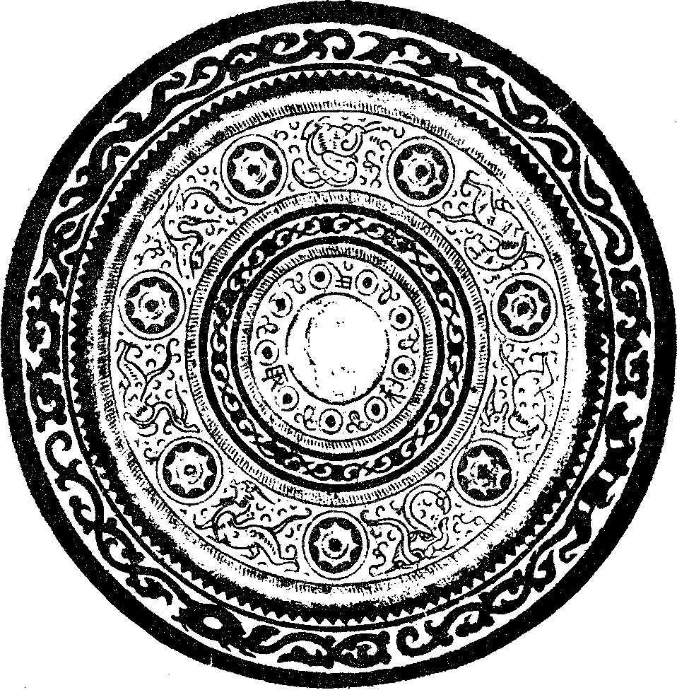

Fig. J  
Animal-belt mirror

ration are surrounded by rings like those on Pl. 5 o. The border pattern consists of S-spirals with two bars. In general, the craftsmanship is inferior if compared to all previous mirrors and it can hardly have been made before the third century A. D., probably not before the middle of the century.

Another type of *shou-tai* mirror is shown on Pl. 5 z. It is distinguished from all previous mir­rors by a different arrangement of the centre decoration. It no longer consists of concentric zones divided by broad bands placed on a toothcomb background but it is worked in a single piece decorated with just a few thin, concentric thread-lines and a raised ridge with the 'egg and ripple' pattern *(c f.* Pl. 51). The figures on the main zone of decoration are slightly embossed, and the

tiger has the same long neck as the one on Pl. 5o. However, the style of other animals has under­gone some change, especially the rather strongly stylized bird. Goats and sheep have always been a favourite motif on mirrors, yet this sedate looking animal is rather unlike the one on Pl. 57 dated 117 A. D. The immortal is of a type which can be found on many mirrors in the later part of the second century A. D. The rim is decorated with S-spirals and bars, yet its workmanship is of a quality far superior to the mirror on P1. 5 z which has a similar border pattern. This mirror is a fine example of the style which flourished in the later part of the Eastern Han period and the first half of the third century A. D.

Although the bird mirror, Pl. 5 3, does not really belong to the *shou-tai* mirrors it will be included in this group. A comparison with the elegant bird mirrors of the Western Han period (Pl. 33 and 34) expresses better than any words the change in the type of society which patron­ized the art of the mirror maker. The long-legged water birds have been replaced by sketchily drawn, plump birds which resemble quails. Mirrors decorated with similar birds have been dis­covered in several tombs of the Eastern Han and post-Han period", some even in a tomb of the Wei Dynasty. On many mirrors the bodies of the birds are embossed and, instead of pursuing each other as on P1. 5 z, they are shown in pairs on both sides of a nipple. The number of birds varies from four to six, but more often eight are shown arranged in four pairs.76 This number may have a bearing on a phrase included in an inscription on a mirror; it reads "the eight birds face each other and follow the norm of the primeval beginning" A,g chi , *( ku shih* being an expression which as Karlgren77 points out occurs already in the *Tao-te-ching).* The nipples on Pl. 5 3 resemble those on P1. 48 but are different from those on Pl. 5 z and 52 which are surrounded by an additional ring. The period in which such bird mirrors flourished was the second and early third century A. D.

A mirror from the Tomb of the Painted Basket in Korea has an even more simplified centre field than the mirror on P1. 5 2. It consists of a raised ridge with only the *"egg* and ripple" deco­ration. It is a fairly crude mirror and its figures are worked in a rather high and rounded relief. It includes in its decoration the figure of a running immortal or man with his arms raised on either side of his head not unlike the one on P1.49 although differing in many other ways. The bodies of the animals on this mirror as well as the garment of the immortal are decorated with simple, fluted lines foreshadowing a treatment seen on many mirrors which, according to their inscriptions, were made during the third century A. D. in the Kingdom of Wu. The Tomb of the Painted Basket cannot be earlier than the second century A. D. so that the date of this mir­ror falls into the second or early third century A. D.

The centre field of the mirror on Pl. 54 differs from all previous *shou-tai* mirrors by being set in a square frame filled with a quatrefoil not unlike those on Wang Mang mirrors. The tiger with its long, thin neck is akin to those on other late first and second century A. D. mirrors except for its movements. It appears not to walk but to fling itself into the clouds very much like the animals painted on lacquer objects found in Korean tombs, *e. g.* on a lacquer tray dated 68 A. D.78, or on a lacquer table found in the Tomb of the Painted Basket.79 The shredded cloud

75 *Kao k'u t'ung,* 1956, No. 4, p. 3o (C); *ibid.,* 1956, No. 2, P1. 19 (4-5), p. 64 (B); *ibid.,* 1957, No. 4, p. 6o (H).

76 The significance of the number of birds is discussed by Prof. Karlgren in 'Inscription', *op. cit.,* P. 44. 99 *Ibid.,* p. 45.

78 Wang Hsu's Tomb. Pl. LIX.

79 Hamada, Kosoku, *Lo-lang, the Tomb of the Painted Basket,* Keijo 1934, Pl. 53 and 68.

signs are related in style — although not identical — to those on the same table. The bodies of the various animals are marked with striae, an unknown feature in the first century A. D. Moreover, the animals are not worked in a rounded but in a flat relief showing only slightly above the surface. This forecasts a technique which became increasingly popular at the end of the second century and in the post-Han era. The border shows a row of animals and immortals worked in the same style as those on P1.49. A comparison with the style of other works of art allows us to conclude that this mirror belongs to the second century A. D.

*Shou-tai* mirrors continued to be popular long after the close of the Han Dynasty. The one on P1. 5 5 is said to have been found in Shao-hsing (Yueh-chou) in the province of Chekiang. According to the contents of tombs excavated in this region this place was used as a burial ground from the end of the Han period to the middle or end of the sixth century A. D. Inscrip­tions found in these tombs refer to dates ranging from 229 A. D. to 5 66 A. **D."** On some mirrors the Wu Dynasty is mentioned which ruled over this country in the third century A. D. Among the many mirrors found in these tombs were some which closely resembled the one shown on Pl. 55. As on Pl. 54 the four quadrants of this mirror are decorated with an animal. Yet they differ widely in style. They are less graceful and agile than those on the previous mirror though they are impressive and more powerful creatures. Typical of the later period is the size of the animals which completely fill the quarters of the mirror assigned to them, while on Pl. 54 and other mirrors there is still plenty of free space. The animals are worked in less rounded relief than those on P1. 5 o and, in general, look more angular and lack a certain subtlety as if they had been cut out of a hard material such as leather, or had been carved in wood. The knob is set in a square frame and the four corners are decorated with semi-circular motifs, instead of the quatrefoil, each one symbolizing a mountain.

The foregoing survey has shown that, in contrast to TLV mirrors, the development of *show-tai* mirrors did not come to a standstill in the course of the first century A. D. but flourished all through the Eastern Han period and the third century continually evolving new styles. The reason may well be that they were not connected in the minds of the people with the Wang family and Wang Mang and could, therefore, be enjoyed without resentment and misgivings.

*( Shou-tai* mirrors with a dragon-tiger centre will be included in the next group.)

*LUNG-HU, (P'AN LUNG) Eft (* ft) AND SOME OTHER MIRRORS

The name *lung-hu* is often given to mirrors the main decoration of which consists of a tiger and a dragon coiling around the knob, though it is also applied to mirrors showing dragons and tigers on the centre field only. The origin of this style has been discussed in connection with fig. H where the dragon and tiger figures are still confined to the centre field. In the course of the first and especially during the second century A. D. such crouching animals assumed greater importance and gave rise to a new type of mirror in which they formed the major part of the decoration and were always worked in relief. However, the name is not quite adequate insofar as the group often includes other animals or even human figures as shown on Pl. 5 6. This mirror was found at P'ing-yang (Pyongyang) in Korea. The animals are worked in rounded relief and their con‑

80 Umehara, Sueji, *ShOkyO (Shao-hsing) Kokyo Shuei* (Selected ancient mirrors from the Shao-hsing tombs), Kyoto, 194o.

tours are delineated by thin threads. The border pattern provides a clue to the date of this mirror. It resembles in style the one shown on Pl. 54 although it is less crowded as fewer animals occupy more space. This type of mirror flourished from the later part of the first to the middle of the second century A. D.

Other animals, *e.* g. a tortoise, or a tortoise and snake (Black Warrior) were not infrequently given a similar place and treatment on mirror and sometimes the centre and main zone is covered by the figure of a heraldic looking, strongly stylized bird. Though an interesting specimen in the collection of 0. Siren81 resembles to a certain extent a bird dated 9 A. D. decorating a bronze measuring utensilsz most of these mirrors were made in the late second century and post-Han pe­riods. A great number has been discovered in tombs in Korea83 . It is, however, an oversimplifi­cation, to call all of them San Kuo or Six Dynasties periods as done by Liang Shang-ch'un.

The centre of Pl. 57 is decorated with an animal figure worked in light repousse. According to the inscription above its back it is supposed to be a sheep Similar animals are shown on other works of art, especially on pottery tiles, and are described as 'auspicious sheep'. The date of this mirror is A. D. 117 The belt surrounding the animal is divided into sections by the *pa-kua,* the "Eight Trigrams". The characters set between the trigrams are written in an anti­quated style and testify to the interest taken, at this time, in the forms of early characters. This is significant because it was during this same period that Hsu Shen wrote his famous dictionary of ancient characters, the *Shuo-n/in*

The most common type of *lung-hu* mirrors is shown on Pl. 58. Two pairs of animals — their bodies more or less hidden by the knob — are facing each other from opposite sides of the mir­ror. The long neck of the tiger and the shape of its head show clearly that this mirror cannot have been made before the second century A. D., and the rim with its narrow middle band decorated with a rather flat double zigzag line supports a late second or third century date.

As a decoration of the centre dragons and tigers continued to be popular all through the Eastern Han, San Kuo, and part of the Six Dynasties periods. The mirror on Pl. 59 is said to have been found in tomb No. **2** in Lo-lang in Korea. It is an interesting specimen. The animals and immortals as well as the floral pattern on the rim are drawn in the classic style of Wang Mang's time although the latter reappears on late Eastern Han and post-Han mirrors. However, this early date is refuted by other features. The two pairs of dragons snarling at each other are worked in a relief which is much deeper than on Pl. 57 or 5 6. This technique was hardly used before the beginning of the second century or even the end of the Middle Eastern Han period. More important is the raised ridge with the *'egg* and ripple' pattern which separates the knob from the dragon centre. This combination, as will be shown later, denotes a lack of taste which would have been impossible at an earlier date. The ring is drawn rather closely around the knob, a feature common to many mirrors of the later part of the second and third century A. D. The eclecticism of the motifs on this mirror proves that it was made at a later time, probably between the beginning and the end of the third century A. D.84 The inscription begins with *Ch'ing-kai*

81 Siren, 0., *History of Chinese Art.* The Han Period, Pl. 68 A.

82 Jung Keng, *Hai-wai ku chin t'u lu,* Pl. 146.

83 Sekino, Tadashi and others, *RakurOgun jidai no iseki,* Vol. I, 1925.

84 This mirror should be taken as a warning. The renaissance movement encouraged people, especially in the third cen­tury A. D., to recast various types of ancient mirrors. Luckily, they sometimes changed the border patterns or included other contemporary features which give away their true date.

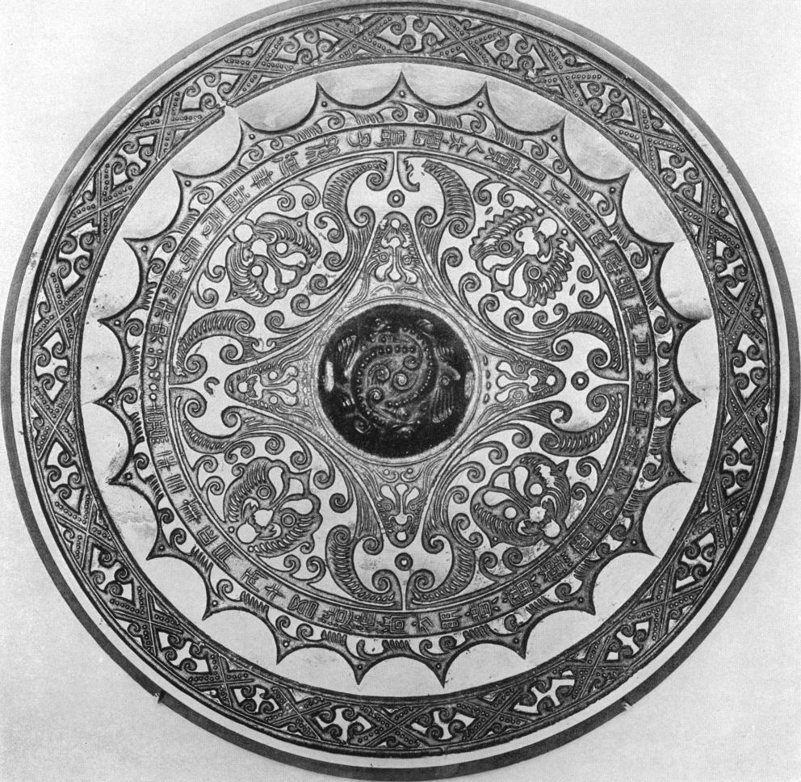

Fig. K  
Animal-head mirror, dated 174 A. D.

*tso thing Ch'ing-kai* is taken as a name in Japanese and Chinese publications, while

Professor Karlgren85 thinks that it is a script variation for *ch'ing yang`.* the 'green auspicious (metal)'86.

The mirror on Pl. 6o illustrates the introduction of new motifs into the decorations of mir­rors which began during the later part of the second century A. D. and became generally ac­cepted in the following century. The centre is decorated in the traditional manner with dragons and tigers while the main zone includes chariots, men on horseback, and other unusual and new motifs such as the two immortals with a divining board between them. In the Eastern Han pe­riod, and especially in the second century A. D., similar scenes are engraved in stones or stamped in bricks. The border pattern on this mirror is of a type which flourished from the later part of third century onwards and long after the close of the Han period. The fact that the rim is flat *(cf.* Pl. 42 and Pl. 72) and lacks the upturned outer edge most common on late Han and third century mirrors *(cf.* Pl. 49.50.54,58 and so forth) speaks for a Six Dynasties period date.

The mirror on Pl. 6i bears a dated inscription from A. D. 293 =---

5--EW (Western Chin

Dynasty). A number of similar mirrors are known with the same inscription except for the first phrase. One begins — as on Pl. 5 9 — with *"Ch'ing Kai" fr-f-Arf-A.;* another one published by Swallow87 is dated A. D. 196, and he calls it "a Sung reproduction of a Han mirror". That the bronze caster wanted to copy a mirror of the Eastern Han period can hardly be doubted, but his skill was inferior to that of the earlier master. The lines are not clearly defined and the motifs are inaccurately copied. The dragon and tiger figures in the centre lack precision and vigour when compared to those on Pl. 5 9.

ANIMAL HEADS *(SHOU-SHOU* wn) MIRRORS AND RELATED TYPES

The prominent feature of decoration on mirrors of this group are the heads of animals. They are placed, as can be seen in fig. K, in the hollows formed by the caved-in sides of the square in the centre. Four additional, smaller animal heads take up the inside of the four corners. Its date is A. D. 174 = $ and a number of other mirrors of the same type carry second cen­tury88 dates which confirm that they must have been in demand from about the end of the Middle Eastern Han period onwards. All animal heads on this mirror face the onlooker and have their tongues sticking out. The very elaborate knob is composed of coiled animals studded with bronze pearls. However, plain knobs not unlike that on Pl. 63 are not unknown in the second century A. D. The main part of the mirror is enclosed by a belt or arcs reminiscent of earlier mirrors as, for instance, on Pl. 24 and 25; the difference between both types is that on the earlier mirrors the main decoration was placed outside the arcs while on the later ones it runs along the edge enclosing the whole mirror except the rim. The border is decorated with lozenges trimmed with pearl edges. Each lozenge contains four scrolls. These rather ornate and decorative

**85** Karlgren, B., 'Inscriptions', *op. cit.,* p. 37.

**86** Or should `ch'ing-kai' here be a play with words as it could also mean 'bright umbrella'?

87 Swallow, R. W., *Ancient Chinese Bronze Mirrors,* Peking 1937, Pl. 25.

**88** *e. g.* A. D. 146, A. D. 156, A. D. 164, and so forth.

looking mirrors are said to have been made especially in the province of Szechuan which had been a centre of art during the Han period.89

Such mirrors were still very popular in the third century A. D. The one on Pl. 62 has a rather large and flat knob typical of some third century mirrors. It is distinguished from the previous mirror by a representation of the four animal heads in profile. They are not easily identifiable except for the dragon's head with curled horns. They are drawn in few and broad lines and look more decorative than those on the preceding mirror. The corners of the inner square are filled with four characters expressing good wishes. Similar stereotyped phrases can be found on a great variety of mirrors. The most common inscriptions read *"chiin i kao kuan","ch'angi kir sun",* or *"mei chip san kung" Airtg:4 ; g* ;

The curvilinear square on these mirrors is again referred to as *piers fu*tmg, i. *e.* 'bat' pat­tern and is regarded as a sign of good omen because it is homonymic with fu, 'happiness'. Other writers take the arms of the square as stylized signs of birds. The border on Pl. 62 is filled with a geometrical pattern consisting of two rows of simple spirals attached to either the inner or outer side of the border and turning either towards the left or towards the right. Larger scrolls enclose two small ones opening alternately towards the inner and outer border. The inscription is placed outside the belt of arcs. It is interesting to note that it still contains phrases discussed previously such as "the four barbarians have submitted, the people have got rest, the *Hu* are exterminated," and so forth.

Some mirrors which according to their inscription date from the second part of the third century A. D.90 differ from earlier ones in details. The big scrolls follow the arms of the curvi­linear square and do not branch off as on fig. K and Pl. 62. These mirrors were still popular in the time of the Six Dynasties. Frequently, the festoon of arcs and the animal heads were omitted and the space between the four arms filled solely with scrolls.

Some parts of the patterns on these mirrors are in more than one way related to those on earlier ones such as were shown on Pl. 24 and 25. They not only share the festoon of arcs but both later and earlier patterns are associated with winding or spinning plays. The large scrolls, partly hidden by the bat- or bird-like endings, represent stylized images of reels covered with coiled strands. The lines connecting two scrolls are signs of strands rotating between them, and the spirals branching off them represent threads attached to smaller bobbins. They illustrate a more complicated variant of winding plays than on earlier mirrors.90a

A slightly different type of mirror is shown on Pl. 63. Not only the heads but the complete animals are placed on all four sides. Their feet are turned towards the knob, but their heads are bent backwards so that they form the nucleus of each bulge of the square. The bird and dragon figures are worked in band-relief recalling dragon and dragon arabesques on Western Han

**89** This is confirmed by a mirror found in Sze-chuan and inscribed " made in Kuang-han, western Shu". (Cheng

Te-k'un, *Archaeological Studies in Szechwan,* 1957, Pl. 67.)

901 In the hymns of the *Shih-Chi* and in other texts the movements of Heaven and Earth or of *yang* and *yin* are sometimes described in terms of weaving, the one being associated with the woof, the other with the warp threads. In the Eastern Han period a more complicated method is referred to *e.g.* in the *Po-hu-t'ung,* (Tj an Tjoe- Som. *Po-hu-t' tang.* Leiden 1949, p. 312) where the movements of the Five Planets are described as woof threads running clockwise, while those of the twenty-eight lunar zodiacal constellations (mansions) are associated with warp threads running anti-clockwise. Such associations are not mere metaphors but rooted in ancient cosmological plays.

**90** *e. g.* Umehara, S., "Dated mirrors", *op. cit., e. g.* Pl. 27, 28 dated A. D. 254 and A. D. 26o (those on Pl. 27 have knobs surrounded by flame-like motifs).

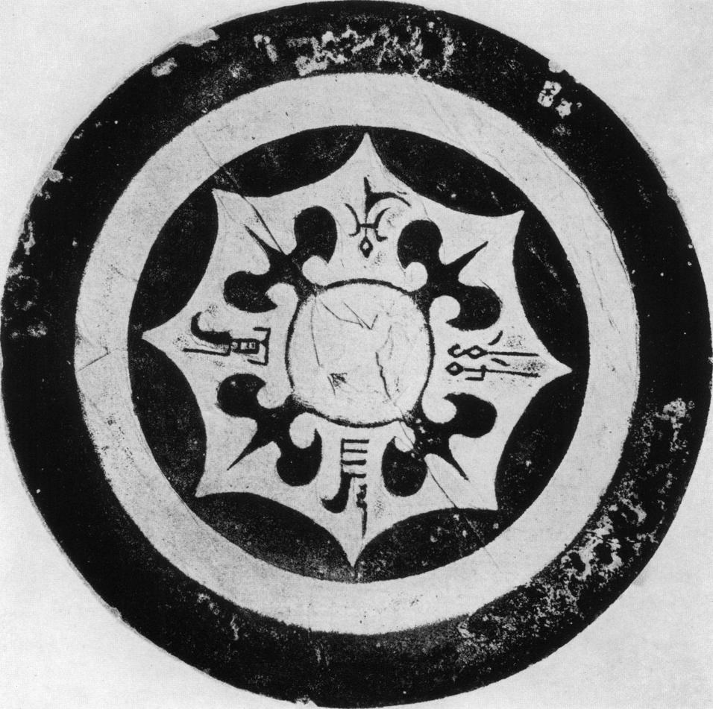

Fig. L  
*Ssi pa lien-hu* mirror

mirrors from Shou-chou. This is not accidental but part of the renaissance which began in the later part of the Eastern Han period. Yet, as with most revivals, the ancient forms are transform­ed so as to suit contemporary tastes. This mirror lacks the large scrolls and spirals which had been essential part of Pl. 6z. Yet some parts of the pattern show that it is no less intimately connected with winding plays. The small, plain ring circling the main zone of decoration just inside the festoon of arcs is adorned on the outside with tooth-like and T-shaped motifs which resemble hooks and spools used for the holding and winding of strands of yarn. In contrast to other mir­rors of the late Eastern Han period this one has a flat, undecorated rim reminiscent of earlier mirrors, *e. g.* P1. 19 and 21. Though it has no dated inscription it cannot have been made much before the middle of the second century A. D. This type of mirror remained in demand long after the disintegration of the Han Empire.

The decoration of the main zone on Pl. 64 partly resembles that of a mirror dated A. D. 14591 On both mirrors the animal heads are placed between elaborate quatrefoils with long needle-like endings and their contours are drawn with additional lines. Most of the decoration is worked in rather broad band-relief, and the heads of the animals are so stylized as to give the impression of a geometrical pattern. The knob is small and does not even have a knob-seat. This is not a genuine Han mirror but of a much later date. In contrast to earlier mirrors the festoon of arcs has been enlarged so as to form the outer border of the mirror, and the whole decoration breathes a kind of elegance which fits into the Six Dynasties or even Sui period.

Although, strictly speaking, it does not fall into the group of 'animal-head' mirrors fig. L will be included in this section because the shape of its quatrefoil and the festoon of arcs essen­tially resemble those in this category. The simplicity of its design and the plain, flat rim have persuaded scholars like Liang Shang-ch'un and others to assume that this type of mirror origi­nated in the late Western Han period. Yet, so far none of these mirrors has been discovered in a Western Han but many in late Eastern or post-Han tombs.92 The large size of the knob on this mirror suggests that it was probably not made before the third century A. D. In fact, such mirrors were popular not only during the time of the Three Kingdoms but also in the Six Dy­nasties period. Because of the quatrefoil and the belt of arcs these mirrors are often referred to as *ssu- pa lien hu* F[M._*_:_gc, or they are simply named according to their inscription *e. g. Chang i tau sun,* and so forth

MIRRORS WITH FOUR SQUARE SEAL PANELS

An excellent example of a late Eastern Han mirror is shown on Pl. 65. Its inscription is dated A. D. 189 The knob is decorated with flat, round, and semicircular disks; and the main zone of decoration has four winged animals with huge heads, long necks, protruding eyes, horns, fan­like tails, and short front legs. Their bodies are elaborately decorated with fluted lines. They are all worked in relief and separated by square panels each covered with four characters. Four nip­ples with concave tops are placed below each panel. A pearl border encloses the seat of the knob. The inscription is placed on the inner section of the rim, and the outer belt is decorated with a simple pattern of scrolls alternately issuing from the inner or outer side.

*e. g.* Umehara, S., "Dated mirrors", Pl. 6.

92 *e. g. K'ao ku tung,* 1956, No. 6, p. 67 (E); *ibid., 1957,* No. 4, p. 41 (G); *ibid.,* 1958, No. 7, P1. 9 and p. 55 (0).

Panels resembling seals can be found on a number of other mirrors. Some of them carry in­scriptions giving a second century A. D. date 93 Such panel mirrors — although of a different type than the one shown on Pl. 65 — have been discovered in the province of Kiangsu in a late Eastern Han tomb together with a mirror belonging to the type shown in fig. **L.94**

INSCRIPTION MIRRORS

The mirror with the big knob shown in fig. M definitely postdates the Han period. Ac­cording to the inscription it was made during the Western Chin period in the year A. D. 281 It has been included in this survey to give an idea of the deterioration of workmanship and taste so evident in many mirrors after the end of the Han period. Such crude mirrors can only have satisfied people who lacked all feeling for quality in craftsmanship and design. A compari­son with inscription mirrors of the Western Han period *(e.* g. Pl. 2I and 22) reflects the dif­ference between the people who patronized mirrors in the earlier and those who had them made in the later period. It should not be forgotten that at this time barbarians invaded China in great numbers and they may have coveted the possession of mirrors without due regard to quality.

MIRRORS WITH PICTORIAL DECORATIONS *(HUA-HSIANG* OR *SHEN-JEN HUA-HSIANG* ft, ;

Mirrors in this group comprise all those decorated with figures of divinities as well as with animals. Sometimes they are called *shin-shou P;14176* mirrors, that is the vast group adorned with figures of immortals and animals. They gained popularity in the second part of the Eastern Han period and can be grouped together according to arrangement of figures, depth of relief, and other features. The divinities most frequently depicted on second and third century mirrors are Hsi-wang-mu, the Queen Mother of the West, and her consort Tung-wang-kung, the Lord King of the East. Their identity is well established on a number of mirrors where their name is in­scribed next to their pictures *(e.g.* Pl. 7o). However, the inclusion of Hsi-wang-mu in the reper­tory of mirror decorations goes back to the time of transition as exemplified by fig. F and Pl. 39 and 4o. It is interesting that on these early mirrors her counterpart is not Tung-wang-kung but the divine archer Hou-i. On Pl. 39 we see the goddess sitting under a tree accompanied by the hare of the moon pounding the elixir of life, and the bird of the sun with its three legs. Other small birds sitting in the branches of the tree indicate that this is meant to be the Fu-sang, the tree which the sun climbs up and down the sky. winged man with the bow to the right of Hsi-wang-mu is Hou-i who on many Han reliefs is shown shooting the birds of the sun off the Fu-sang. Hou-i is closely connected with Hsi-wang-mu. According to the legend, he visited her and received from her the pill of life which he brought down to earth where it was stolen by his wife who escaped with it to the moon. There she was turned into a toad and became the goddess of the moon, Cheng-o. Moon and star myths are the basis of these legends. Hsi-wang­mu is originally a moon goddess and Hou-i seizing the pill of life causes the death of the moon,

**93** *e.* g. Umehara, S., "Dated Mirrors", *op. cit.,* Pl. 9, dated A. D. 158.

**94** *K'ao ku t'ung,* 1957, No. 4. p. 4o (G).

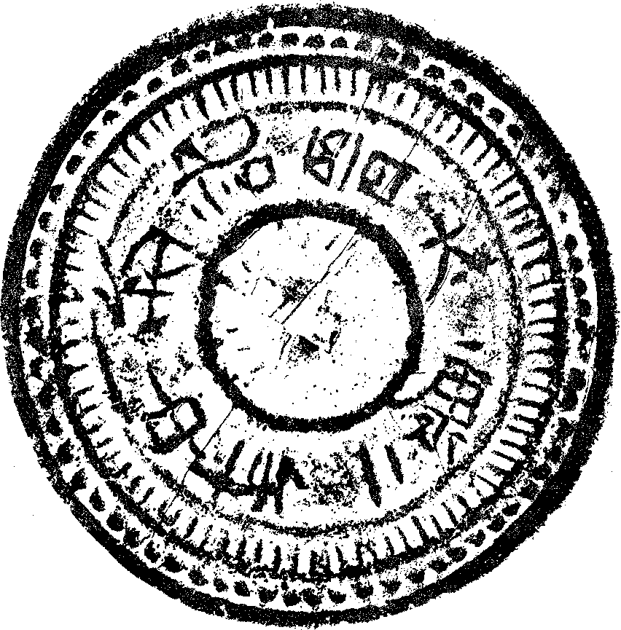

Fig. M  
Inscription mirror, dated A. D. 281

which wanes and dies. The return of his wife with the pill ensures the birth of the new moon. Hou-i is a famous hunter and archer and his deeds include the shooting or killing of other constellations; thereby ensuring their disappearance from the sky at the right time of the year. Like Orion, Hercules or Gilgamesh he is famous for his heroic deeds, such as the fight with the Speckled Serpent, the Great Boar (a constellation of winter and the northern sky), the Celestial Wolf, and others. On the mirror (Pl. 30 he is seen shooting an animal resembling a tiger, and on the remaining sides he is setting out on his celestial journey drawn through the realms of air and water by fishes and birds.

In fig. F Hsi-wang-mu and the hare of the moon are depicted on the right side of the mirror, while on the other side Hou-i is attacking a large stag and below, a boarlike animal —probably the Celestial Boar — seems ready to pounce on a bird. The fact that Hsi-wang-mu and Hou-i are placed on opposite sides of the mirror forecasts the later arrangement in which

Hsi-wang-mu and Tung-wang-kung are placed on diametrically opposite sides of mirrors so as to symbolize their residence in the Western and Eastern sky respectively. Actually, in the famous offering shrines at the Hsiao-t'ang shan **95,** Hou-i with his bow and not Tung-wang-kung (as in the Wu Liang shrines) is shown in the centre of the Eastern gable. He is pictured inside a hall and the God of the Winds, whom he has wounded in the knee, is blowing the roof off.96

The female figure on Pl. 4o sitting with her hands stretched out towards Hou-i — who is just alighting in front of her — is either Hsi-wang-mu or his wife asking for the pill of life. On the other sides of the mirror he is pictured performing his heroic deeds. On one side he is en­countering the Dragon, on another the Tiger, and on the third the Speckled Serpent marked by signs on her back which resemble the 'egg and ripple' pattern. Although Hsi-wang-mu is not shown on the mirror in fig. G the forward-bent figure is Hou-i about to slay a growling tiger. He resembles in appearance and attitude Hou-i figures on other mirrors and could not be mis­taken for an immortal such as is depicted on the rim of the mirror.

The celestial journey on the mirror, Pl. 66, proceeds in a slightly different manner. The two travellers ride in cloud-chariots drawn by birds, tigers, and dragons, that is by the constel­lations of summer, autumn and spring. Hsi-wang-mu is not represented; on the remaining side there is a fight between a winged, horned animal resembling a buffalo and another one looking like a sheep. These may well stand for zodiacal constellations. According to the Chinese zodiac the ox symbolizes the second and the sheep the eighth month of the year. Fragments of a similar journey can be seen on a stone slab found in Nan-wu yang 97 bearing an inscription with the date 87 A. D. It represents a man in a sledge drawn by birds. A middle of the first to early second century date is supported by other features of the mirror, *e. g.* the size of the knob and the centre field which resemble Pl. 25 dated A. D. 64.

On Pl. 67 Hsi-wang-mu and Tung-wang-kung conform to their most common pattern, being placed on opposite sides of the mirror surrounded by attendants. The queen stretches her hand towards a kneeling lady as if expecting something to be handed over to her. On the other side, the king is listening to a male attendant who approaches him respectfully, covering his mouth with a tablet. A messenger staff decorated with tassels stands behind him while the attendant on the other side of the king carries a similar staff in his hand. A deer-like animal, approaching the queen, has a staff in its mouth. Streamers adorned with the same tassels float behind the second animal. Similarly decorated staffs and streamers are carried by performers or attached to horses and carriages shown on the walls of the famous tomb in I-nan98. The authors propose A. D. 18°— 189 as the most probable date of the tomb but this date seems too early and a first half of the

**95** Chavannes, E., *Mission archeologique.* No. 48.

**96** Tung-wang-kung is a divinity invented only in the later part of the Han period. As consort of Hsi-wang-mu his residence is believed to lie just opposite hers in the Eastern part of the sky. This reflects well the desire of the people of the Han period to balance and systematize the realm of the gods. Hou-i is still often represented in the art of the later part of the Eastern Han period but his activities are restricted to shooting the ten suns off the Fu-sang and other tasks. One of the reasons why the divine archer lost his dominant position is probably the fact that the moon myths on which his story was based had become obsolete and lost their emotional appeal. Another one is perhaps the rather weird two-fold re­lationship between him, Hsi-wang-mu, and his wife which was contrary to the aspiration of that time which strove to invest its divinities with more human and charitable qualities.

**97** Chavannes, E., *Mission archaologique,* No. '55.

**98** *I-nan ku hua-hsiang shih mu fa-chiieh pao-kao.* 1956, (Pl. 91, 92, 96, 97, 98, 'oz.)

third century date more in keeping with the style of the composition, figures and ornaments.99 Yet this type of mirror shows features developed in the course of the first and second century A. D. A male attendant standing to the left of Hsi-wang-mu might be a messenger. On a tray found in the tomb of Wang Hsu in Korea — dated A. D. 68 — Hsi-wang-mu is shown in a similar position with a female attendant kneeling at her side which suggests that this arrangement was popular, at least, from the time of the middle of the first century A. D. onwards. The peculiar style in which the skirt of the kneeling lady is drawn is similar to that of a lady depicted on a stone pillar dated A. D. 118.100 The immortals on this mirror are rather angular with their stiff, capelike collars and therefore unlike their lithe counterparts on earlier specimens. The centre field differs from those of the following mirrors (Pl. 68 and 69) in that it still retains the belt of `tooth-comb patterns' between the knob-seat and the raised ridge with the *'egg* and ripple' pat­tern. As on many similar mirrors the plain nipples in the main zone of decoration are surrounded by additional rings. The border is decorated with rather elongated animals, some with twisted tails like plaits. They lack a certain gracefulness if compared with those on the border of fig. J. Four circles divide the border into quarters; one of them is adorned with the figure of the toad of the moon, and the other with that of the three-legged bird of the sun. The border pattern and the nipples refute an early second century date, and the late second and early part of the third century A. D. is the time in which mirrors like this one flourished.

Both the constant elements and the variations of the theme are well exemplified in some other mirrors. The figures on Pl. 68 appear rather simplified when compared with Pl. 67. The robes of the queen and her two female attendants are drawn with just a few lines, and their heads are disproportionately large in relation to their bodies. A number of motifs have been omitted; *e.g.* the toilet box in front of the queen, and the box or table in front of the king. The man facing the king with bowed head — presumably an attendant — is presented without his staff. However, the tiered object in front of him may well be the top of a messenger's staff. Similar motifs appear on a number of mirrors, most of them undoubtedly made after the close of the Han Dynasty.

**99** The early date is proposed by the authors because after that time the hitherto prosperous region became devastated by war and rebellion which they think would have made impossible the building of a tomb of this size and magnificence. This date seems to me not acceptable for stylistic reasons, especially if figures and episodes are compared with similar ones shown on the walls of the Wu Liang shrines. The differences between both exclude the possibility that they were built more or less at the same time. That the tomb in I-nan is of later date is supported by other features such as orna­mental and architectural designs. On the other hand a comparison with the decoration of tombs of the fourth century A. D. shows even more convincingly that it could not have been built at that time. In fact, it cannot be later than the middle of the third century A. D. because characters in inscriptions are written in the Eastern Han style and not in that of the Wei or Chin dynasty. A first part of the third century A. D. date would be supported by historical conditions favourable for the erection of such a tomb. During the first decades of the Wei dynasty, as is well known, some of the landed gentry families were extremely wealthy and powerful, especially those who had helped the Wei dynasty in their struggle for power or were related to them by blood or marriage. They were certainly able to engage the best artists and craftsmen of their time for such a work. An early Wei dynasty date is supported by other factors such as the prominent place reserved on the wall for pictures of acrobats, tight-rope walkers, jugglers (some performing while standing on galloping horses), dancers and musicians. Though such scenes are depicted on walls of tombs and offerings shrines of the first and second century those in I-nan far surpass anything in scale and elaboration. The show includes acts never shown previously such as the chariot drawn by dragons and other features. According to the commentary quoting the *Wei Liieh* (composed by Yu Huan between A. D. 239 —265) in the *San Kuo Chih* (chapter 3, p. 4,— year A.D. 235) Wei Ming ti's period of reign (A. D. 227-239) was famous for its mechanical toys made by the clever Ma Yuan, for its revival of spectacles of the Han period and for its elaborate processions including chariots, large figures of animals, mounte­banks on horsebacks and so forth. In general the conclusion can be drawn that the tomb in I-nan was built between the end of the Han period and the middle of the third century A. D.

pao Chavannes, E., *Mission areheologique,* No. 1z.

They can hardly have been added to the existing decorations of mirrors much before the end of the second century A. D. Mountain signs appear on both mirrors : those on P1. 68 are formed by a pile of three semicircular motifs similar to those in the centre field of Pl. 55, while on Pl. 67 they are simple elevations raised only slightly above the outer border. Peculiar to this mirror (Pl. 68) are the five nipples which prevent a symmetrical arrangement of the queen and the king on opposite sides but allow the artist to decorate the remaining section with three animals; a deer, a dragon, and a tiger. The style of the animals supports a late second and third century A. D. date. In movement and details they are not very different from animals depicted in the tomb in I-nanica, and the date of the mirror lies between the end of the second and the end of the third century A. D.

Again another type is that shown on Pl. 69. Each of the divinities is seated between two kneeling attendants. This mirror is outstanding in the quality of its workmanship. The dragon and the stag are drawn in delicate lines and are beautifully arranged in a perfectly balanced man­ner. The decorative treatment of the mirror is best exemplified by comparing the vigorous stag in fig. F with this elegant, perhaps even effeminate looking animal. Clouds in the shape of buds are typical of the revival of older patterns which began in the later part of second century A. D. and were even more pronounced in the third. A small belt studded with pearls surrounds the knob. The flat 'wave' or river zigzag pattern on the rim supports a late second to middle of the third century A. D. date.

Again a slightly different type is shown on Pl. 7o. The fragment of a similar mirror has recently been discovered in a Han tomb1o2 which proves that they were first made at that time. Mirrors like Pl. 7o were discovered in Shao-hsing and probably made all through the third century. The mirror found in the Han tomb differs from the one on Pl. 7o in details. The knob is placed as on Pl. 7o into a square frame *(cf.* Pl. 5 5) but it is not surrounded by a collar of festoons as on Pl. 7o. Such petal-like collars can be found on some mirrors dated A. D. 228 and 229. The difference between the four knobs on the mirror fragment and on Pl. 7o lies in the ring of pearls; the pearls on Pl. 7o are fewer and of larger size. The tiger and dragon on Pl. 7o are bigger and treated in a more decorative manner than those on the mirror fragment al­though the broken condition of the latter does not allow a close analysis of style. The most probable date of this mirror lies between the beginning and later part of the third century A. D.

The main characteristic of the mirror on Pl. 71 and a variation of all previously discussed motifs are the travellers in a chariot drawn by winged horses. Such mirrors are known as *ch'e ma VA, i.e.* "chariot and horse" mirrors. This mirror has been excellently described by W. A. Watson.i.4 The divinities resemble in style those on P1. 69 and 7o; they are worked in a kind of flat relief with a few lines indicating their eyes and mouths. The number of attendants and guards has been increased to include an immortal who is of a type common to late mirrors. His body is tubular and his pleated sleeves and trousers have the rigidity of corrugated iron. The scenes are depicted with meticulous care to all details such as the antlers on the cap of the guard standing behind the king or the parasol above the lady kneeling before the queen. Some of the horses and riders are worked in a slightly more rounded relief. The horses are drawn

101 *I-nan pao-kao, op. cit.*

**102** *K'ao ku* 1959, 1. P1. 6, (6), (P).

103 *e.g.* Umehara, S., "Dated Mirrors", *op. cit.,* P1. 33.

104 Watson, W. A., "A Bronze Mirror from Shao-hsing", *B. M. Q.*, Vol. XIX, No. 1, 1954, P. 41ff.

realistically and as individual animals; one turns its head looking back while the other two stride forward with heads raised high. In style and movement, but even more in their caparison, they resemble some horses in the tomb in I-nan.ros The lines running along their necks and chests represent the long panels with which these horses were decked out. They ran along their necks and chests and were apparently fastened to the saddle-girth underneath the animals' bellies. They were held in position by bands running across the necks and through the mane of the animals, and these bands are indicated on the mirror by parallel lines on the horses' necks. A very unusual scene is featured on the other side of the mirror. Men on horseback — some with swords in their hands — are pursuing each other and are racing towards Hsi-Wang-mu apparently in an effort to show off their equestrian skill. It is typical of the development that the centre field continues to diminish in size until it is nothing more than a mere pearl border. On Pl. 65 this consists of small pearls, while those on Pl. 71 have increased in size and are bigger still on Pl. 72. The border is decorated with animals in outlines only; their tails are curled like winding plants reminiscent of earlier designs. However, they lack a certain gracefulness and are more purely ornamental. Watson believes the quality of the mirror to be a sign that it was still made during the Han period; its most probable date is the third century especially, up to the middle of the century.

The journeys depicted on this and many other mirrors are not only illustrations of the cosmic travels of the two divinities but can be linked to an old mystery cult of the Han period centering around Hsi-wang-mu. According to Professor Dubbs106 the goddess was worshipped by the common people not only by sacrifice, dancing and singing, but part of her cult consisted in riding in carriages or galloping on horseback from one village to another. Moreover, people carried wands made of stalks of straw or hemp which they passed from one to the other saying: "I am transporting the wand of the goddess' edict." This wand may have been represented by the staff with tassels shown on Pl. 67 and on other mirrors. In the third century A. D. when the ritual plays of the Han period were re-enacted (see: p. 85, note 99) such simple folk plays were most probably converted into elaborate performances in which not villagers but trained per­formers took part. This interest may well account for the popularity of these mirrors.

The mirror on Pl. 72 belongs into the same group although it differs from the last one in many ways. The two winged divinities sit on seats or mats, Hsi-wang-mu on an oval, and Tung­wang-kung on a rectangular one. Each is surrounded by eight immortals, four on either side, one always riding on the shoulder of the other. They are of the same type as on the preceding mirror. Two chariots, each drawn by five horses harnessed abreast, convey the travellers from one place to the other. The chariots are closed in front but the travellers are visible in the back which, so it seems, must have been open. Small pyramid-shaped motifs symbolize mountains of the sky crossed by the chariots. These signs are piled up high, not unlike some seen in the tomb in I-flan..07 Motifs like the winged divinities and the immortals can be found on mirrors and other works of art in the Eastern Han period, especially in the later part. This mirror differs from the last one, insofar as it lacks the narrative quality. If we compare the horses on this mirror with those on the previous one it becomes apparent that on Pl. 72 they have lost all individuality and

105 *op. cit., e. g. P1.* 24.

106 Dubbs. H. H., "An Ancient Chinese Mystery Cult", *Harvard Theological Review,* 1942, p. 232ff.

107 *op. cit., e. g.* P1. 24.

have turned into uniform, stereotyped animals. The whole mirror is designed to achieve a cer­tain pattern-like beauty, and the various motifs are arranged in such a way as to enhance the decorative effect of the composition. The freely drawn scrolls underneath the seats of the divi­nities are more akin to post-Han designs than to Han patterns. In general, the figures are less crowded together and the decoration is more liberally spaced. The border pattern consists of C-shaped motifs alternately opening towards opposite sides and interspersed with five animal figures which are not too easily identifiable. The apparent disintegration of animal designs and the introduction of purely geometrical motifs would already suffice to make even a late Han date rather doubtful. This mirror belongs to the group of Shao-hsing mirrors which were first pro­duced in the course of the third century and still popular in the fourth century A. D.

The mirror on Pl. 73 is interesting for various reasons. According to a report it was ex­cavated on the 25th of June, 1925, in Ma-po-tsun near Loyang in Honan.108 It was said to have been found in the tomb of the wife of Kuang wu ti, the first Emperor of the Eastern Han Dy­nasty (A.D. 25-57). It is impossible to verify the statements of this report which may have been circulated by a person bent on forging the age of this mirror by burying it to acquire the wanted patina. On the other hand, it may still contain a grain of truth. The mirror is made of iron covered with a gold sheet. The design is cut out and worked in slight repousse. Though iron mirrors are sometimes said to have first been made in the later part of the Eastern Han period, most of them were found in post-Han and Six Dynasties periods tombs. A similar, though not identical mirror is published in the *Chin-shih-so1.9* and attributed to the Han period. In general, such mirrors should be very carefully examined as they could easily have been copied by any skilled forger. However, the excellent quality of the gold and the design speak for the authen­ticity of this mirror. According to the catalogue of the Exhibition of Early Chinese Bronzes the scene illustrates the meeting of the Prince of Ch'i and the King of Lu. However, the figures and their arrangement on the mirror resemble too closely those on previous samples to support this opinion, the more so as the elaborate hat of the queen is certainly meant to portray her famous headgear. The two chariots occupy one side of the mirror leaving the other one free for a dancer, a sitting musician or singer, and a number of acrobats, thus illustrating some of the activities which were performed during the festival in honour of Hsi-wang-mu. Figures of dancers and singers appear on mirrors which, according to their inscriptions *(e. g.* "Han has good copper . ..") were still made in the Han period and became very popular in the third century A.D. (fig. 12). The queen is again shown on a raised, oval-shaped seat. The divinities are waited upon by four attendants, and the groups are arranged in such a way as to suggest depth and space. Those sitting near the centre are supposed to be on the far side, and the others on the near side of this scene. The distinguishing features of this mirror are the greater com­plexity and pictorial quality of its decoration as well as the striking elegance of the figures. For instance, the very slim and well proportioned attendants (again with antlers on their caps) stand­ing behind the king are quite unlike those on previously discussed mirrors. As far as the date of this mirror is concerned it is imp )rtant to note that the main zone of decoration is directly attached to the collar of the knob and is not even separated from it by the usual ring of pearls. This elimination of the centre field is typical, and can often be found, on mirrors of the third

108 *Exhibition of Early Chinese Bronzes, Stone Sculptures and Pottery,* Yamanaka and Co., New York, 1926, Pl. z6.

109 Peng Ylin-p'eng and Feng *Chin-shih-so,* 1893.

Fig. **12**  
A lady playing the *Win* and another one dancing. (Umehara, *Shina Karla' Seika,* Vol. V, Pl. 87).

century A.D. The gold sheet and the elegant design support the assumption that it was made for the wife of an emperor or, at least, for somebody at his court, though the style of the mirror precludes the possibility that it may have been made for Kuang wu ti of the Han Dynasty. Yet Wu ti is a dynastic title given to other founders of dynasties and rulers during the time of the Three Kingdoms and Six Dynasties. Assuming that the story of the excavation is not a complete fabrication one may speculate as to whose tomb this was. Some Wu ti's can be excluded at once because neither they nor their wives could have been buried near Lo-yang. The most likely Wu ti is the founder of the Western Chin Dynasty whose capital was Lo-yang and who was buried in its vicinity. The mirrors made during his lifetime were famous for their quality and are highly valued by Chinese dealers. He is known to have been a very pleasure-loving monarch and his harem is said to have contained ten thousand ladies. He ruled from A. D. 265-29o, and his queen or members of his harem may well have survived him into the fourth century A.D. For historic reasons they could hardly have been buried at Lo-yang after 3o9 A.D. It is most unlikely that anybody of high rank and wealth was buried near Lo-yang during the later part of the fourth century when it was nothing but a desolate and partly deserted place. However that may be, the most probable date for a mirror of this type is the third century A. D., especially some time during the middle and later part of the third or the very beginning of the fourth century A. D.no

Although the mirror on Pl. 74 does not really belong to the group of mirrors discussed in this study its inclusion seems appropriate because an analysis of some of its features may help in identifying other mirrors. It is beautifully decorated and engraved with figures cut out of silver and gold set in lacquer, a technique which was already very popular in the T'ang period. It is usually assigned to the Six Dynasties period. In general layout and in many details it re­sembles the previous mirror. The mountains have still the same pyramidal shape, the tops separated by lines from the lower parts. The posture of the dancers on both mirrors is similar as are the types of chariots. The figure of the queen has been omitted but a host of new motifs has been added. The question is whether this mirror was still made in the time of the Six Dynasties, the T'ang period, or even later. There are several factors which rule against an early date. First of all, the shape of the ewer standing to the left of the king is usually associated with the Sung period and not with the preceding dynasties. The same holds good for the phoenix and the whole decoration has a kind of slickness which is wholly foreign to the spirit of the Six

Such a date is supported by the style of the border pattern on the similar mirror shown in the *Chin-shih-so.*

Dynasties or even the T'ang period. In addition, the shape and size of the mirror as well as the decoration of the centre field refute such an early date. Although the artist copied the tooth-comb pattern around the knob-seat his treatment has become purely ornamental and he seems to have lost the meaning of its original function. This lack of understanding is even more pronounced in the border pattern. This is no longer a procession of spirit animals pursuing their celestial course but an agglomeration of odd creatures drawn in a purely decorative manner. In fact, it resembles in style decorations of bronze objects made in the Sung and Ming period which pur­port to copy ancient bronze vessels. A revival of interest in mirrors of an earlier epoch would be quite in keeping with the antiquarian interest of that time. The excellent workmanship of this mirror excludes the possibility of modern forgery, and the conclusion can be drawn that, at its earliest, this work belongs to the Sung period, if not to an even later time.

Another type of mirror in which divinities form the nucleus of the decoration is surrounded by a ring which is often described as *pan-yiian fang-chio tai* *114)] AT because semi-circular lobes and rectangular seal-panels project into a sunken belt enclosing the main zone of deco­ration which is studded with nodules symbolizing the stellar sky. On most of these mirrors the seal panels are inscribed with characters. They are sometimes part of a long inscription as in Pl. 79, Fig. N. Or else, as in Pl. 78, 76, each seal may contain the same four characters *T'ien­wangjih-yfieh* KT 19 'the heavenly kings days and months'.Hi The earliest known specimen is that shown in fig. N dated A.D. Io53mu-t*. Unfortunately, no photographs of this mirror are available and the 'improved' rubbing is not a reliable substitute. However, mirrors made in the second century A. D. with dated inscriptions **II2** are very similar and allow us to draw some general conclusions in regard to their style in the second century A.D. In fact, fig. N shows that the main characteristics of these mirrors were already firmly established in the Middle Eastern Han period. The divinities on this and other mirrors (Pl. 75 and 76) are placed on seats which may be described as T- or mushroom-shaped, the stems ending in a curve running out near the border. Each of the three (or, on later mirrors four) large animals holds a flat bar in its mouth like a bit. The rubbing in fig N. is misleading, insofar as the bars are not short sticks but, as can be seen on Pl. 75 and 76, run into the raised ridge surrounding the knob. In fact, they may be compared to spokes fixed to the nave of a wheel thus creating an impression of movement as if the animals were turning the whole structure by pushing against the bars. Although it does not elucidate the meaning the following sentence, sometimes included in mirror inscriptions, may have a bearing on these creatures. It is said that on the mirror "there are divine animals, dragons and tigers; on their bodies they have designs, and in their mouths they hold rings" (carpenter squares) figA n The animals on all these mirrors curve around the outside of the main zone of decoration. They are uniformly covered with parallel running, slightly fluted lines. The joints of the animals are decorated with rings (fig. N) which are signs of nipples with a cup-like concave top. The motifs above the rings look like twisted strands or like a decorated staff; similar motifs can be found on other mirrors from the second century A.D. The divinities sit on raised seats on top of the animals and look like wooden busts

=== Bulling, A., "Decoration of Some Mirrors", *op. cit.,* see p. 35 ff. for canopy imitated by this type of mirror and meaning of the inscription.

"2 *e. g.* Liang Shang-ch'un, *Yen k'it ts'ang thing,* Vol. IV, P1. 2, dated 147 A. D., and Umehara "Dated Mirrors", *op. cit.,* P1. tz, dated 167 A. D.; Pl. 9, fig. i 1, dated i59 A. D.

Karlgren, B., "Inscriptions", *op. cit.,* p. 33, No. **222.**

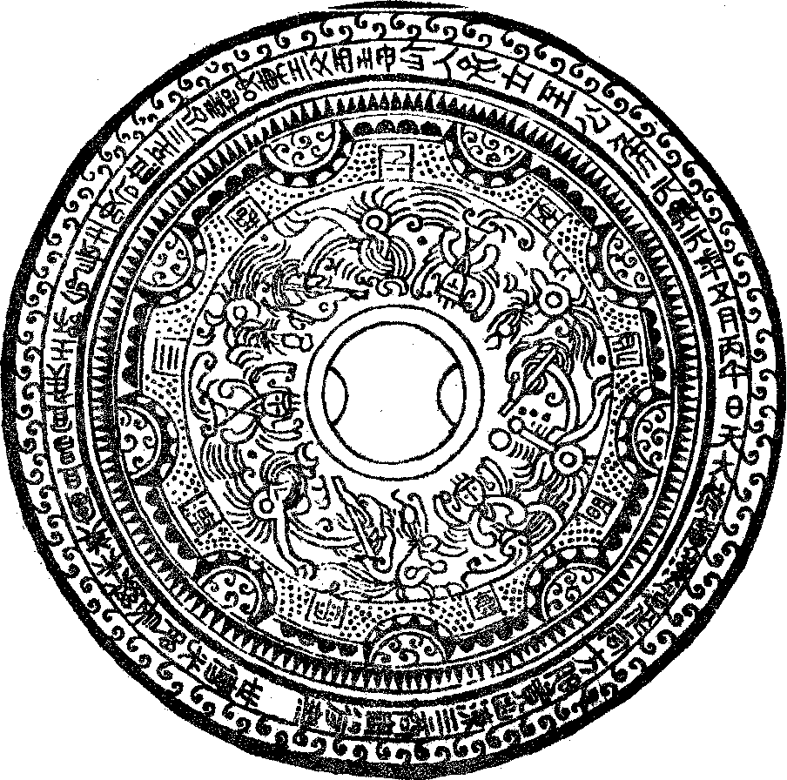

Fig. N

*Sben-jen hua-hsiang* mirror  
dated A. D. 105

placed on a pedestal, whereas the divinities on previously discussed mirrors *(e.g.* Pl. 67 and 7z) were always shown three-quarter length looking much more like pictures of real people. Those in fig. N are all dressed alike, and their faces turned towards the onlooker are framed by wing­like, gently curved ribbons attached to their shoulders. They wear V-necked coats and three-pronged caps. Although the divinities on these mirrors are not as clearly identified as those on Pl. 7o it is safe to say that they represent divinities who reside in the sky. Hsi-wang-mu and Tung­wang-kung are mentioned in the inscription on the rim. It is, therefore, possible, though not cer­tain, that they are represented by two of the three figures ; the third one being the image of another unidentified divinity. It is difficult to decide their sex yet this particular kind of three-pronged cap was mostly worn by male figures. Divine trinities of male gods play an important role in China. Most famous are the San Huang, 'the Three August Ones', primeval ancestors and legendary

heroes who in the divine hierarchy ranked above the Five Celestial Emperors (Wu Ti), and who most probably were believed to occupy places in the sky above or superior to them. It can reasonably be assumed that the circumpolar region of the sky was their place of residence. It is, therefore, possible that at this time the San Huang were identified with the divinities residing on the San Kung, the Three Dukes, constellations of the circumpolar sky. The *San Kung* are men­tioned in the inscription of this, and of many other mirrors. Their importance is stressed by the fact that the phrase *wei-chih .ran-kung*=

fA./-k is sometimes the only inscription of a mirror placed in a prominent position as on Pl. 80. Most scholars translate and interpret this phrase in secular terms only as expressing the wish to attain the rank of the three highest officials in the country but, in addition, it most probably has a hidden metaphysical and esoteric meaning. As proved by one of the pictures in the Wu Liang offering shrines the visit of the Divinity of the Northern Bushel *(pei-tou)* — corresponding to stars in the constellation of the Great Bear" — is one of the most important stations of the celestial travellers whose journey leads them across the sky following the orbits of other stars. These celestial journeys are closely connected with the route to be followed by the souls of the dead in order to accomplish their re-birth as a spirit-body.lis To adorn mirrors with pictures of the San Huang or San Kung must have seemed to the people of the Han period an eminently meaningful decoration because the divinities of the circumpolar sky not only controlled the stars and planets but were held to be the supreme arbiters of fate in this world and the beyond. Typical of mirrors of the second century A.D. is that the rim (fig. N) is divided into two belts, the inner one bearing the inscription, and the outer one being filled with simple scrolls *(e. g.* Pl. 65).

Mirrors with three divinities were particularly popular in the second century A.D. However, mirrors divided into quandrants by four large beasts are known to have been made already in the first part of the second century A. D.116, although quite a number carry dates of the later part of the second and third century. On many of these mirrors five and not four major deities are shown, three are placed each it—o one quadrant while the fourth side is occupied by two divinities sitting side by side. Major divinities are always recognisable by their V-necked coats. Very often they wear ruff-like collars whose curved edges give them the appearance of wings (P1. 75, 76, 8o, 8i). The fact that five divinities are shown on these mirrors (Pl. 75 and 76) suggests that they represent the Five Celestial Emperors (Wu Ti) each ruling over one of the Five Elements. Four are held to control the four seasons taking their seats in that region of the sky associated with them, while the fifth occupies the centre, that is the circumpolar region. However, this position became untenable when the San Huang took up the same place. This dilemma was solved by the scholars of the late Han period by relocating the Celestial Emperor ruling over the centre and the element of Earth to the southwestern region of the sky near the Celestial Emperor ruling over the element of Metal. This explains the grouping on these mirrors. The two divinities sitting next to each other are those con­trolling the Western Quadrant of the universe *(i. e.* Huang Ti and Shao Hao) ; correspondingly, the one on the opposite side is the Celestial Emperor T'ai Hao ruling over the Element of Wood, and tho se above and below are associated with the Element of Fire and the Elemen

114 Chavannes, E., *Mission archeologiques, op. cit.,* No. 535.

115 Bulling, A., "Totenspiele", *op. cit.,* p. 4o.

116 *e.*

*g* Liang Shang-ch'un, *Yen k'u ts'ang ching,* Vol. IV. P1. 2, dated 547 A. D.

of Water respectively. On both mirrors attendants kneel in front of the Celestial Emperors ruling over the Western and Eastern parts of the universe. The attendant on Pl. 75 (left side) is reverently holding a tablet in front of his mouth while his counterpart on Pl. 76 again wears a cap adorned with antlers. The cosmological speculations centering around the Celestial Em­perors and the Five Elements embrace the whole universe in all its aspects. The Celestial Em­perors controlled the eternal cycle of creation and destruction and all life depended on their movements and victorious struggles. The range of phenomena, customs and institutions asso­ciated with each Emperor is immensely wide and embraces sacrifices, colours, taste, generations of ancestors, and so forth.

The mirrors on P1. 75 and 76 can roughly be attributed to the time between the end of the second and the end of the third century A.D. A mirror resembling Pl. 76 was made in A. D.196...7 These mirrors are particularly difficult to date because neither the position of the animals nor their fluted bodies or cup-like studs do change much in the course of the third or even fourth century A. D. However, decorations above the ring similar to those on Fig. N. cannot be found on late mirrors and any mirror with this type of design can confidently be called 'second century A. D.' On later mirrors the same place is filled by small kneeling human figures or animals (Pl. 75, 76). This arrangement is interesting because the animals turn their backs towards the deity sitting between them. In fact, the same composition can be found on many bricks and stones of the Han and post-Han era. It represents a divinity sitting on a seat formed by the bodies of two animals, their heads protruding on both sides like the sidepieces of a chair. Actually the chair on which the two divinities are sitting in the middle zone of the mirror shown on Pl. 79 is formed by two animals. Though it is in many cases impossible to attach a name to these animals there are examples where there can be no doubt that the seat is formed by a dragon and a tiger; the constellations of spring and autumn. The logical conclusion in regard to the divinities on these mirrors is that they were meant to be carried by constellations. Another point, which in certain cases can be helpful in dating these mirrors is the depth of the relief. It seems to be deeper in mirrors made at the end of the second and early part of the third century than in those made in the later part. In fact, some dated mirrors of the later part of the third century especially up to A. D. 270 have a fairly flat relief. When the surface of the mirror is so closly covered with figures as to leave hardly a spot undecorated it was most probably made in the early or middle part of the third century but hardly later.

The mirrors Pl. 75 and 76 both have a rim consisting of two belts, the outer one containing scrolls similar to those on Pl. 62. This type of scroll pattern was very popular in the late second and third century A.D. The inner belt is decorated with animals and immortals all part of an apparently fast-moving procession. They include not only the familiar animals such as dragons, birds, and tigers or the disk of the sun and the moon, but also a boat carrying a divinity and manned by immortals. This type of decoration with the figures worked in relief can still be found on mir­rors of the Six Dynasties periods. The cavalcade symbolizes the orbit of the stars and planets and the route taken by celestial travellers and is, therefore, a most essential component in the make-up of mirrors. Consequently, when the main zone of decoration was filled with other motifs these processions were transferred to the rim. The widening scope of the participants of this cavalcade, especially the inclusion of boats, illustrates the fascination this subject had for the people of that

117 Umehara, S., "Dated Mirrors", *op. cit.,* Pl. 71; one dated A. D. z97 is, however, not very different.

period. It is admirable how the artist adapted the various motifs, and his manner of fitting the boat into the narrow border testifies to his skill and artistic sensitivity.

The quality of the mirror P1.77 is not as good as that of the two preceding mirrors. The composition lacks order, the animals do not really move in the same rhythm and their fluted bodies lack precision and merge into the striped background. The decoration has been simplified and some of the figures and finer details omitted. Although there are four large beasts there appear to be only three major deities; the fourth side is filled with the figure of an attendant with his head bent low. The divinities wear the same kind of ruff-like collar as on the other mirrors but they look less elegant due to the fact that their heads are disproportionately large. Moreover, the busts are not placed on high seats or pedestals but rest directly on the outer border while their heads touch the inner border which aggravates the impression of clumsiness. Although this trend begins to appear on mirrors from the very end of the second century on­wards it becomes more outspoken in the third century A.D. and can be seen especially on mir­rors with an inscription mentioning the Wu Dynasty (A. D. 222-277.) A third century date is supported by the petal-like ring of arcs surrounding the knob *(c f.* Pl. 7o), and its possible date lies between the beginning of the third century and first years of the Western Chin dynasty.

Mirrors with fluted animal bodies are only one variant of this particular group. Another, equally important type, is shown on Pl. 78 and Pl. 78 a. The main difference between this and the previous specimen is the arrangement and shape of the large animals. They are sturdy beasts with big heads and bulging eyes worked in a well rounded relief. Their winged bodies are decorated with scrolls and other motifs. Though they too hold bars in their mouths they could hardly cause the structure, resembling a wheel, to rotate since they move in different directions and turn towards each other. This type of mirror must have originated in the second century — most probably not before the middle of the century — but it was even more in demand during the third century A.D. In the Moriya collection 11$ there was a mirror dated A.D. 219 which is par­ticularly interesting because the divinities and beasts not only fill the main zone of decoration but spill into the sunken belt where two animals are sitting on opposite sides of the mirror exactly below the seat of the divinities. In addition the sunken belt includes circles and other small motifs. We may conclude, therefore, that at the end of the Han period people felt a strong desire to fill the surface of mirrors with as many figures and motifs as possible.Again there is no clear distinction between late Han and post-Han mirrors. Although quite a number of fine mir­rors were still being made at the end of the Han and during the San Kuo period, in general, there was a slow decline in the standard of workmanship and taste. The disintegration of the power of the Han Dynasty which had already started before the end of the second century coincided with a lowering of aesthetic sensitivity. This becomes even more pronounced in mir­rors which according to their inscriptions were made in the region dominated by the Wu Dynasty. However, some mirrors of good quality suggest that even during this time some craftsmen were still able to produce excellent mirrors if given the chance by wealthy patrons in prominent positions. In general, however, this was a period in which most people could not afford to buy expensive mirrors but had to be content with cheap ones.

Some mirrors made at the very end of the Han and in the San Kuo period, are easily recognisable. The divinities are not only coarsely drawn with short busts and large heads not

118 Siren, O., *Kinas Konst under tre Artusenden, op. cit.,* Vol. I, P1. 87 A.

unlike those on Pl. 77, 8o and 81 but often bodies of divinities and beasts alike are monotonously overlaid with crude stripes.

The four powerful beasts on Pl. 78 and 78 a are not unlike those on Pl. 65 (dated A. D 189) although their necks are shorter and they have lost a certain decorative elegance and vigour. Two divinities sit on T-shaped seats while the pedestal of the two others are adorned with animal heads akin to those in fig. K and in the tomb in I-nan.119 The head of one of the di­vinities (Pl. 78 a) rests on a long, stick-like neck and is turned towards one side. This gives the impression of a wooden doll with its head turned sideways. Toys with movable heads were used in rites and religious performances in the Han period, especially in the second century A. **D.12o** The different motifs can be traced back to the second century, and the overcrowdedness in the design suggests that such mirrors were first made at the end of the second or beginning of the third century A.D. The small winged immortals kneeling at the side of two divinities cannot be found on other mirrors of the second century A.D. and this points to a third century date. As usual the rim consists of two belts, and the geometrical pattern in the outer circle is akin to the border in fig. K though it lacks the studded line running inside the bands. The celestial cavalcade is partly obliterated but includes a small immortal riding a dragon, and other familiar motifs. Such mirrors seem to have been popular for quite a time and were made perhaps still as late as the end of the third and the beginning of the fourth century A.D.

During the Six Dynasties period this type of mirror underwent certain changes. Pl. 79 is a good illustration of the innovations as well as of the permanent features of the design. There are only four major divinities on this and the previous mirror. The difference in headdress and expression of the two divinities in the middle section of Pl. 79 suggests that they represent Hsi­wang-mu and Tung-wang-kung and not the Celestial Emperors dominating the Western and Eastern quadrants of the universe. In position and attitude the divinities resemble closely those on earlier mirrors. Some wear ruff-like collars and sit on the same kind of pedestal. The mirror is divided horizontally into three sections by a framework of bars forming a kind of scaffold. This does not necessarily point to a later date as similar arrangements can be seen on mirrors from the late part of the second century A.D., although they appear on another type of mirror *(e. g.* Pl. 8o and 8i). However, there is a slight difference between the earlier and later scaffold­ing; on Pl. 79 the construction is more elaborate and its many joints are decorated with all kinds of scrolls. The divinities in the middle zone are seated between animals which are more elegant than those on earlier mirrors. The pair on the left, for instance, has graceful movements not usually encountered in the Han and San Kuo period. The crown-like head-decoration of the one on the right is related to similar patterns of the fifth and sixth century A.D. The rim is still decorated with a procession of animals, immortals, and boats but more widely spaced than on previous mirrors. The workmanship is of high quality with a clear rendering of figures and details.

The most important change between this and the preceding mirrors is the different feeling for space and composition. While the entire surface of mirrors as, for instance, on Pl. 75, 76 and 78 was densely covered with figures this has been avoided on Pl. 79 where the divinities and beasts are more widely spaced. Moreover, while on earlier mirrors the relief is more or less of equal depth it is not so on Pl. 79 which accentuates the effectiveness of its composition. The less

*lig I-nan pao-kao, op. cit., e. g.* Pl. 40, 41, 42, 43. **120** Bulling, A., "Totenspiele", *op. cit.,* p. 32.

important parts, such as the scaffolding and other decorative elements, are worked in flat and the divinities and beasts in high, well-rounded relief thus creating an additional ornamental effect. Even more significant than the visual changes is the new idea underlying this composition. Instead of a juxtaposition of figures, they have now been arranged in a meaningful and logical sequence so as to express a definite movement. Starting with the divinity at the bottom the beasts on both sides turn away from it towards those sitting above, leading the way to the divinities in the middle section. The animals at the top take up the movement, turning their faces towards the group in the centre while focussing attention on the divinity above and the two attendants below. Additional figures, not seen on earlier mirrors, are the two men on either side behind the beasts in the upper section. In their position on the mirror and in their attitude they are not unlike worshippers or donors on Buddhist stelae. The one on the left is wearing an unusual collar with fringes resembling animal tails and a round cap, while the one on the right is dressed in a coat with a kind of cowl and a low belt. A small figure standing a little above the divinity in the lower section has a similar gown and a high, soft cap. These are not Chinese garments and it is quite possible that at this time when China was invaded by foreign people the Chinese adopted the style of dress worn by the nomadic or Central Asian conquerors. Compared with the sturdy animals on earlier mirrors the four large beasts on Pl. 79 are slender creatures twisting their lithe bodies around the nipples reminiscent of the even more snake-like movements on a mirror dated A. D. 494. It can be assumed that this mirror was made some time between the fourth and the end of the fifth century A. D.

MIRRORS ARRANGED IN TIERS *(CHUNG LIEH CHING MN ,E)*

Another type of mirror with divinities as the main decoration is shown on Pl. 8o and 81. The inclusion of an even greater number of figures in the pattern has been achieved by placing them on a kind of scaffold, one above the other. **I2I** These mirrors have sometimes wrongly been called Wu Ti, 'Five Celestial Emperor-mirrors' **122** although the number of divinities always ex­ceeds five and may include others such as the San huang or T'ien huang mentioned in the in­scription on some of these mirrors. The figures of the Black Warrior (tortoise and snake) in the lower section of both mirrors, and the dragon and tiger on the left and right of P1. 81 con­firm that the arrangement follows the traditional pattern with North below and South above.

These mirrors were first made in the second century A. D., and the great number of mirrors with a date from the *chien-an* w-k-- period (196-220 A. D.) suggests that they were especially popular during the reign of the last Emperor of the Han Dynasty. They were still produced in large quantities during the San Kuo period particularly in the country ruled over by the Wu Dynasty which is often mentioned in the inscriptions. Many carry dates referring to the period between **222** and 229 A. D. That large heads and short busts are typical of this period has already been pointed out. Each one of the divinities is seated on a small pedestal and they all wear the large, decorative collar seen on previous mirrors. Their shoulders and sleeves are rather sum­marily covered with parallel lines. In general, their workmanship compares poorly with previous

**121** Such an arrangement in no way contradicts the theory that the mirror is an imitation of a parasol. As shown on many reliefs they were often held like fans by servants standing behind their masters.

**122** Ardelia Ripley Hall, *Ostasiatische Zeitschrift,* 1934, No. 1/2, p. 16ff.

mirrors and their artistic quality is inferior. Typical of the development of decoration, especially from the end of the second century onwards, is the constant increase in the number of divinities assembled on one mirror which tends to create an appearance of congestion. Moreover, the lack of characterisation between the various divinities gives them a pattern-like anonymity and sameness. The centre field on most of these mirrors has been eliminated in order to provide as much space as possible for the figures of the divinities. There is not even a ring to separate the knob-seat from the main zone of decoration. The wish to include the traditional good wishes — which on other mirrors had their place in the centre field — forced the artist to find a place for them in the main zone of decoration. They simply let the characters run down along the middle axis, thus dividing the mirror into two halves. This is especially typical of mirrors of the *chien-an* period. The rim is plain and small and decorated with either an inscription or a geometrical pattern. It does not detract attention from but rather focusses it on the divinities in the main zone of decoration. Mirrors as shown on Pl. 8o were made during the last years of the second century and in the early part of the third century A.D.

The striking feature of the mirror on Pl. 81 is its exceptionally fine workmanship. It lacks the inscription dividing the mirror into two halves, thus permitting two divinities to take its place. This can also be seen on other mirrors from the San Kuo period. The hope to strengthen the magic potency of a mirror is clearly reflected in the increasing number of figures and signs in the pattern of decoration. An umbrella or canopy is placed above the heads of the divinities on both sides of the knob resembling P1.71, except that they are bigger and more elaborate. The knob is large and hemispherical. In composition and arrangement this mirror differs from one in the Museum of Fine Arts in Boston dated A.D. 264 which has a much larger and flatter knob *(c f fig.* M) and is worked in a less rounded relief. This eliminates the last remains of individual features. In conclusion it may be said that the mirror, Pl. 8i, originated in the third century A.D., although probably not much later than during the middle of that century.

The division of the pattern into two halves (P1. 8o) created a prototype for other mirrors. On one the figures are arranged on both sides of a broad band runing through the centre of the mirror, and on another — probably as a reaction against overcrowded design as, for instance, on Pl. 8o and 81 — the divinities have been replaced by two large scrolls. However, both these types hardly developed before the end of the Han Dynasty and, therefore, fall outside the range of this study.

GUIDE FOR DATING

*Centre fields*

In general, there is much less variety in centre field decorations of the middle and later part of the Eastern Han period than in preceding times. Though some of the older types of design continued to be used on mirrors of the second and third century A.D. they are exceptions rather than the rule. Sometimes their late date is exemplified by the size of the knob (Pl. 54), by the less delicate treatment of the quatrefoils (Pl. 5o), or by other relevant details. The two major lines of development can best be described as an inflation and a deflation of the centre field designs. Examples of the first group were shown on Pl. 58 and 56 where the original centre field had increased in size and had annexed the space otherwise reserved for a different type of

decoration. This also applies to fig. K, Pl. 62 and 63. While the quatrefoil developed into the main design it changed its shape and resembled more and more a piece of stretched cloth held tightly at the four corners allowing the sides to sag. However less changed in shape are the enlarged quatrefoils on mirrors such as are shown in fig. L, and Pl. 64. The origin of these designs accounts for the fact that there is no longer any clear division between the knob-seat and the main zone of decoration. This sets off another development in the opposite direction, i. *e.* a decrease in the importance of the centre field design. In fact, from the end of the second century onwards and also during the third century A.D. a number of mirrors omit the knob-seat decoration altogether as illustrated by Pl. 8o, 81, and Pl. 73, fig. M.

During the second and third century it became increasingly popular to surround the knob-seat with a raised ridge decorated with the *'egg* and ripple' pattern. However, this pattern can already be found in the first century A.D. On some mirrors the ridge encloses a wide centre field *(e. g.* Pl. 67 and 5i), on others the circle is much smaller and forms a unit with the knob-seat *(e. g.* Pl. 5z and 68). Most new mirror types use one and the same centre field design throughout their time. The same type of raised ridge surrounds the knob-seat of mirrors as illustrated by Pl. 75, 76, 78, 79. The fact that a similar raised ridge divides the knob-seat from the tiger and dragon centre on Pl. 59 shows the indiscriminate and incongruous use of motifs in the post-Han period or third century A.D.

The standard design on another type of mirror (Pl. 65, 69, 71 and 72) is a ring of pearls dividing the knob-seat from the main zone of decoration. There is no longer a proper centre field design. During the course of the second and third century A.D. *(cf.* Pl. 65 dated A.D. 189 with Pl. 71 and 72) there is a marked tendency to increase the size of the pearls.

The sign of a late Han or third century A.D. date are knob-seats surrounded by a circle of petal-like arcs like those on Pl. 7o and 77.

Except in mirrors of the type shown in fig. K and on Pl. 65 the knobs are mostly undeco­rated but differ in size and shape. In general, knobs get bigger in the course of the Eastern Han period. This development reaches its climax in the middle and later half of the third century A. D. ; at the same time the knob loses its hemispherical shape and becomes flatter *(e. g.* Pl. 62, fig. L and M). However, the size of the knob is no reliable and conclusive guide for all mirrors, *e.g.* it does not alter substantially during long periods of time on types such as are shown on Pl. 76, 78, and 79. Nor does the smallness of knobs necessarily indicate an early date; on the contrary, knobs tend to be very small on mirrors in the fourth and fifth century A.D. *(e. g.* Pl. 64).

*Immortals ( Hsien* or *shanjen)*

The mirrors of the later Eastern Han and post-Han period manifest a certain paucity of imagination and a lack of gracefulness in the design of immortals when compared with the variety and vigour in preceding periods. The lithe type of immortals is not discontinued alto­gether but they are now shown in relief (Pl. 52) sketched with merely a few sweeping lines. Types like those in fig. 13 a and b can be found on mirrors from the later part of the second century onwards but especially in the third century A.D. A good example of the general trend are the immortals on Pl. 67 and 68. They retain to a certain degree the shape of earlier immortals *(cf.* Fig. F), yet are drawn more rigidly with stiffer wings. This development culminates in the design

of immortals as on Pl. 7o, 71 and 72. Their bodies look like sticks, and their sleeves are stiff and angular. This is the most common type of immortal found on mir­rors at the end of the second century, and especially in the third century A. D. although they can still be seen on specimens from the Six Dynasties period. Pl. 78 and 78 a show a very different type of immortal. This is a much more compact figure of small size, often with a large head. It is very inconspicuous and plays a less important part in the decoration than the long legged creatures previously mentioned. It was never very popular and does not appear on mirrors before the end of the second century A.D.

Fig. x 3 Immortals  
a and b. On late second and third century mirrors

*Border patterns with animals*

The use of animal figures in the decoration of the rim of mirrors can be traced back to the late Western Han period. They became more and more popular in the course of the Eastern Han period. The difference between early and late patterns as illustrated by Pl. 4o fig. G, and Pl. 42 has already been pointed out. Another late variant of this type is shown in fig. 14a. A related pattern is composed of double spirals alternating with animals. An early version is that of fig. 14 b. The spirals end in plant-like motifs which is typical of mirrors of the firts century A.D. In fig. J the animals have been transformed into long, drawn-out creatures with tails like tendrils which creates the impression of a geometrical pattern rather than a procession of animals. Another stage of development is exemplified by the border on Pl. 67. The spirals have been omitted and are replaced by disks which divide the border into four parts. The tails of the animals have lost their plant-like character and intertwine like a plait. Such borders can be found on mirrors of the later part of the Eastern Han period and first part of the third cen­tury A. D. Pl. 71 is another type which flourished during the later part of the second century A. D and in the San Kuo period. The tails of the animals are twisted in a rather intricate manner and their bodies are outlined in a simple thread relief. The disintegration of this pattern is shown on a Six Dynasties periods variant, *e.g.* P1. 72. The animals are no longer clearly defined, and purely geometrical C-scrolls supplant the winding animal tails.

As early as the beginning of the first century A.D. a new type of design appears (fig. 14 c). The bodies of some animals are no longer outlined in thread-relief or filled in solidly but they are drawn with thin and thick lines which heightens their decorative effect. It is hard to tell whether such designs were influenced by patterns worked in inlay or by capricious drawings in black and white ink. A good example from the late first or early second century A.D. is the pattern of Pl. 56. Its development in the course of the later Han period is shown on Pl. 54. The increase in the number of motifs is typical of this period. According to the catalogue of the Hallwyl collectionm it includes : "a pair of fishes, two birds, a dragon, a rhinoceros, two men with pickaxes hacking away at some rocks which shelter a gourd-shaped vessel, an animal impossible to distinguish, a stag, an elephant, a buffalo, a hare, a crow with three legs, and finally a nine-tailed fox". How popular this type of design was is proved by similar figures

'23 Karlbeck, 0., *Catalogue of the Hallwyl Collection,* Cat. E., p. 86.

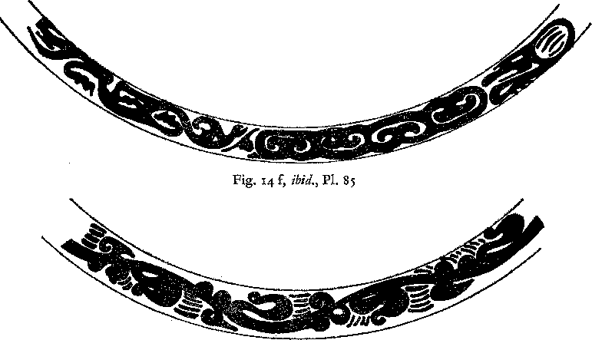

Fig. 14 g, *ibid.,* Pl. 94  
Fig. 14 Border patterns from mirrors

stamped in brick as shown in fig. 14 d. Pl. 49 is another variant of this design. It resembles Pl. 56 although it is less compact. The border on Pl. 68 shows a decline in gracefulness which is typical of the development at the end of the Han period and in the third century A.D. Another characteristic feature of the development in later periods is the widening of the rim (Pl. 42.A and Pl. 6o) and the treatment of the animal border which is less delicately designed than on earlier mirrors *(e. g.* Pl. 56).

Another type of border pattern is worked in rounded relief *(e.* g. Pl. 75, 76, 77, 79). It orig­inated in the second century, gained popularity in the third century A.D., and was still used on Six Dynasties periods mirrors. Generally speaking, the earlier ones are simpler than the later ones. The procession on these mirrors includes not only animals, immortals riding on dragons, but also boats drawn by six dragons. The decorative motifs between the figures are cloud or wave signs. Although border patterns are not in all cases a reliable guide for dating they can often help to classify a mirror within a certain limit of time. For example, border patterns like those in fig. 14e, f, *g,* h are quite common on third century mirrors. The earliest possible date for any mirror with a similar pattern would be the very end of the second century A.D.

*Scrolls and Geometrical Patterns*

Although S-spirals and related motifs do not altogether disappear as decorations on the rim of mirrors they lose their importance in the later part of the Eastern Han period, though they can occasionally still be found on mirrors as shown on Pl. 5z and 55. In the second century simple scrolls were preferred as illustrated by fig. N and Pl. 65 ; they were not even abandoned when the rim of mirrors was divided into two belts (Pl. 75 and 76). Diamond patterns undergo the same development. They became very popular during the second century A.D. *(e. g.* fig. K) and were relegated to the outer border when the rim was divided into two belts. The difference between diamond patterns of the second century A.D. and later periods has already been dis­cussed in this survey. On late Eastern and post-Han mirrors the rim quite often thickens to­wards the outer edge forming a kind of ridge.

CONCLUSIONS

he development of mirrors in the course of the Han period shows, on the one hand, the continuity of religious conceptions and, on the other, their flexibility. Throughout that

**T**

entire period all figures and patterns stand for cosmic symbols representing various agencies and powers active in the universe. They were believed to control the eternal cycle of creation and de­struction to which nature and man are equally subject. Yet, except for the *ssta shin* and a few other symbols, the signs and motifs change continually. In fact, nothing could be more dis­similar than the elegant dragon arabesques of the early Western Han period and the crude figures of the divinities on late Eastern Han mirrors. Among the agents promoting changes those generated by the intellectual aspirations and anxieties of succeeding generations are strongest, but the effect of material forces should not be underestimated. Purely political events exert the least influence on art unless they are coupled with other factors of a positive or negative nature. The reason why the tremendous upheaval at the end of the third and the be­ginning of the second century B. C. had no immediate effect on the style of art was partly due to the fact that it did not coincide with the disintegration of the religious basis of society. The beliefs held by preceding generations and their conceptions of the inter-relationship between the universe and human beings were still valid. There was, therefore, no need to search for new ways of expression or for new symbols. Artistic interest could concentrate on the perfection and variation of established types. This changed in the course of the second century B. C. Not that beliefs were disintegrating but they had to be adjusted to conform to the knowledge and ex­periences of a new era. Though cosmological speculations were essentially based on ideas identical with those of the past, their interpretation changed and the vision of the network of cosmic forces widened in scope and became more complicated and intricate. This precipitated changes in the decoration of mirrors because the old signs could no longer adequately express the new ideas.

The development of mirrors during the later part of the Western Han period provides a good example of the effect of more tangible forces on art. It was a time of growing prosperity which in nearly all societies has a beneficial influence on art insofar as it promotes the demand for objects of beauty and luxury. Moreover, the possession of works of art adds to the prestige of a family, and the collection of art as a pastime has always been one of the best means of gaining access to the leading and educated classes of society. This is of particular importance in times of great social changes such as the first century B. C., the more so as during this period wealth became one of the major means for climbing the social ladder. While in the past rich merchants had been strictly barred from holding office, money would now open the way to position and

power. However, whether prosperity leads to a mere increase in the quantity of works of art or to an improvement in the quality depends on a variety of factors. It throws a favourable light on the society of those days that the mirrors produced at that time were of outstanding beauty and workmanship. It seems that the upper classes were apparently able to retain their high artistic standards, and that wealth had not corrupted their sensibilities. The perfection demanded by the wealthy and educated classes encouraged the designers and craftsmen to do their best. This period came to a final close with Wang Mang's death.

The beginning of the Eastern Han period had no immediate impact on art. On the contrary, it appears to have been a time of stagnation. This is not surprising but can be interpreted as an intellectual and emotional reaction against the preceding period; an anticlimax to the speculative theories put forward during the Western Han period. This is all the more understandable since Wang Mang's failure had proved the fallacy of some of the new theories, not only in the economic field but also in regard to cosmological speculations. Kuang Wu ti's attitude towards certain problems of his time and his refusal to take risks reflects the sobering down of the intellectual atmosphere in the early Eastern Han period. In addition, the country had not yet recovered from the economic chaos in which it found itself after Wang Mang's death, and money was scarce. Under the growing influence of Confucianism values changed, and extra­vagance and luxury were regarded as signs of bad taste not to be indulged in by a gentleman. This is most forcefully expressed in a poem describing the difference between the capitals of the Western and Eastern Han periods.124 The first Emperor of the Eastern Han period is lauded in true Confucian spirit for his frugality and is contrasted favourably with the rulers of the Western Han Dynasty who surrounded themselves with beautiful objects and lived a life of luxury squandering their wealth. The effect of such an attitude on art and, in this particular case, on mirrors, could only be negative.

This stagnation was overcome during the later part of the first and in the second century A. D. with a sudden emergence of a great number of new types of mirrors. This may again partly be due to improved conditions. People were able to amass large fortunes, and even at the time of decline towards the end of the Eastern Han period powerful families still tried to vie with each other in a display of their wealth. However, most though not all of the new types of mirrors were inferior in regard to beauty of design, composition and workmanship when compared with those of the Western Han period. While the causes for such a decline were manifold, the growing influence of Confucianism was crucial. It tended to channel the artistic interests of the educated classes into narrow confines. Especially calligraphy and music were considered forms of art worthy of a gentleman, while nearly all other branches were thought inferior and outside the proper domain of interests of educated people. Nearly everywhere the lack of patronage by these classes leads to a deterioration of artistic standards.

Yet the production of mirrors did not decrease and the vitality and manifoldness of the designs prove that they continued to be one of the essential media through which men could ex­press new ideas. The only difference is that less sophisticated classes took the lead and made their impact felt in a diminishing interest in their purely aesthetic appeal. They introduced a nar­rative element into the decoration which is always the sign of a more primitive or naive mentality.

124 Chang Heng 11 8-139, A. D. "Hsi-ching-fu" and "Tung-ching-fu" (poetical descriptions of the capitals of the West­ern [Ch'ang-an] and of the Eastern (Lo-yang) Han periods.

The growing importance of divinities in human form as decoration of mirrors is a signifi­cant indication of the changes in the intellectual atmosphere. Although the beginning of this trend can be traced back to the Western Han period and had its roots in ancient myths it gained momentum in the Eastern Han period, especially during the latter part. It reflects the growing desire to humanize ancient cosmological conceptions. This is the signal of a new era. Although it developed from ancient Chinese conceptions these changes fit in with a widespread religious movement, and it is certainly not accidental that it coincides with the introduction of Buddhism into China.

During the last decades of the Han period the country was torn by rebellion and warfare; economic conditions deteriorated, and the people were exposed to hardship and danger. However, the great number of mirrors with dates from the time of the last Emperor of the Han Dynasty confirm that they were still in great demand. This is not surprising as the super­natural powers with which these mirrors were believed to be imbued became even more im­portant in times of strain and stress than during periods of prosperity and peace. That the most favoured mirrors of this time (Pl. 8o and 81), were made not for an elite but for the great mass of the people is reflected in the vulgarity of their design and their low standard of workmanship. It seems that artistic qualities were of no account to the people who clamoured for the possession of these mirrors; all they wanted was a charm to protect or guide them. In order to enhance the potency of the mirror its surface was covered with an increasing number of divinities. This is a portent of the disintegration of ancient forms of belief. It shows a waning confidence in the effectiveness and power of the individual divinity and symbol and necessitates, as a con­sequence, the amassing of as many figures as possible on one mirror. The breaking up of the ancient religious fabric continues in the following period and created a vacuum which even­tually was filled by Buddhism.

The fall of the Han Dynasty and the political changes which followed had again no direct impact on the art of the period but only intensified the trend already apparent in the beginning of the third century A.D. During the famous heroic age of the Three Kingdoms the graces disappeared more and more from the arts to return, gradually, in the time of the Six Dynasties.

BIBLIOGRAPHY

*In Western Languages:*

**ANDREWS,** F. H., "Ancient Chinese Figured Silks, excavated by Sir Aurel Stein at ruined Sites in Central Asia", *Burlington Magazine,* April 1926.

**BULLING,** A., "The Decoration of some Mirrors of the Chou and Han Periods", *Artibus Asiae,* Vol. 18, No. 1, 1955, pp. zo-43, abbrev. "Decoration of some mirrors".

* "Die Kunst der Totenspiele in der ostlichen Han Zeit", *Oriens Extremus,* 3. Jahrg., 1956, pp. z8-56, abbrev. "Totenspiele".
* *The Meaning of China's Most Ancient Art,* Leiden 195z.
* "Late Chou and Han Art in the British Museum", *Burlington Magazine, May* 1951.

**CAMMANN, SCHUYLER,** "TLV patterns on Cosmic Mirrors of the Han period", *Journal of the American Oriental Society,* Vol. 68, Oct./Dec. 1948.

* "Suggested Origin of the Tibetan Mandala Paintings", *The Art Quarterly,* Spring 195o.

**CHAVANNES, EDOUARD,** *Mission Archeologique dans la Chine Septentrionale,* z vols., Part I, Paris 1912. **CHANG TA-K'UN,** *Archaeological Studies in Szechwan,* Cambridge University Press, 1957.

DUBS, H. H., "An ancient Chinese Mystery Cult", *Harvard Theological Review,* 1942.

**ERKES, EDUARD,** *Beitrage zur Geschichte des Chou kung.* Bericht fiber die Verhandlungen der Sachsischen Akademie der Wissenschaften zu Leipzig, Philosophisch Historische Klasse, Bd. tot, Heft 3.

**GRAY, BASIL,** "The Eumorfopoulos Lacquer Toilet Box and Blue T'ang Horse", *British Museum Quarterly,* 1940, pp. 49-53.

**KAPLAN, SIDNEY M.,** "On the Origin of TLV mirrors", *Revue des Arts Asiatiques,* XI 1937.

KARLBECK, 0., *Catalogue of the Collection of Chinese and Korean Bronzes at Hallwyl House,* Stockholm 1938.

* "Selected Objects from Ancient Shou-chou", *Bul. MFEA,* No. z7, 1955.
* "Karlbeck Syndicate 1931/3z".

**KARLGREN,** B., "Huai and Han", *Bull. MFEA,* No. 13, 1941, pp. 1-1 25, abbrev.: *H. & H.*

* "Early Chinese Mirror Inscriptions", *Bull. MFEA,* No. 6, pp. 9-81, abbrev.: "Inscriptions".
* "Exhibition of Early Chinese Bronzes", *Bull. MFEA,* No. 6, pp. 81-133.

**LEGGE, J.,** "The Chinese Classics", Vol. III, *The Shu Ching and The Bamboo Annals,* 1885.

**NIESSEN, C.,** *Handbuch der Theaterwissenschaft,* Bd. I, "Der Ursprung des Asiatischen und Antiken Dramas und des Totenkultes", 1952.

PELLIOT, **PAUL,** *Les Grottes de Touen Houang,* (Six portfolios plates), Paris 1914-24.

**PLATO,** *The Republic,* transl. by H.D.P. Lee. Penguin Books, repr. 1958.

RIPLEY HALL, ARDELIA, "The Wu-ti mirrors", *Ostasiatische Zeitschrift,* N.F. To. Jahrg., Heft 1/2, 1934, p. 16. ROSTOVTZEFF, M., *Inlaid Bronzes of the Han Dynasty in the Collection of C. T. Loo,* Paris 1927.

SAVATCHANKA, E. A., *Singhalese Folkways,* Ceylon 1953.

SICKMAN, LAURENCE and SOPER, ALEXANDER, *Art and Architecture of China* (The Pelican History of Art), 1956.

SIREN, 0., *Kinas Konst under Tre Artusenden,* Stockholm 1942. *— History of Early Chinese Art,* Vol. II, London 193o.

SWALLOW, R. *W., Ancient Chinese Bronze Mirrors,* Peiping 1937.

UMEHARA, SUE JI, "Mr. Moriyas's Collection of Ancient Chinese Mirrors", *Artibus Asiae,* Vol. 18, No. 3/4 1955, pp. 238-256.

TOMITA, Kojmo, "Chinese Bronze Mirrors of the second century B.C.", *Museum of Fine Arts Bulletin,* Boston, June 1931, pp. 38ff.

TREVER, CAMILLA, *Excavations in Northern Mongolia* 1924/25, Leningrad Memoirs of the Academy of History of the Material Culture, Leningrad 1932.

WATSON, W., "A bronze Mirror from Shao-hsing, Chehkiang Province", *British Museum Quarterly,* Vol. XIX, No. i, 1954, pp. 4i ff.

WATERBURY, FLORENCE, *Bird Deities in China,* Artibus Asiae, Suppl. X, 1952.

WHITE, WILLIAM CH., *Tomb Tile Pictures of Ancient China,* Toronto 1939.

YAMANAKA & CO., *Exhibition of Early Chinese Bronzes, Stone Sculptures and Pottery,* New York 1926.

YETIS, W. PERCEVAL, *The Eumorfopoulos Collection,* Vol. II, London 193o. *— The Cull Chinese Bronzes,* London 1939.

*Chinese Publications:*

*Ch'ang-sha fa-chueh pao-kao* 41 a* (Report on Excavations in Ch'ang-sha). Abbrev. Ch'ang-sha report.

Archaeologica Sinica, Special number, No. z [111=91Tf-AA2%. Peking 1957.

|  |  |  |
| --- | --- | --- |
| CHANG I-PENG r : 'Hsi-ching-fu'  *Liu-ch'en chu wen hsuan* | in: | , 'Tung-ching-fu' *(Fu* of the Western and Eastern Capitals). |
|  |

*Ch'iian-kuo chi-pen chien-she kung ch'eng chung ch'u-euwen-wu chan-lan t'u-lu* 1:21g*MR.I.f14:1W,±.4t ma (Illustrations of Chinese Cultural Objects excavated at Construction Sites since 1949). Peking 1955.

FPNo YUN-P'No and FtNo YON-YON 3 : *Chin-shih-so* (Compendium of Metals and Stone).

Published 1822, reprinted 1893.

JUNG MING : *Hai-wai ku-chin t'u-lu M- t.* it (Illustrated Catalogue of Bronzes in Foreign Collections).

1935.

*Ku-tai chuang-shih hua-wen hsuan-chi* --M-MWEVriE*. (A Collection of Ancient Decorative Patterns). ed. Northwest Historical Museum 61L.H.4114INVA. 1953.

LIANG SHANG-CH'UN *Yen k'u ts'ang ching* wmar. (Illustrated Catalogue of Mirrors in the Yen k'u

Collection). Vols 1-4. Peking 1941-42.

|  |  |  |
| --- | --- | --- |
| Lo CHEN-Ye *Ku ching t'u lu* to, |  | (Facsimilies of Ancient Mirrors). Peking 1916. |
| !NI |
|  |

*I-nan ku-hua hsiang-shih-mu fa-chueh pao-kao* ;F.MtVit4ERffint- (Report on ancient stone engravings found in a tomb near I-nan) by Ts'eng Chao-shu 1 Chiang Pao-keng ; Liu Chung-i

and others. Published by the Bureau of Relics and Ministry of Culture _EA Shanghai 1956.

*Chinese Periodicals:*

*K'ao-ku t'ung-hsun* (Archaeological Bulletin). Abbrev. K'ao-ku t'ung.

*K'ao-ku t'ung-hsiin* (ed. K'o-hueh ch'u-pan-she win). Peking:

* (A) 1956, No. r, p. 36 ff. WE* : iIVIUTIANA*MCITAFT.
* (B) 1956, No. 2, p. 64 *ff. N141itiVM3114 ItTgMXttan*  
  *(C)* 1956, No. 4, p. 12 ff. MMit1Z1tWITI 'At : NiMV,AVXMAROW
* (D) 1956, No. 6, p. 36 ff. : Ai/*AM931EQ
* (E) *ibid.,* p. 66 ff. p-smkti-a-NAs

(F) 1957, No. 3, p. 15 ff. V'Jti-itiZtrAnWal 1AU4t*Pg*SEM9Ili1Uli

* (G) 1957, No. 4, p. 33 ff. 11,tM : ir41 11-1WiXM 31fUR

(H) *ibid.,* p. 59 ff. 51qA : Ri/JA".±.ORTSMAM

* (J) 1957, No. 5, p. 4o *ff.* NIMItIZIWagveir : MPgRiAiMclIA-NaMild\M
* *(K) ibid.,* p. 7, ff. MMAilinithtainff331 (AAA )
* *(L) ibid.,* p. 75 ff. RlisINZffiMAAIrpIlli
* (M) 1958, No. 2, p. 14 ff. pUl'Iltigttn.Ot' *: OCAMAtONAANRIEN (N) 1958, No. 7, p. 22 ff. JRM):1 atgAs : IEUtlivifERKMEMAIN'agg-E
* (0) 1958, No. 7, p. 54 ff. 7p7M'kFATJ'At)nViff-n:(4g.
* (P) 1959, No. 1, p. 21 ff. UVI MTVAMIIIKARI-AMA3TINQ

*Wgn-wu ts'an-kao tzii-liaoV'7i.-4*$4* (Journal of Museums and Relics). Abbrev. Wen-wu. Peking:

* (A) 1955, No. II, p. 37 ff. itiff : elJilt
* (B) 1956, No. 5, p. **21** ff. *41MtificIMA-e- :17-_-*3MMAntrAgfrittlA
* (C) 1957, No. 8, p. 35 ff. it.-ER

*K'ao-ku hsiieh-pao* -Ng-f-gi (Chinese Journal of Archaeology). Peking:

* (A) 1958, No. **2,** p. 39 ff. 01* MitikEtinNiXE *Japanese Publications:*

**HAMADA, KOSAKU FEIWP** *Lo-lang; the Tomb of the Painted Basket* OVIMEW. Chosen-koseki-kenkya-kai (Society for the Study of Korean Antiquities). Keijo 1934.

**HARADA, YOSHITO** and others JAW& A 4,1 ***Lo-Zang,*** a *Report on the Excavation of Wang Hsu's Tomb AINE'* 011S . Tokyo 193o.

* *Sen5ku seish5 kankyo bu* 4LEMIN,155 (Catalogue of Chinese Bronzes in the Sumitomo Collection). Ancient Chinese Mirrors. **2 Vols.,** 1921.

**OBA, TSUNEKICHI** and **K4YAMOTO, KAMEJIRO :** *Lo-tang; the Tomb of Wang Kuang*vaiyEa• Keijo 1935.  
**SEKINO, TADASHI** and others: *Rakurogun jidai no iselei *RZSIVtpit* M (Archaeological Researches on

the ancient Lo-lang district). **2** vols. (plates and maps) 1952, r vol. (text) 1927. Government General of

Chosen.

**UMEHARA,** SUEJI Ite:*it: *Kan sangoku rikuch5 kinen 'kyo zusetzu* 3N (Illustrations and

Designs of Dated Mirrors of the Han, Three Kingdoms and Six Dynasties Period). Abbrev. Umehara, Dated Mirrors, Vol. 1 in the series Kokogaku Shiryo. Imperial University, Kyoto 1944.

* *TOinro wakan kokan zuroku* ma (Catalogue of Ancient Japanese and Chinese Mirrors  
  in the Seki Collection). **2 vols.** Nara 1925.
* *Shina Kod5 Seika 3* N-'JFIV (Selected Relics of Ancient Chinese Bronzes from Collections in Europe and America). Vols. IV and V. *Mirrors.* Yamanaka, Osaka. 1933.
* *TOkan Kokyo Zuroku* vt**-Ns IA (Illustrated Catalogue of 63 Ancient Mirrors in the Collection of Tomioka Ken*. Kyoto 1924.

*RyOkin no kan rikuch5 kyo* 0A-AM a (Gilded Bronze Mirrors of the Han and Six Dynasties Periods).

*Yamato Bunka* .tfliDZ*, No. 6, April 1952, pp. r-ro.

* *ShOkyo (Shao-hsing) Koky5 Shuei* MR-NrMA (Selected Ancient Mirrors from the Shao-hsing Tombs).

Kyoto 1933.

*Kan Sangoku rikuch5 kinen ky5 siimoku* fIE ea AVie*ii,6Q . *K5kogaku zasshi A-filftr2,* Vol. 4o,

No. 4, 1955, pp. 207-217.

* *Kokyo no kenkyii* 0 FR (Collection of Essays on Ancient Mirrors in the Collection of Tomioka

Kenzo). Kyoto 192o.

LIST OF PLATES

P1. 1 Mirror *(pa-yao hsien-lien-hu)* Diam: 14 cm. By courtesy of His Majesty, the King of Sweden III

Pl. 2 Shou-chou mirror. Diam: 14.3 cm. By courtesy of His Majesty, the King of Sweden . I

PL 3 Shou-chou mirror. Diana: 24 cm. By courtesy of Mr. Frank Caro, New York I

Pl. 4 Shou-chou mirror. Diam: 24 cm. By courtesy of Mr. Frank Caro, New York II

Pl. 5 Shou-chou mirror. By courtesy of Mr. Frank Caro, New York II

Pl. 6 Shou-chou mirror. Diam: 15.8 cm. By courtesy of His Majesty, the King of Sweden III

Pl. 7 Shou-chou mirror. Diam: 19 cm. By courtesy of the British Museum, London . . III

Pl. 8 Shou-chou mirror. Diam: 18 cm. By courtesy of His Majesty, the King of Sweden . IV

Pl. 9 Shou-chou mirror. Diam: 19 cm. By courtesy of His Majesty, the King of Sweden . IV

Pl. 10 TLV mirror. From the collection of the late Kenzo Tomioka. Umehara, *Tokan Kokyo Zuroku,*

P1 **2** V

Pl. Ii TLV mirror. Diam: 18.5 cm. By courtesy of the Musee Guimet, Paris V

Pl. 1z TLV mirror. By courtesy of the Ostasiatiska Samlingarna. Stockholm III

Pl. 13 TLV mirror. Diam: 13.5 cm. By courtesy of His Majesty, the King of Sweden VI

Pl. 14 *Ts'ao-yeh* mirror. Diam: 13.2 cm. Formerly M.W. Calmann Collection, Paris VI

Pl. 15 *Ts'ao-yeh* mirror. Diam: 11.7 cm. By courtesy of His Majesty, the King of Sweden VII

Pl. 16 Mirror with simple spirals. Diam: 11.6 cm. By courtesy of His Majesty, the King of Sweden VIII

Pl. 17 Mirror with simple spirals. Diam: 9.5 cm. By courtesy of His Majesty, the King of Sweden . VIII

Pl. 18 Mirror with four dragons. Diam: 11.5 cm. By courtesy of Hallwyl House, Stockholm . . IX

Pl. 19 Mirror with four spirals. Diam: '5.1 cm. By courtesy of the University Museum, Philadelphia IX

Pl. zo Inscription mirror. Diam: 7 cm. By courtesy of Mr. Frank Caro, New York X

Pl. zi Inscription mirror. By courtesy of His Majesty, the King of Sweden X

Pl. zz Inscription Mirror. Diam: 18.5 cm. By courtesy of Rohsska KonstIodjdmuseet, Goteborg XI  
Pl. 23 Inscription Mirror (dated A.D. 6). Formerly Moriya Collection. By courtesy of Professor

S. Umehara XI

Pl. 24 *Ch'ing-pai* or *ming-kuang* mirror. Diam: 21.5 cm. Formerly David Weill Collection, Paris XII  
Pl. 25 *Ch'ing-pai* or *ming-kuang* mirror (dated A.D. 64). Diam: 13.4 cm. By courtesy of the Fogg

Art Museum, Harvard University XII

Pl. 26 Hundred Nipples mirror *(paiju).* Diam: 12.9 cm. By courtesy of the Ostasiatiska Samlingarna XIII

Pl. z7 Hundred Nipples Mirror. Diam: 15.1 cm. By courtesy of Hallwyl House, Stockholm . . XIII

Pl. 28 Mirror with Heavy Rings *(chung ch'ilan)* (pattern in gold). Diam: 19.4 cm. By courtesy of

the British Museum, London XIV

Pl. 29 TLV mirror. Formerly Moriya Collection, Japan. By courtesy of Professor S. Umehara . XV

Pl. 3o TLV mirror. By courtesy of the Musee du Louvre, Paris XV

Pl. 31 Shou-chou mirror. Diam: 18.4 cm. By courtesy of the Smithsonian Institution, Freer Gallery of

Art, Washington D.C. XVI

Pl. 32 Bird Mirror. Diam: 11.6 cm. By Courtesy of Mr. Frank Caro, New York XVII

Pl. 33 Bird Mirror (Shou-chou). Formerly Ostasiatisches Museum, Berlin XVIII

P1. 34 Bird Mirror. Diam: 15.1 cm. By courtesy of His Majesty, the King of Sweden XVIII

Pl. 35 TLV mirror. Diam: 22 cm. By courtesy of His Majesty, the King of Sweden . XIX

Pl. 36 TLV mirror. Diam: 17 cm. By courtesy of the Metropolitan Museum of Art, Rogers Fund

1917, New York XX

Pl. 37 TLV mirror. Owner unknown XX

**P1.** 38 TLV mirror. By courtesy of the Smithsonian Institution, Freer Gallery of Art, Washington

D.C. XXI

P1. 39 TLV mirror. Formerly Collection of Mr. Liang Shang-ch'un XXII

Pl. 4o TLV mirror. By courtesy of His Majesty, the King of Sweden XXII

Pl. 41 TLV mirror. By courtesy of the Museum of Fine Arts, Boston XXIII

Pl. 42 TLV mirror. Diam: **18.3** cm. By courtesy of the Nelson Gallery, Atkins Museum (Nelson

Fund), Kansas City, Missouri XXIV  
Pl. 42 a TLV mirror. By courtesy of the Raymond A. Bidwell Collection, Museum of Fine

Arts, Springfield, Mass XXV

Pl. 43 TL mirror. Diam: 18.5 cm. By courtesy of the Royal Ontario Museum, Toronto XXV  
Pl. 44 Animal belt mirror *( Shou-tai ).* From the collection of the late Kenzo Tomioka. S. Um‑

ehara, *Tokan Kokyo viroku.* Pl. zz XXVI

Pl. 45 *Shou-tai* mirror. By courtesy of the Museum of Fine Arts, Boston XXVII

Pl. 46 *Shou-tai* mirror (seven stars mirror). By courtesy of the Museum fur Ostasiatische Kunst,

Cologne XXVIII

Pl. 47 *Shou-tai* (seven stars) mirror. By courtesy of the Museum of Fine Arts, Boston . XXIX

P1. 48 *Shou-tai* (seven stars) mirror. Former Moriya collection. By courtesy of Professor S. Umehara XXVIII

Pl. 49 *Shou-tai* (seven stars) mirror. By courtesy of Mr. Frank Caro, New York XXXI

Pl. 5o *Shou-tai* (seven stars) mirror. By Courtesy of the Museum of Fine Arts, Boston XXX

Pl. 51 *Shou-tai* (seven stars) mirror. Diam: 18 cm. By courtesy of Mr. Frank Caro, New York . XXXI

Pl. 5z *Shou-tai* mirror. Diam: 11.5 cm. By courtesy of the Smithsonian Institution, Freer Gallery

of Art, Washington D.C. XXXII

Pl. 53 Bird mirror. Diam: 9 cm. By courtesy of Mr. Dugald Malcolm, London XXXII

Pl. 54 *Shou-tai* mirror. Diam: 17.3 cm. By courtesy of Hallwyl House, Stockholm XXXIII Pl. 55 *Shou-tai* mirror. Diam: 21.5 cm. By courtesy of the Honolulu Academy of Art, Honolulu XXXIII Pl. 56 Dragon-tiger mirror *(lung-hu ).* Former Moriya Collection. By courtesy of Professor S.

Umehara XXXIV  
Pl. 57 Mirror with sheep in relief (dated A.D. ii7). Diam: io.2 cm. By courtesy of the British

Museum, London XXXV

Pl. 58 Lung-hu mirror. Diam: 12.8 cm. By courtesy of Mr. Frank Caro, New York . . . XXXIV  
Pl. 59 *Shou-tai* mirror with a dragon-tiger centre. Found in Tomb No. 2 in Lo-lang, Korea.

Sekino, *Archaeological Researches in the ancient Lo-lang district.* Vol. I. Pl. 89 XXXVI

Pl. 6o *Shou-tai* mirror with *lung-hu* centre. Courtesy of the Museum of Fine Arts, Boston . XXXVII

Pl. 61 *Shou-tai* mirror with *lung-hu* centre (dated A.D. 291). Diam: 18 cm. By courtesy of Mr.

Frank Caro, New York XXXVI

Pl. 6z Animal head *(thou-shou)* mirror. By courtesy of His Majesty, the King of Sweden XXXVIII

Pl. 63 *Shou-shou* mirror. By courtesy of His Majesty, the King of Sweden XXXVIII

Pl. 64 *Shou-shou* mirror. Diam: **12** cm. By courtesy of the Ostasiatiska Samlingarna, Stockholm XXXIX

Pl. 65 Four panels mirror (dated A.D. 189). Formerly Moriya Collection. By courtesy of Pro‑

fessor S. Umehara XXXIX  
Pl. 66 Mirror with pictorial decoration *(Hua-hsiang ching).* By courtesy of the Smithsonian

Institution, Freer Gallery of Art, Washington D. C XL

Pl. 67 *Hua-hsiang* mirror. Diam: 18.8 cm. By courtesy of the Victoria and Albert Museum, London XLI  
P1. 68 *Hua-hsiang* mirror. Diam: 13.8 cm. By courtesy of the Metropolitan Museum of Art, Rogers

Fund, 1917, New York XLI

Pl. 69 *Hua-hsiang* mirror. Formerly Moriya Collection. By courtesy of Professor S. Umehara XLII

Pl. 7o *Hua-hsiang* mirror. Diam: zz cm. By courtesy of the University Museum, Philadelphia XLIV

Pl. 71 *Hua-hsiang* mirror (with chariots and horses, *ch'e ma).* Diam: zz cm. By courtesy of the

British Museum, London XLIII

Pl. 71 *Hua-hsiang* mirror *(ch'e-ma).* Diam: 2.1.4 cm. By courtesy of Mr. Frank Caro, New York XLIV  
Pl. 73 *Hua-hsiang* mirror *(ch'e-ma).* Iron mirror with gold sheet. Diam: 16,3 cm. By courtesy

of the Smithsonian Institution, Freer Gallery of Art, Washington D. C . XLV  
Pl. 74 *Hua-hsiang* mirror *( ch'e ma).* With engraved silhouettes of gold and silver embedded in

lacquer. Diam: z7 cm. By courtesy of the Smithsonian Institution, Freer Gallery of Art,

Washington D.C. XLVI  
**PI.** 75 *Hua-hsiang* mirror with *pan-yiian fang-chio* belt. By courtesy of Mr. John Hadley Cox,

Chevy Chase, Maryland XLVII  
Pl. 76 *Hua-hsiang* mirror with *pan-it/an fang-chio* belt. Diam: 18 cm. By courtesy of Hallwyl

House, Stockholm XLVIII  
**Pl.** 77 *Hua-hsiang* mirror with *pan-yuan fang-chio* belt. By courtesy of the Metropolitan Museum

of Art, Rogers Fund, 1917, New York XLVIII  
**Pl. 78** *Hua-hsiang* mirror with *pan-yiian fang-chio* belt. Diam: 11.5 cm. Formerly Ostasiatisches

P1.78 a Detail of Plate 78 XLIX

Museum, Berlin XLIX

**Pl.** 79 *Hua-hsiang* mirror with *pan-yiian fang-chio* belt. Diam: 18 cm. By courtesy of Mr. Richard

C. Bull, Villanova (Pa). XLIX  
Pl. 8o Mirror arranged in tiers *(chung lieh ).* Diam: 11 cm. By courtesy of Mr. Frank Caro, New

York

Pl. 81 *Chung lieh* mirror. By courtesy of the Museum of Fine Arts, Boston

LIST OF LARGE FIGURES

Fig. A Inscription Mirror. Lo Chen-yii, *Ku cbing t'u lu,* Vol. II. p. 6 right z9

Fig. B Inlaid Bronze bowl. Rostovtzeff, M., *Inlaid BrotRes of the Han Dynasty in the Collection of C. T. Loo,*

Pl. IX 34

Fig. C TLV Mirror found in Ch'ang-sha in a tomb of the later Western Han period. Ch'ang-sha report, P1.63 (z) 39

Fig. D TLV mirror. Lo Chen-yii, *Ku thing t'u lu,* Vol. II, p. z (1) 41

Fig. E TLV mirror. (Wang family and Hsin dynasty mentioned in the inscription). Lo Chen-yu, *Ku*

*thing t'u lu, V ol.* II, p. z3 (1) 48

Fig. F TV mirror (dated A.D. 1o). Umehara, 'Dated Mirrors', Pl. z 5o

Fig. G TLV mirror. Lo Chen-yii, *Ku thing t'u lu,* Vol. II, p. 6 (1) 54

Fig. H TLV mirror. Lo Chen-yii, *Ku thing t'u lu,* Vol. II, p. 3 (r) 57

Fig. J Animal Belt mirror. *Ku-tai chuang-shih hua-wen hsiian-chi,* Pl. zI 71

Fig. K Animal Head Mirror (dated A.D. 174). By courtesy of the Freer Gallery of Art, Washington D.C. 76

Fig. L *Sskpa lien-hu* mirror. Lo Chen-yii, *Ku ching t'u lu,* Vol. III, p. xo (1) So

Fig. M Inscription Mirror (dated A.D. 28x). Lo Chen-yii, *Ku ching lu,* Vol. III, p. z3 83

Fig. N *Shin-fin hua-hsiang* mirror (dated A.D. xo5). Umehara, 'Dated Mirrors', Pl. 5 91

LIST OF SMALL FIGURES

Figs. I a and b. Design of centre and of nipple

**Page**

28  
43

Fig. z Running man (from Shou-shou mirror, Karlgren *H. & H.,* Pl. 56, F. i 6)

Fig. 3 Dragon-bird on third cent. B. C. mirror 43

Fig. 4 from border patterns

1. mirror publ. by Umehara. *Kokyo no Kenkyfi,* Pl. 27 56
2. mirror publ. by Karlbeck Syndicate 1931/32, No. 198 56
3. figure cut out of gold-foil (Ch'ang-sha report, Pl. 83) 56

Fig. 5 a) fragment of a TLV mirror (gilded) (W. P. Yetts, *The Eumorfopoulos Collection,Vol.* II, B. 9) 6o

1. TLV mirror, (Umehara, *Shina Kodo Seika,* Vol. IV, Pl. 66) 6o
2. TLV mirror, *(ibid.,* Vol. IV, Pl. 6z) 6o
3. TLV mirror, *(ibid ,* P1 64) 6o
4. TLV mirror, (Umehara, *Tokan Kokyo Zuroku,* Pl. XXII) 6o
5. TLV and other mirrors *(e. g.* Pl. 3o and Umehara, *Shina Kock' Seika,* Vol. IV, Pl. 69) . . 6o

Fig. 6 a) centre of toilet box in the British Museum (B. Gray, The Eumorfopoulos Lacquer Toilet Box) 61 b) centre of toilet box found in Wang Hsu's Tomb in Korea (Pl. LXXXV) 61

Fig. 7 border patterns on mirrors

1. Umehara, *Tokan Kokyo Zuroku,* Pl. XII 63
2. Liang Shang-ch'un, *Yen k'u ts'angching,Vol.* II, p. 43 63
3. *ibid.,* Vol. III, p. 48 63
4. see Pl. 3o 63
5. Liang Shang-ch'un, *op. cit.,* Vol. III, p. 18 63
6. *ibid.,* Vol. III, p. zo 63
7. Umehara, *Tokan, op. cit.,* Pl. XIII 63
8. interior belt. (Liang Shang-ch'un, *op. cit.,* Vol. III, p. 75) 63
9. interior belt, *ibid.,* Pl. 64 63

k) on a great number of mirrors 63

Fig. 8 animals

1. from TLV mirror (Umehara, *Shina Kodo Seika,* Vol. IV, Pl. 65) 64
2. from different mirrors 64

Fig. 9 details of Fig. B 66

Fig. Io Immortals from inlaid bronze bowl (Fig. B) 67

Fig. n Immortals from mirrors

a) Umehara, *Tokan, op. cit.,* Pl. XVI 68

1. *ibid.,* P1. XIX 68
2. *ibid.,* Pl. XI 68
3. *ibid.,* Pl. XV 68
4. Mirror found in Lo-lang in Wang Hsii's tomb 68
5. Umehara, *Shina Kock' Seika,* Vol. IV, Pl. 7o 68

Fig. i 2 A lady playing the *ch'in* and another one dancing (Umehara, *Shina Kock, Seika,* Vol. V, P1. 87) 89

Fig. 13 Immortals, on late second and third century mirrors 99

Fig. 14 Border patterns from mirrors

1. late type of border too
2. TLV mirror, Liang Shang-ch'un, *op. cit.* Vol. III, p. 19 too
3. *ibid.,* Vol. IV, p. zz too
4. Similar figures on stamped bricks (Wang Chen-to, *Han tai k'uang-chuan chi-lu,* Pl. z) too
5. Umehara, *Shina Kodo Seika,* Vol. V, Pl. too zoo
6. *ibid.,* P1. 85 too
7. *ibid.,* Pl. 94 too
8. Waterbury, *Bird Deities in China,* Pl. 46 too

INDEX

Arcs, see festoons

Barbarians 36, 37, 78

Buddhism 31, 96, 104

Buildings, Ming-t'ang, Pi-yung, Ling-t'ai 52, 55 Bulling, A., 18, 20, 27, 3o, 35, 63, 9o, 95

Canopies, see parasols

Canton z7, 44

Ceylon 31

Ch'ang-sha 14, 18, 19, 20, 25, 27, 28, 381f., 51, 5z, 68 Ch'in tsun (near Lo-yang) 44

Coins II, 12, 15, 18, 44, 55

Confucianism 103

Constellations, see Heavenly bodies

Cosmological speculations 2I, 13, 31, 35, 95, 102, 104

Festoons (arcs-, scallops) 25, 27, 28, 30, 32, 36, 44, 58, 69, 77, 78, 81, 94

Five Elements 41, 93

Five Celestial Emperors (Wu Ti) 9z, 93, 95, 96

Heavenly Bodies (stars, constellations, zodiac, pla­nets), 13, 31, 32, 35, 37, 38, 42, 51, 56, 69, 78, 9o, 9z, 93

Hosokawa basin 36, 38, 5 **25** 55, 61, 67, 69

Hou-i 56, 8z, 83, 84

Hsi-wang-mu 45, 5z, 56, 8z, 83, 84, 85, 87, 88, 91, 95 Hu (barbarians) 36, 37, 78

Huai-nan (Prince of) zo

Immortals, see Spirits

I-nan (Shantung province) 84, 85, 86, 87, 95

Kao-tsu (first Emperor of the Han Dynasty) 24 Karlbeck, 0., 16, 20, 25, 99

Karlgren, B., 15, 16ff., z6, 27, 31, 36, 42, 43, 46, 52, 72, 77, 90

Korea 14, 28, 3o, 68, 69, 70, 72, 73, 74, 85

Kuang Wu ti (First Emperor of the Eastern Han Dynasty) 88, 89, 103

Liang Shang-ch'un if, 17, 81, 90, 92

Lo-lang (Korea) 3o

Lo-yang (former capital, provence of Honan) 89

Manchuria 14

Mountains 35, 42, 46

Mountain signs 35, 63, 87, 89

Neolithic 3o

No (Great No) 37 Noin Ula 42, 43

Parasols (Canopies) 13, 18, 22, 23, 25, 27, 29, 32, 35, 36, 52, 96, 97

Performances, see Spectacles  
Plays (winding) 3off., 78, 81

Rites (ceremonies), see also Spectacles 13, 30

San huang 91 9z, 96

San Kung 92

San Kuo period 59, 74, 81, 85, 94, 95, 96, 97, 99, 104 Scallops, see Festoons

Script 16, 22, z8, 74

Shao-hsing (province of Chekiang) 73 86 88 Shantung 3o

Shang-fang 45 46 51

*Shuo-win chieb-tzu* 74

Shou-chou (Huai river valley) 16 riff., 24, 25, 38, 42ff., 56, 81

Six Dynasties period 59, 6z, 74, 77, 78, 81, 89, 93, 95, 99, lot, 104

Sky 13, 31, 35, 90

Space 13, 31, 35, 46, 93, 95

Spectacles 37, 43, 70, 85, 87, 88, 95

Spirits (ssa-shen, immortals, evil spirits etc.) 13, 31, 37, 38, 42, 45, 51, 55, 58, 59, 6z, 67ff., 69, 7o, 85, 86, 87, 95, 98ff., ioz

Sung period 46, 77, 89, 90

T'ang Period 89, 90

Tibet 31

Time 13, 31, 35, 37, 46, 90

Tung-wang-kung 45, 84, 87, 91, 95

Umehara, S., 15, 17, 38, 55, 7o, 73, 78, 81, 86, 93

Wang Mang 12, 21, z8, 30, 35, 36, 37, 38, 4z, 46ff.,

51, 52,55, 56,58,59,61,62,67,68,69,70,72,74,103 Wei Ming ti (Emperor) 85

Wen ti (Emperor, Western Han period) 24, 25 Western Chin Dynasty 77, 89, 94

Wu (Kingdom of Wu, third century A. D.) 72, 73, 94, 96

Wu ti (Emperor, Western Han dynasty) 24, 3z, 36,

37, 41, 44

Wu ti (dynastic title) 89

Wu Ti, see Five Celestial Emperors

|  |  |
| --- | --- |
|  | Plate  Shou-chou mirror Diam: I 4. 3 cm  *By courtesy of His Majesty, the King of Sweden* |

|  |  |
| --- | --- |
| Plate 3 Shou-chou mirror Diam: 24 cm  *By courtesy of Mr. Frank Caro, New York* |  |

|  |  |  |  |  |
| --- | --- | --- | --- | --- |
|  |  | | | |
|  |  |  | Plate 4 Shou-chou mirror Diam: 24 cm *By courtesy of Mr. Frank Caro, New York* |  |
|  |  | | | |
| II |  |  | Plate 5 Shou-chou mirror *By courtesy of Mr. Frank Caro, New York* |  |

Plate x Plate 6

Mirror *(pa-yao hsien-lien-hu)* Shou-chou mirror

Diam: 14 cm Diam: 15.8 cm

*By courtesy of His Majesty, the King of Sweden By courtesy of His Majesty, the King of Sweden*

Plate 7 Plate iz

Shou-chou mirror TLV mirror

Diam: 19 cm *By courtesy of the Ostasiatiska Samlingarna. Stockholm*

*By courtesy of the British Museum, London*

|  |  |
| --- | --- |
| Plate 8 Shou-chou mirror Diam: 18 cm  *By courtesy of His Majesty, the King of Sweden* |  |

Plate 9  
Shou-chou mirror  
Diam: 19 cm

*By courtesy of His Majesty, the King of Sweden*

|  |  |
| --- | --- |
| Plate 10  TLV mirror  *From the collection of the late Kenzo Tomioka* Umchara, *Tokan Kokyri Zuroku,* Pl. z |  |

|  |  |
| --- | --- |
|  | Plate  TLV mirror Diam: 18.5 cm  *By courtesy of the Musee Guimet, Paris* |

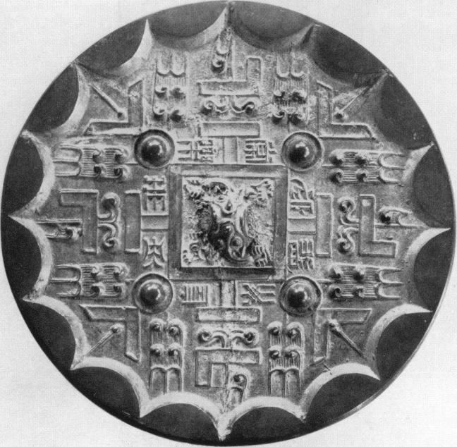

Plate 13  
TLV mirror  
Diam: i3.zcm

*By courtesy of His Majesty, the King of Sweden*

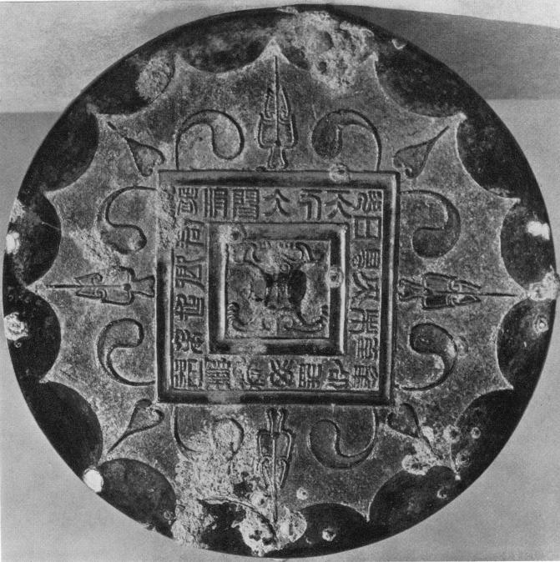

Plate 14  
*Ts'ao-yeh* mirror  
Diam: 13.2 cm

*Formerly M.W.Calmann Collection, Paris*

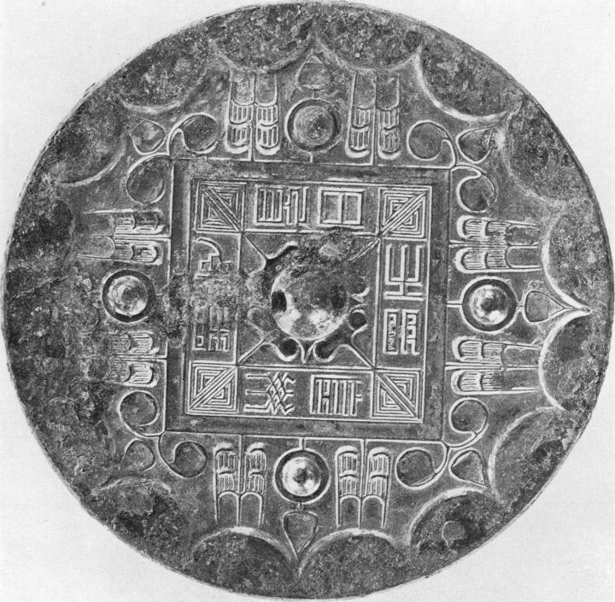

Plate 15  
*Ts'ao-yeb* mirror  
Diam: 11.7 cm

*By courtesy of His Majesty, the King of Sweden*

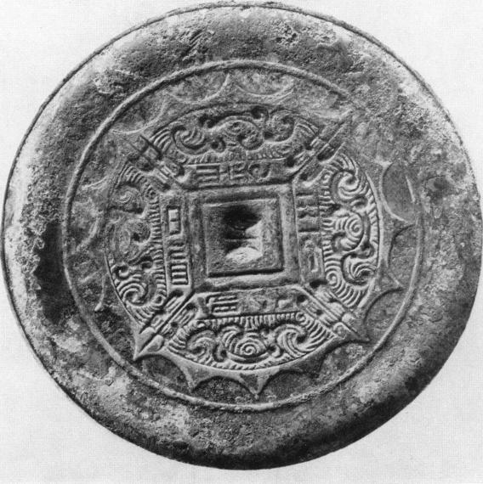

Plate 16  
Mirror with simple spirals  
Diam: ii.6 cm

*By courtesy of His Majesty, the King of Sweden*

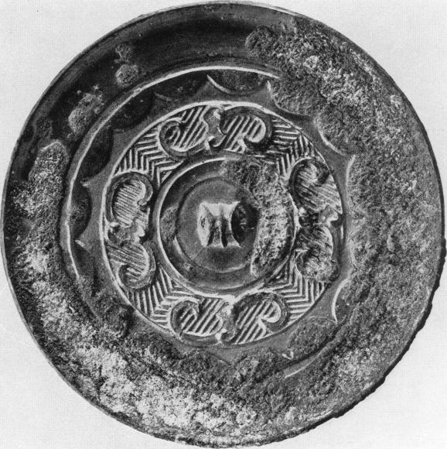

Plate 17  
Mirror with simple spirals  
Diam: 9.5 cm

*By courtesy of His Majesty, the King of Sweden*

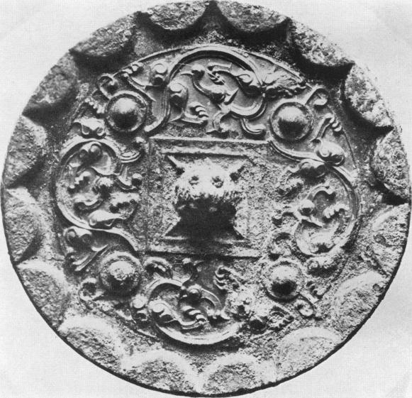

Plate i8  
Mirror with four dragons  
Diam: 11.5 *cm*

*By courtesy of Halimy/ House, Stockholm*

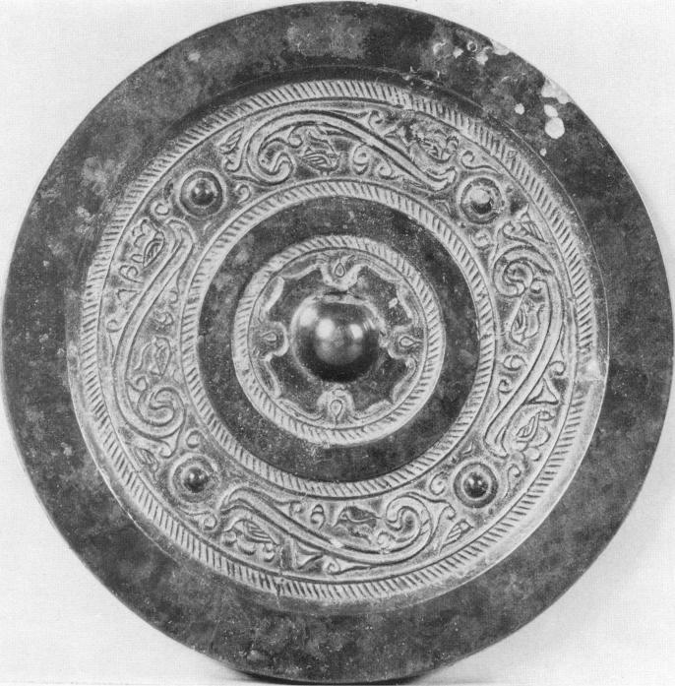

Plate 19  
Mirror with four spirals  
Diam: 15.1 cm

*By courtesy of the University Museum. Philadelphia*

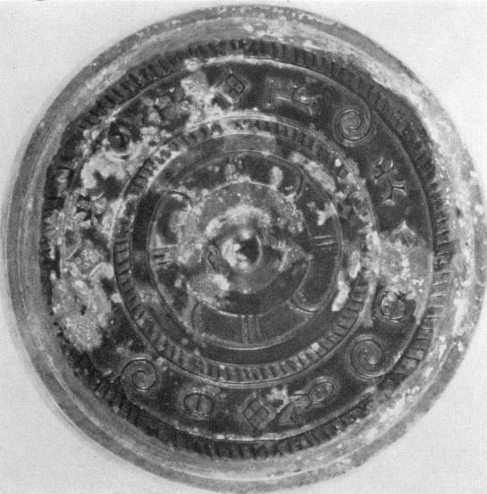

Plate zo  
Inscription mirror  
Diam: 7 cm

*By courtesy of Mr. Frank Caro, New York*

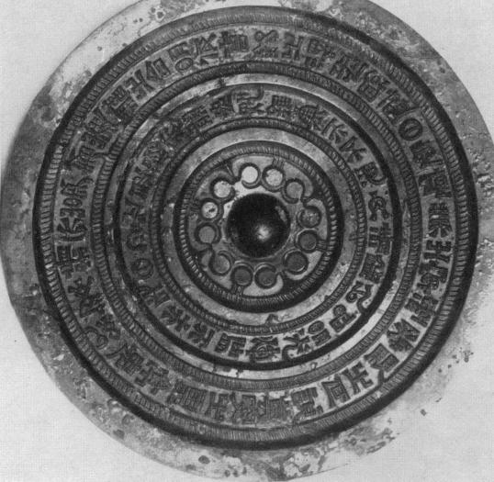

Plate **21**  
Inscription mirror  
*By courtesy of His Majesty, the King of Sweden*

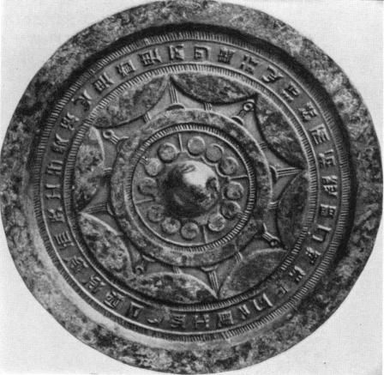

Plate zz  
Inscription mirror  
Diam : 18.5 cm

*By courtesy of Robsska Konstlocljdmuseet, Goteborg*

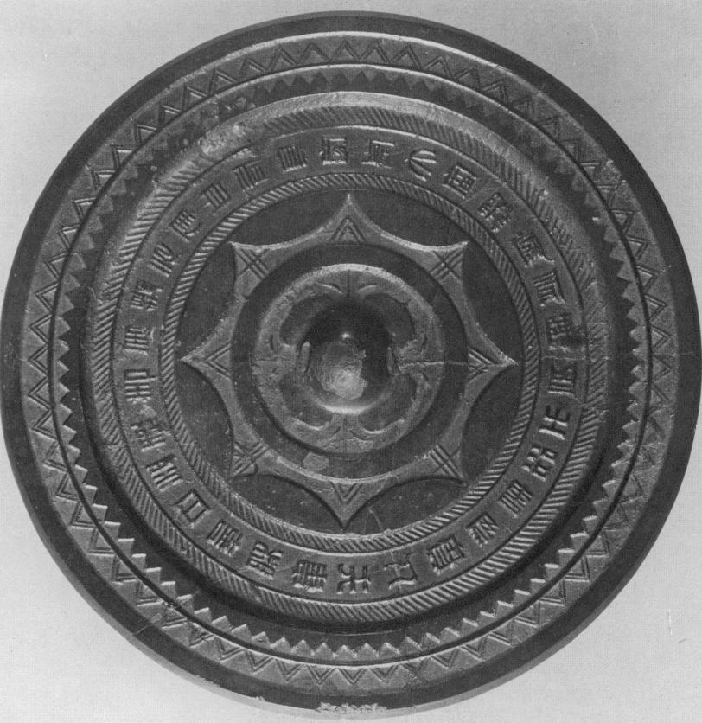

Plate 23

Inscription Mirror (dated A.D. 6.)  
Formerly Moriya Collection  
*By courtesy of Professor S. Umehara*

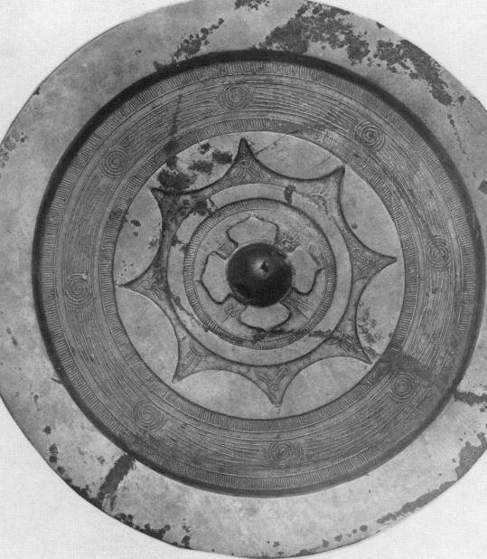

Plate 24  
*Ch'ing-pai* or *ming-kuang,* mirror  
Diam: 21.5 cm

*Formerly David Weill Collection, Paris*

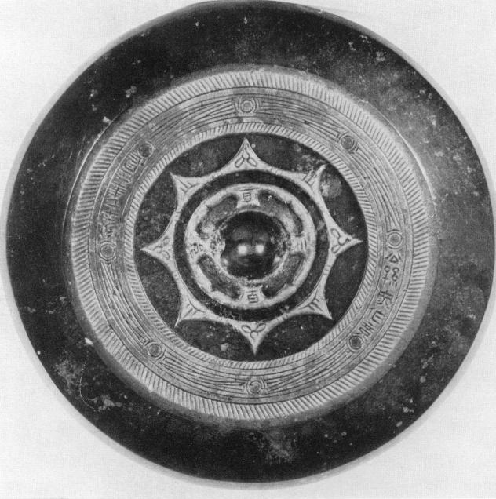

Plate 25  
*Ch'ing-pai* or *ming-kuang* mirror (dated A.D. 64.)  
Diam: 13.4 cm

*By courtesy of the Fogg Art Museum, Harvard University*

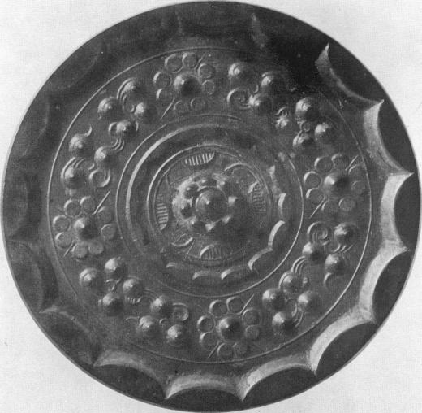

Plate z6  
Hundred Nipples mirror *(pai-ju)*

Diam: 12.9 cm

*By courtesy of the Ostasiatiska Samlingarna*

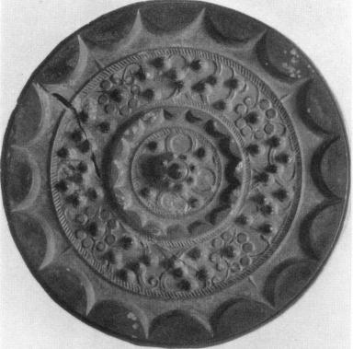

Plate z7  
Hundred Nipples mirror

Diam: 15.1 cm

*By courtesy of Ha1122y1 House, Stockholm*

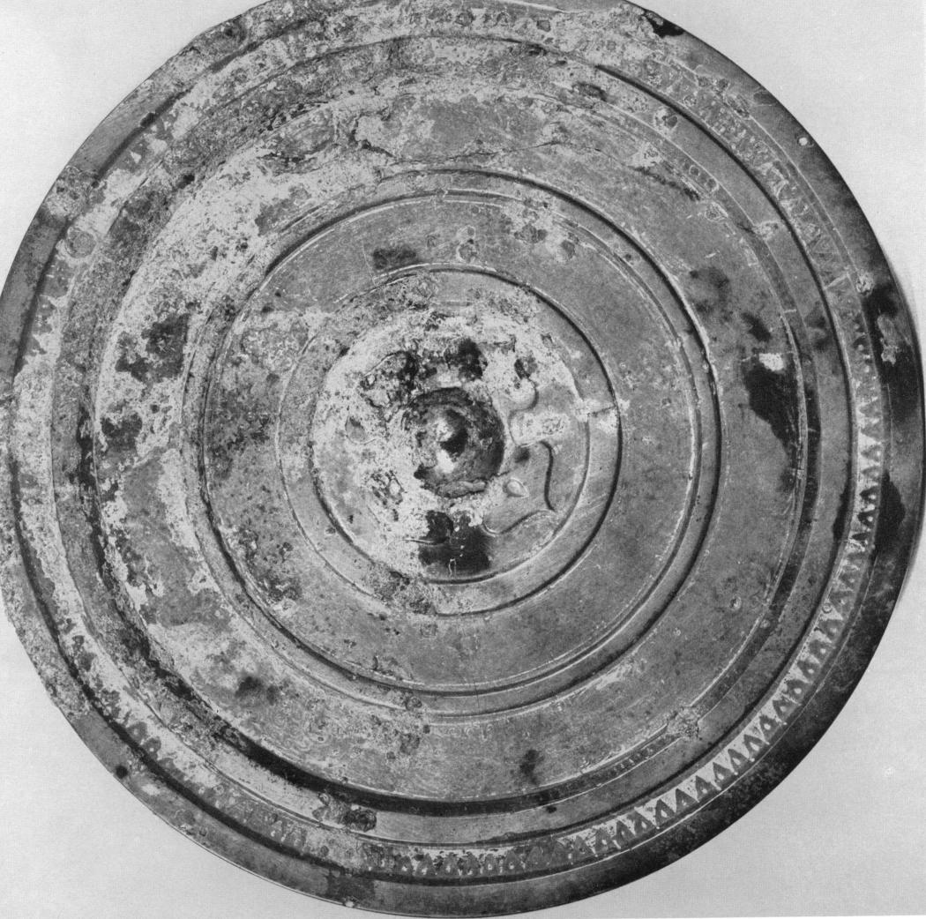

Plate 28  
Mirror with heavy rings *(chung ch'uan)*  
(pattern in gold)  
Diam : 19.4 cm  
*By courtesy of the British Museum, London*

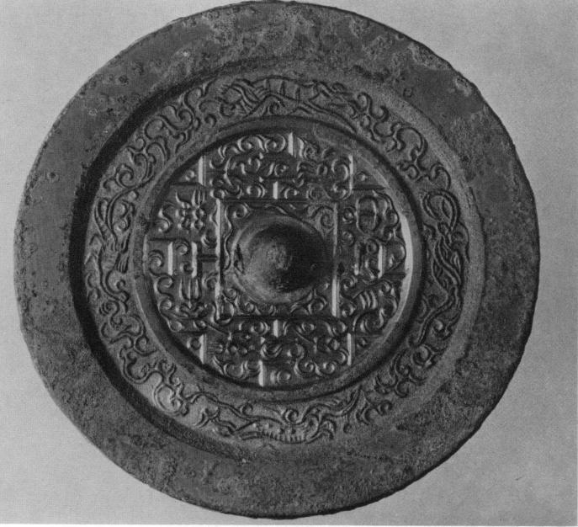

Plate 29  
TLV mirror  
*Formerly Moriya Collection, Japan*  
*By courtesy of Professor S. Umehara*

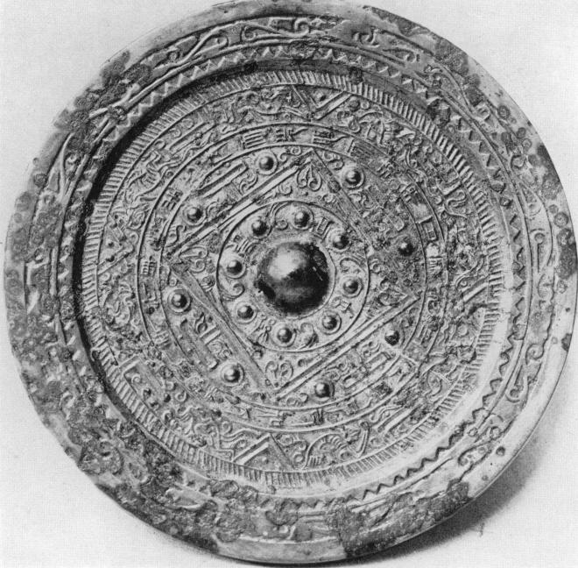

Plate 3o  
TLV mirror

*By courtesy of the Musee du Louvre, Paris*

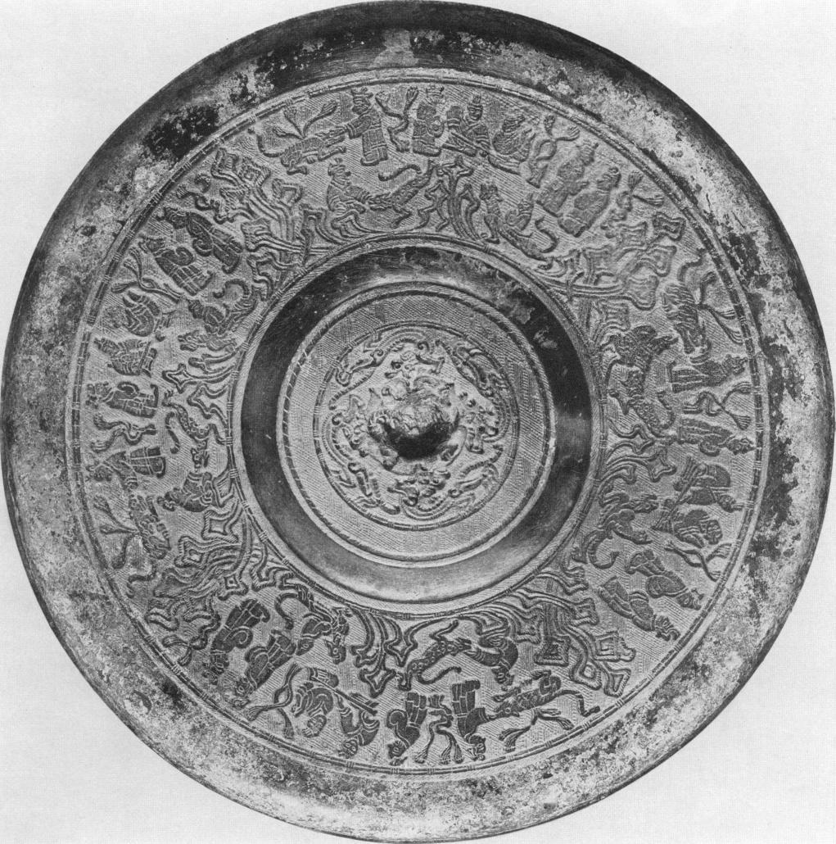

Plate 31  
Shou-chou mirror  
Diam: 18.4 cm  
*By courtesy of the Smithsonian Institution,*  
*Freer Gallery of Art, Washington D.C.*

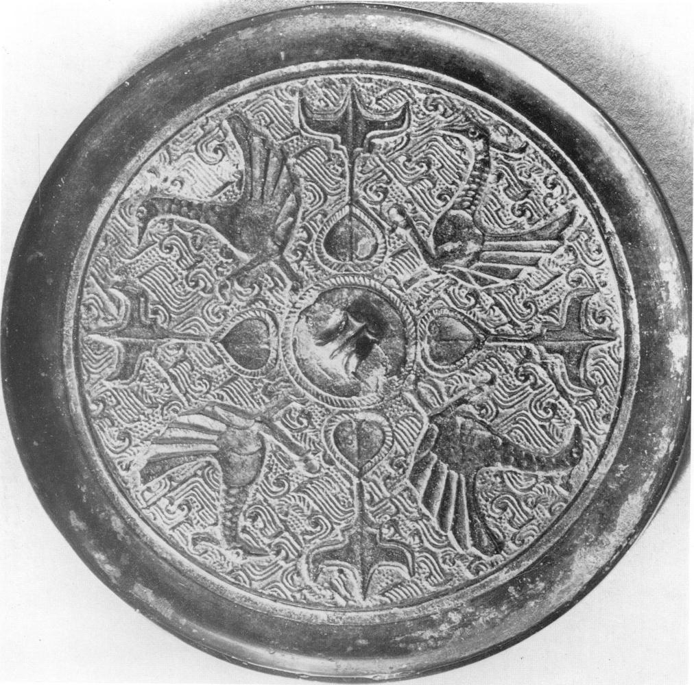

Plate 3z  
Bird mirror  
Diam : i1.6 cm

*By courtesy of Mr. Frank Caro, New York*

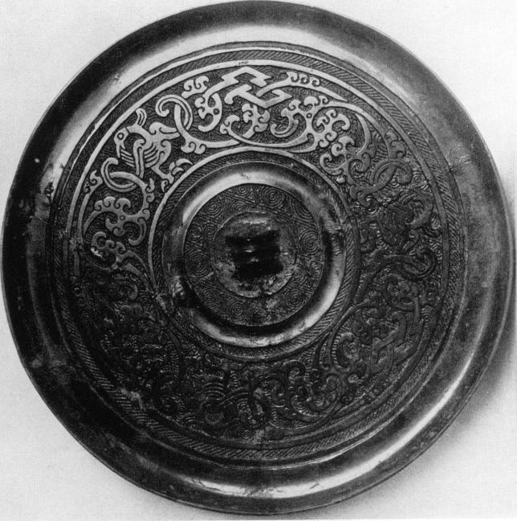

Plate 33  
Bird mirror (Shou-chou)

*Formerly Ostasiatisches Museum, Berlin*

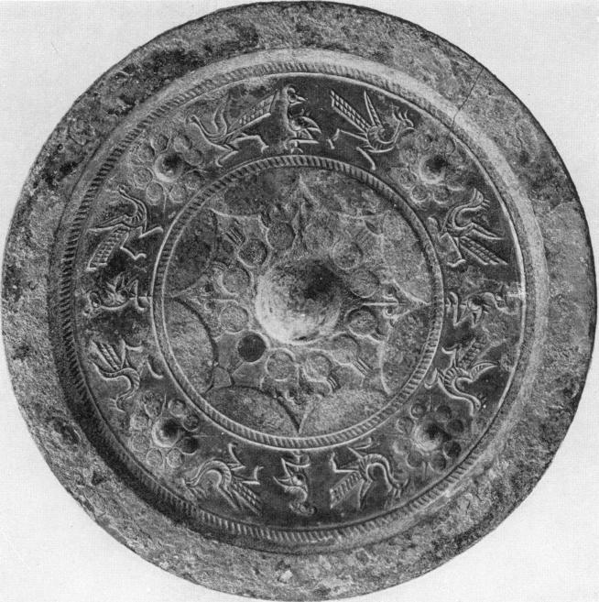

Plate 34

Bird mirror

Diam: 15.1 cm

XVIII *By courtesy of His Majesty, the King of Sweden*

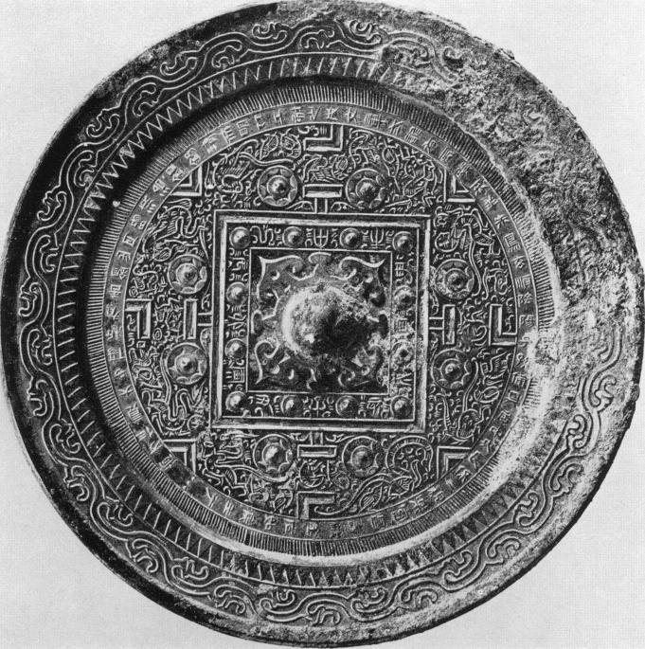

Plate 3 5  
TLV mirror  
Diam: **22** *cm*

*By courtesy of His Majesty, the King of Sweden*

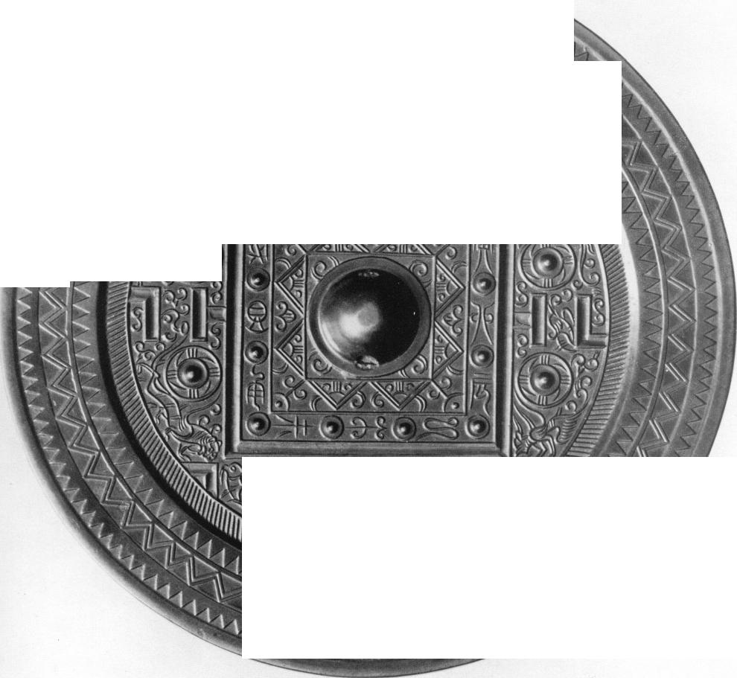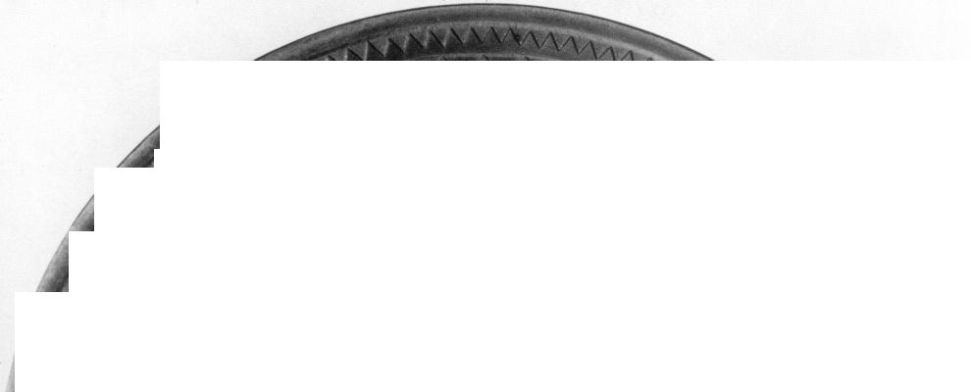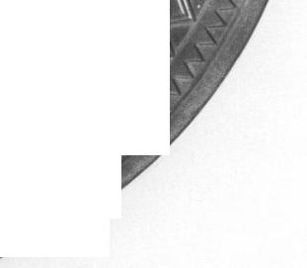

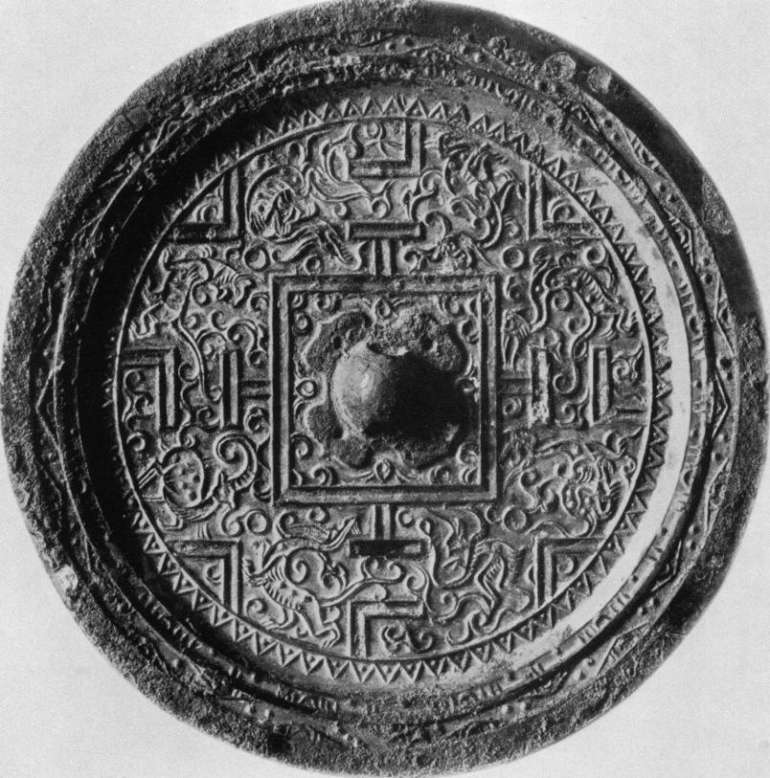

Plate 38  
TL V mirror  
*By courtesy of the Smithsonian Institution,*  
*Freer Gallery of Art, Washington D.C.*

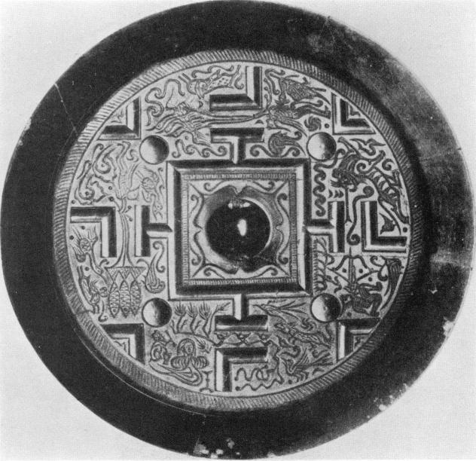

Plate 39  
TLV mirror  
*Formerly Collection of Mr. Liang Shang-ch'un*

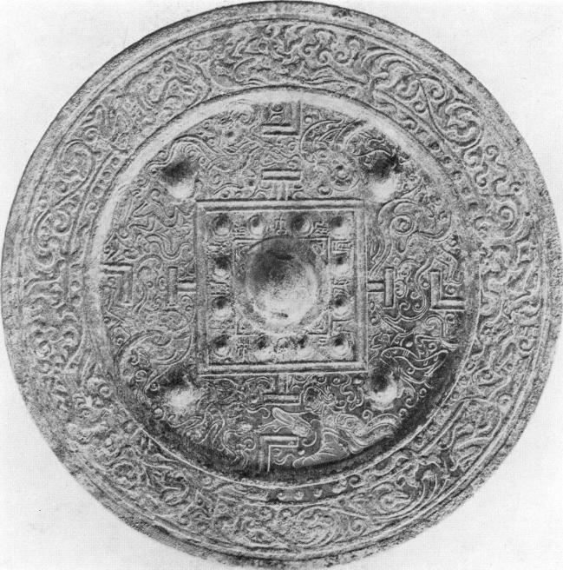

Plate 4o  
TLV mirror  
*By courtesy of His Majesty, the King of Sweden*

|  |
| --- |
| **„..... :....r. .:**  **= i '**  **,...... n••••• /M.N. , MO,**  **....... .,,,,,,,** **mn••••• ••n•n•**  **,..l `...**  n**•••••• ,......**  **0.0.....' ' . '.... • .........**  n**•n... , . ,IN.**  **I...... ..- 1 4.7.4i . "..**  **.0/.** , ...a pm • **,..... .**  **. ' ..,**  ,..•:,,i• / . - ,,,, ,.... ...7.7- "”'  '.1  ,,,o, ...,..."-,...„ „Si ,.•  ,n::, ,... -.-- ..-' ••••.,./ ,_,  ...../. **V ,.. ..tn**  n**'...7..,**  **.11,.. , , : ( .... , , ...m... n . nn,IMIN,**  **-,* 4Z".././K-** - **'**•  ***,* :*''* ;.*" '* ,*_*-*W***  ***e .* ,,*-*, e. *'* .*Z-*.*:*..*.*. %4**  **:,ri**  **\: '**  **.., . _..o.:2 ...; ;.... st_,,.._.7----:(,,..7c*".7 —..- ',**  **171112=Zrri— •-e' 'n MOM= • ,-'‘.**  **.\.. 4,.......--..z...- ,,;•:**  **.. . • ...,.. ,_ 4.7;4. .._:' ,„„,..— : -• -**  **........„**  **,../,,,,i ..."AlLtrr, 'Nac .......—**  **- .**  ***n"...* .**  **n"!**  **.....,,s a0.4. /4 . • d. ((.::•°"".. . ' 0.' '' .:.'**  **.... • .**  **.. r,**  **....•n / , '7. ,'.**  **.......... . / V.. A 10**  **'Tr; \ ./........ in./7,tt , . -1, .."" 1111.=1W ''...//../ \ .01.:, (Z., ;,•'. \ .**  **. \ .... , . ..Nr . ...T.-**  **Oe ..*.e..... `,_...,/,'1. F., ' ••••n•n•n••n .'"'", ,,X.j).0'**  **ae... r . IN. , .,...............,,,,,,**  **....- n11.. r ..-. - ' • " ..S. %.4.1.... ..,1' '**  **N....r ' r../........" ...... / .:::7. ,.....„ , *......*** |

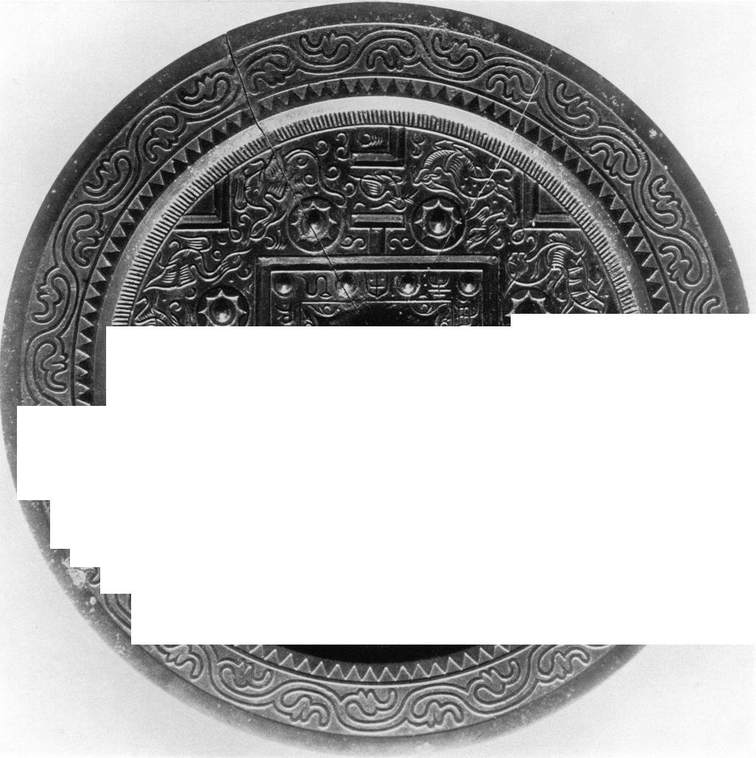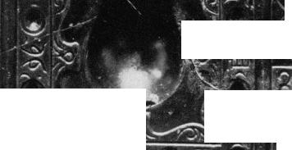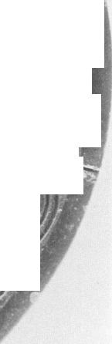

Plate 41  
TLV mirror  
*By courteiy of the Museum of Fine Arts, Boston*

***' I***

***' .***

**• ilk**

**7e.**

**, • „el "**

**/ • • =‘' nf:**

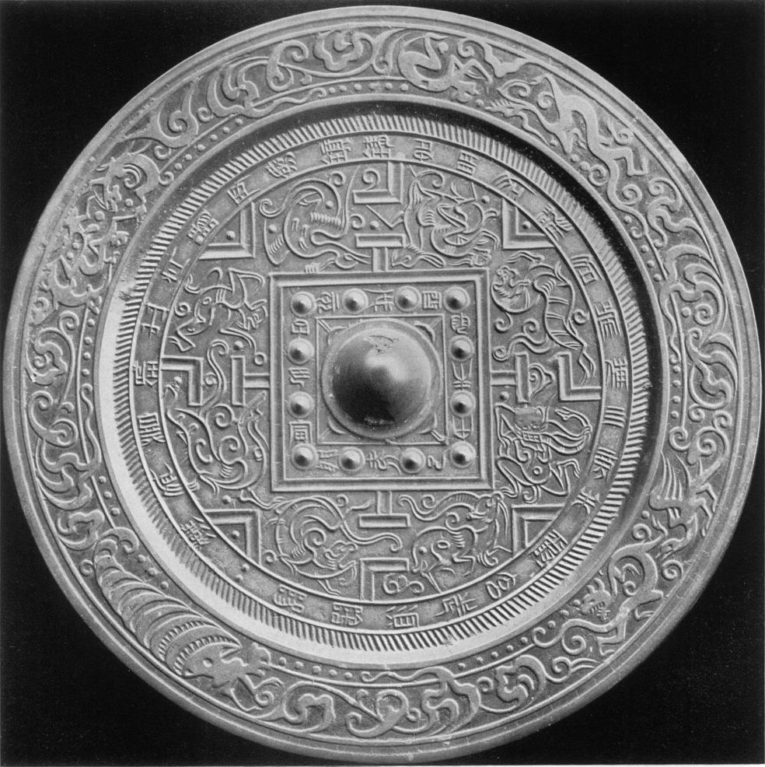

Plate 42  
TLV mirror  
Diam: 18.3 *cm*

*By courtesy of the Nelson Gallery*  
*Atkins Museum ( Nelson Fund), Kansas City, Missouri*

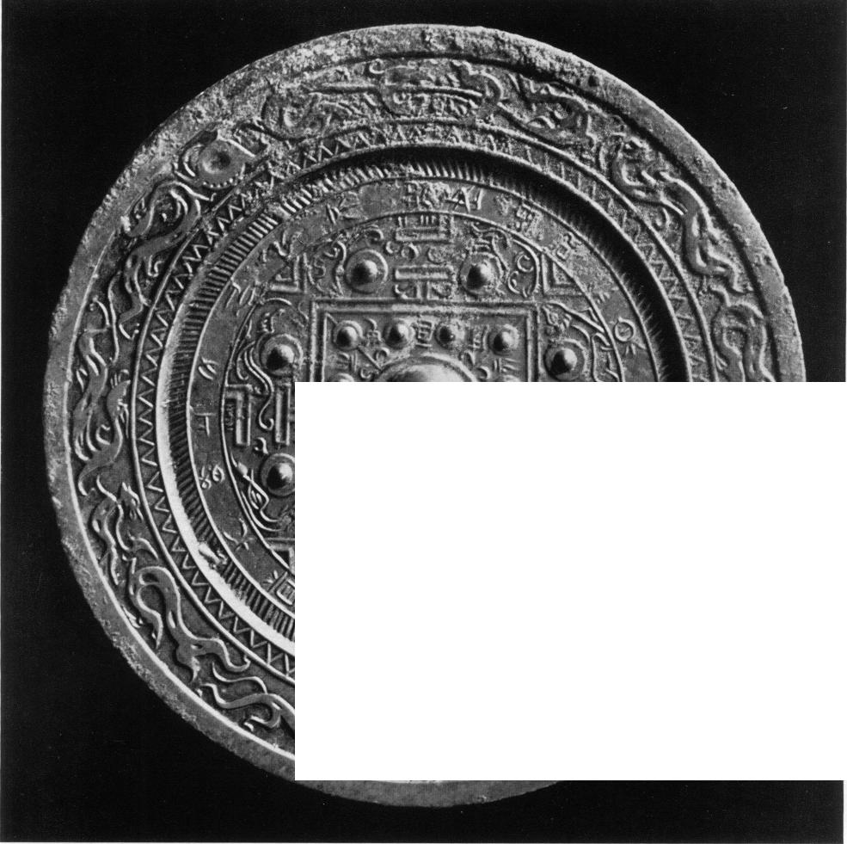

|  |  |
| --- | --- |
| Plate 4z a TLV mirror  *By courtesy of the Raymond* *A. Bidwell Collection* *Museum of Fine Arts* *Springfield, Mass.*  tll't  ......,,, :.  ....-1..!-,   * P   ...1.:'.1.40EY i''   * so.   n -it .1%$ .76 0 **A k ..**  **,.,.„**  *1 ',*  ***.r., ki, --.2. i‘ ''• • :, • •'•***  ***, ..***  .mot. ***.., .. .4 -.4411.* ....d 4. +0.4*.11,-".... .1-- 1;,,,,.. ,..1:-.7**  **N.`**  **;:...14'*--ii. I. Ir.**  **.... i .**  **N., .,\ --"___. 1" . 1 - i \. " : ...!:St. • --....::.7 !"" ' '''' 1W .**  **‘ -......_-__ 1,7.1.21 .. n9 7..., „.... ..,..\,, , \**  !.....r..„.• •.7..„„ ,,..„‘, sue**' _**  **, : v__ % . , <',#1. . ,.r. _.,**  **1\ k)**  **- '**  **\ /V V.V‘i \I\I 1/4.. n .-...........**  Sk.. - ....  **.44 s _ .. Nib . :An ' . •** | Plate 43 TL mirror Diam: 18,5 cm  *By courtesy of the Royal Ontario Museum, Toronto*  XXV |

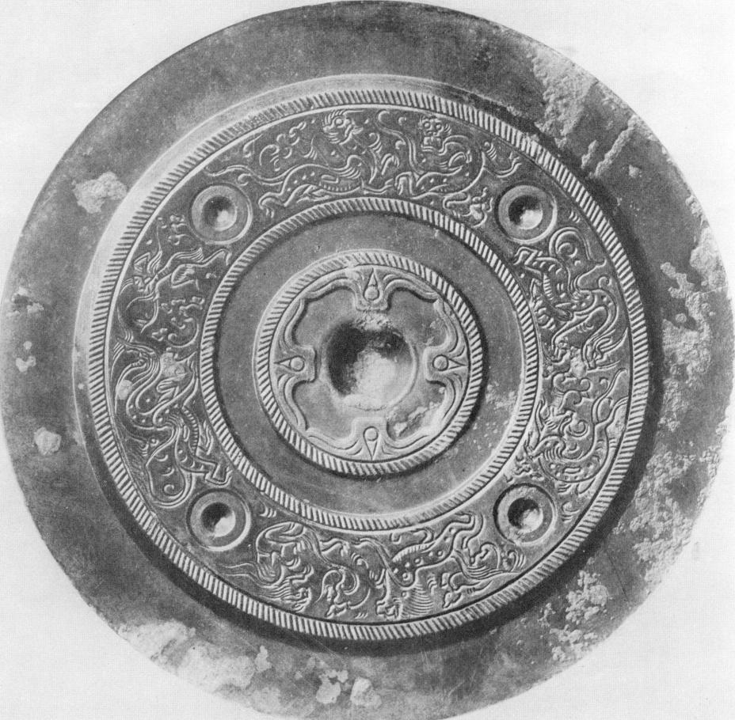

Plate 44  
Animal-belt mirror *(Sbou-tai)*  
*From the collection of the late Kenzo Tomioka*  
S. Umehara, *Tokan Kokyo Zuroku,* Pl. zz

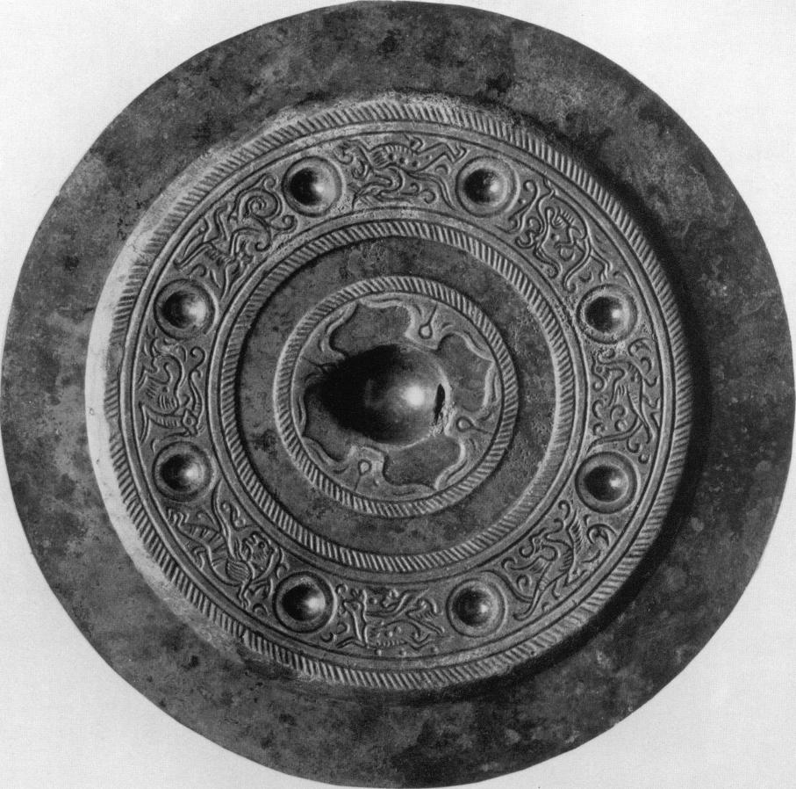

Plate 45  
*S'bou-tai* mirror (eight nipples mirror)

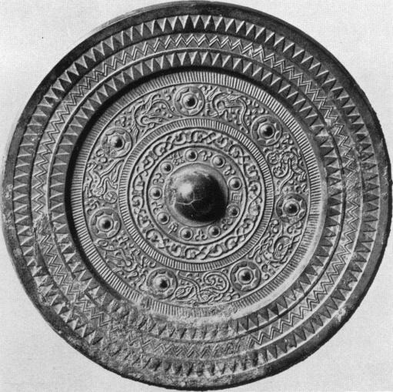

Plate 46  
*,Vhou-tai* mirror (seven stars mirror)

*By courtesy of the Museum fur Ostasiatische Kunst, Cologne*

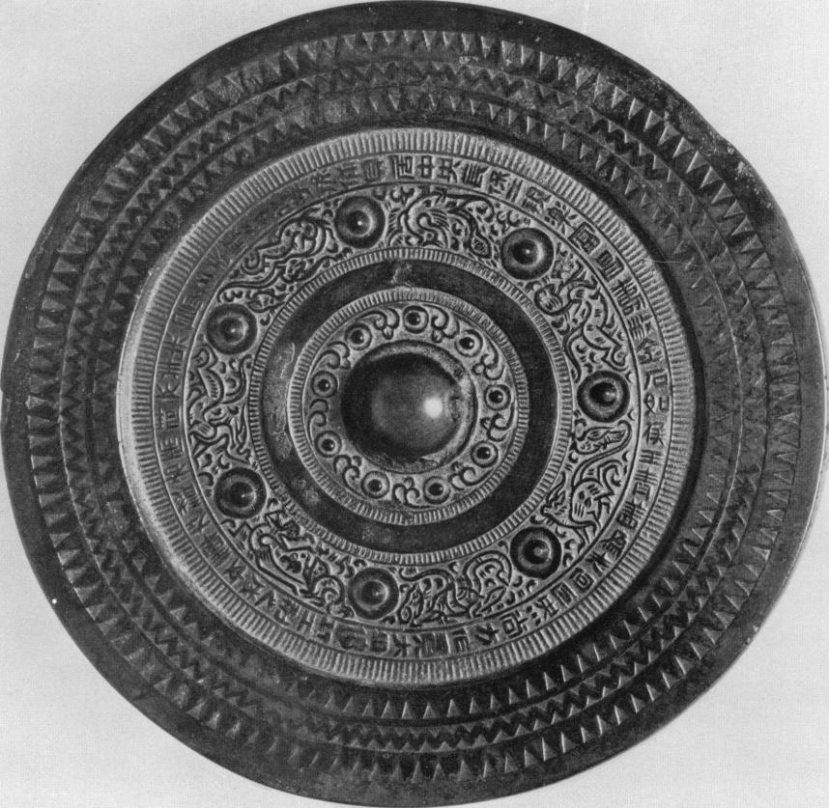

Plate 48

*Shou-tai* (seven stars) mirror (gilded)  
*Former Moriya collection*

XXVIII *By courtesy of Professor S. Umehara*

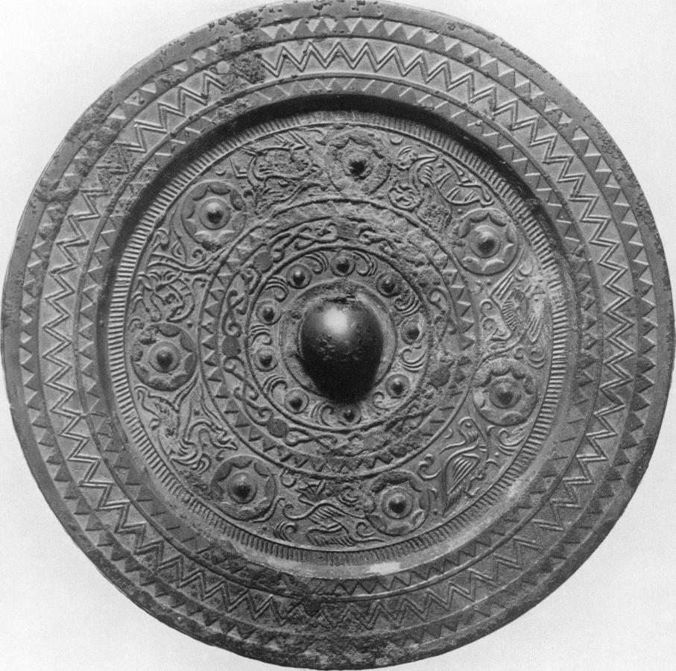

Plate *47*  
*Shou-tai* (seven stars) mirror

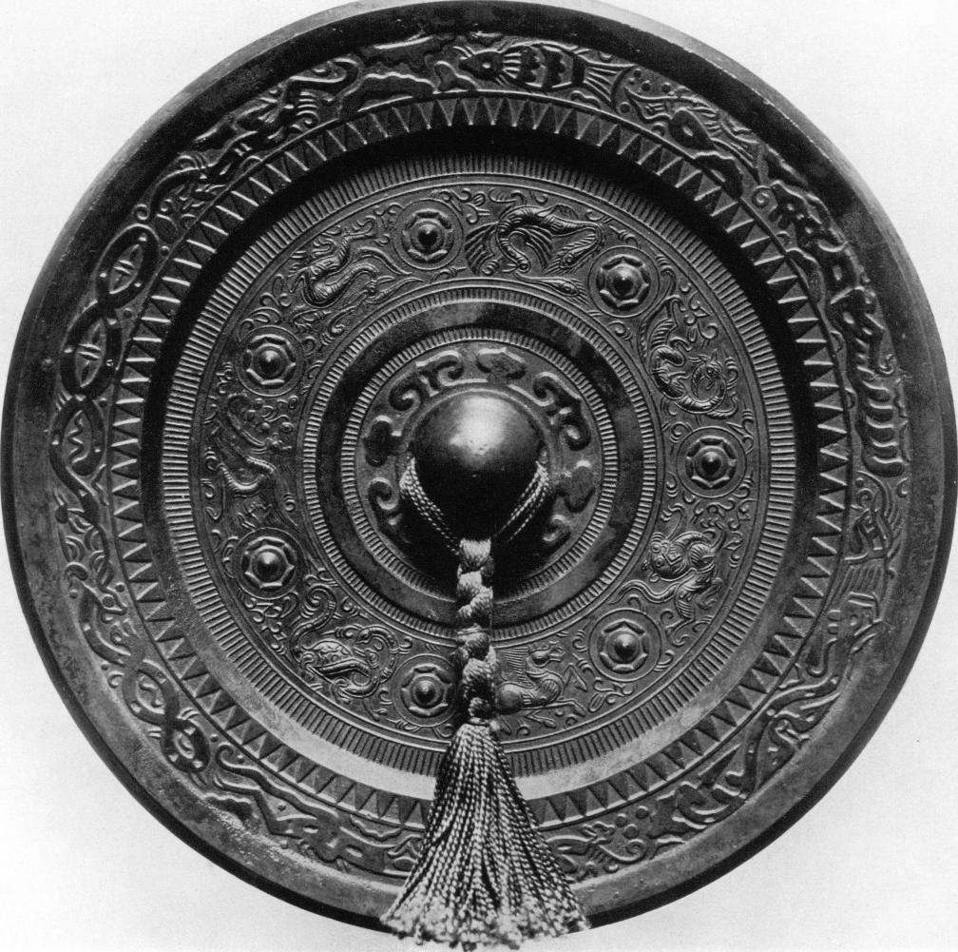

Plate 5o  
*Shou-tai* (seven stars) mirror  
*By courtesy of the Museum of Fine Arts, Boston*

|  |  |
| --- | --- |
| Plate 49 *Shou-tai* (seven stars) mirror *By courtesy of Mr. Frank Caro, New York* |  |

|  |  |
| --- | --- |
|  | Plate 51 *Shou-tai* (seven stars) mirror Diam: i8 cm  *By courtesy of Mr. Frank Caro, New York* |

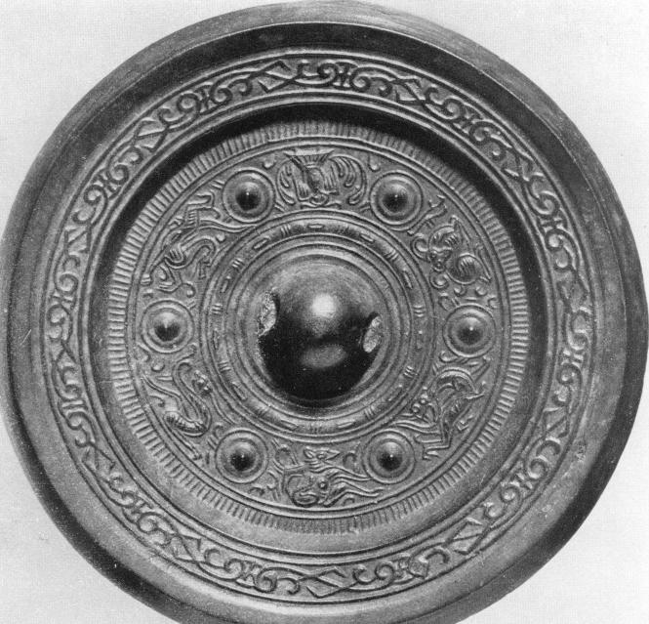

--Amisiessegase:

Plate 52  
*Sbou-tai* (six nipples) mirror  
Diam: 11.5 *cm*  
*By courtesy of the Smithsonian Institution,*  
*Freer Gallery of Art, Washington D.C.*

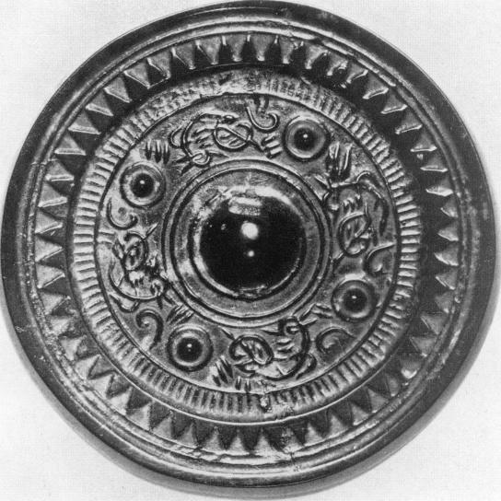

Plate 53

Bird mirror Diam: 9 *cm*

XXXII *By courtesy of Mr. Dugald Malcolm, London*

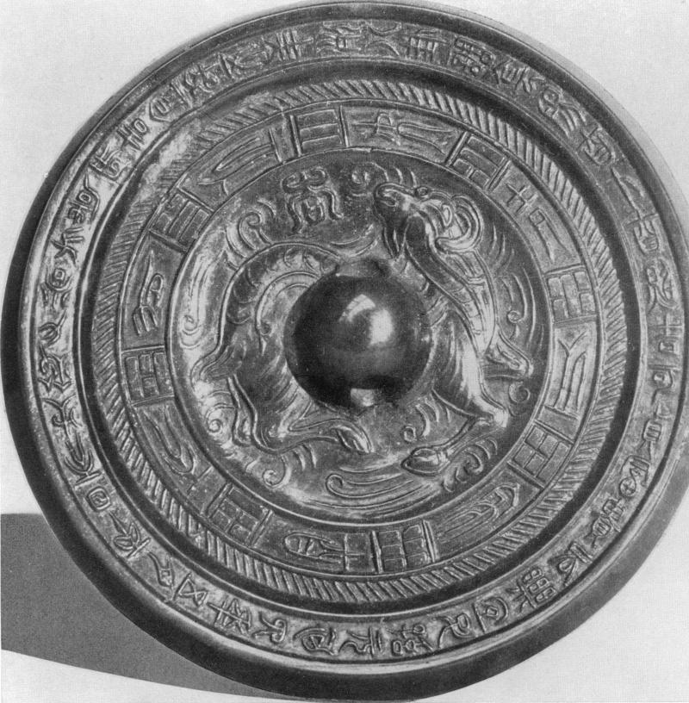

Plate 57  
Mirror with sheep in relief (dated A.D. 117)  
Diam: io.**z cm**

*By courtesy of the British Museum, London*

|  |  |
| --- | --- |
|  | Plate 59  *Shou-tai* mirror with a dragon-tiger centre Found in Tomb No. z in Lo-lang, Korea Sekino. *Archaeological Researches in the ancient* *Lo-lang district.* Vol. I, Pl. 89 |

|  |  |
| --- | --- |
| Plate 61  *Shou-tai* mirror with *lung-hu* centre (dated A.D. 291) Diam: 18 cm  *By courtesy of Mr. Frank Caro, New York*  XXXVI |  |

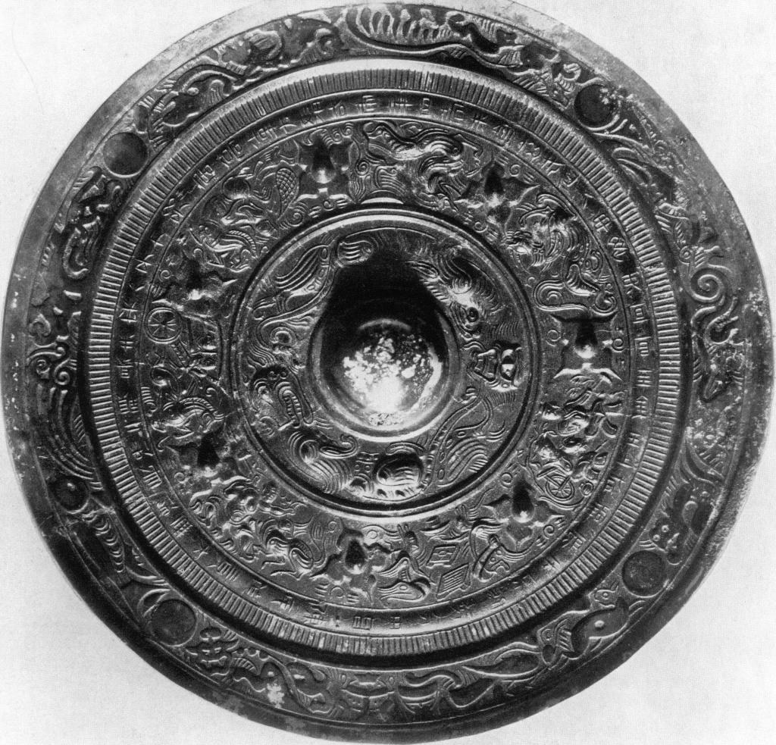

Plate 6o  
*Shou-tai* mirror with *lung-bu* centre  
*Courtesy of the Museum of Fine Arts, Boston*

|  |  |
| --- | --- |
| Plate 6z Animal head *(.thou-.thou)* mirror  *By courtesy of His Majesty,* *the King of Sweden* |  |

|  |  |
| --- | --- |
|  | Plate 63 *Shou-shou* mirror *By courtesy of His Majesty, the King of Sweden* |
| XXXVIII |  |

|  |  |
| --- | --- |
| Plate 64 *Shou-.Thou* mirror Diam: 1z cm  *By courtesy of the Ostasiatiska Samlingarna, Stockholm* |  |

|  |  |
| --- | --- |
|  | Plate 65 Four panels mirror (dated A.D. 139) *Formerly Moriya Collection* *By courtesy of Professor S.Umehara*  XXXIX |

|  |
| --- |
| \Ik  - "7111—il . -11111  41.  /.) T.' i I it , ,.. , 0 *lip*  /,), , -,,,, , ' » ,,,, .;.1.11 9 )' () *iii,*  4  7 n ii  .),,.  ,il‘ *r,,,,;..* :114. 1i1 _,, ' ***I***  *II ''' I\ e':*  *i . .N( 14, (.('' .* .f /)11) )  ( ' \\I . *f* 1/ 't '1,11 1 /,  ..N. ; . T *p* ,:.,‘,.  *i!,* r,  (74 ..l'ir ffiCi  y.  1,Z frl ('  1,,  lit( hi f  .4„,,,,',, !.• / 0 , |

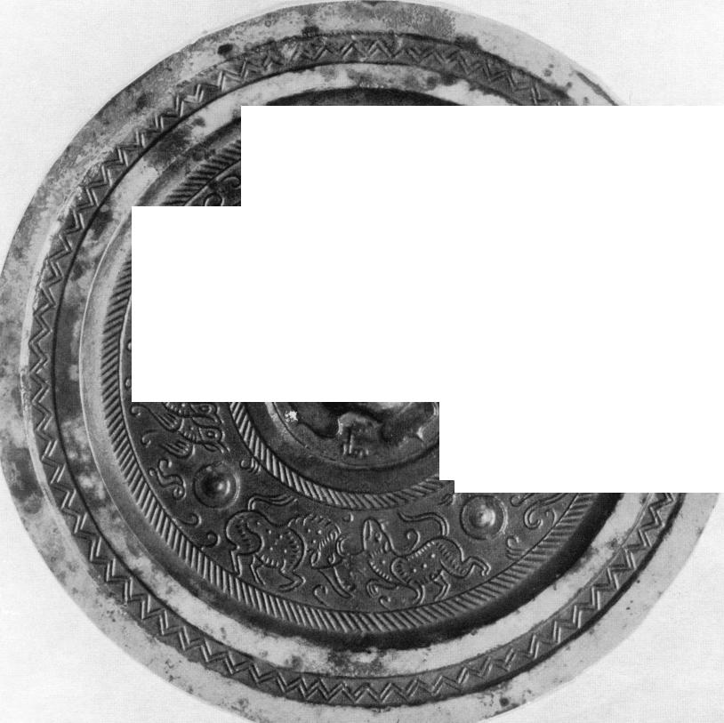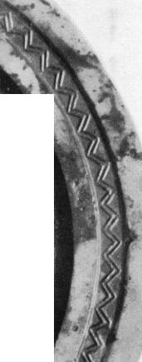

Jo

Plate 66  
Mirror with pictorial decoration  
*( Hua-hsiang ching)*  
*By courtesy of the Smithsonian Institution,*  
*Freer Gallery of Art, Washington D.C.*

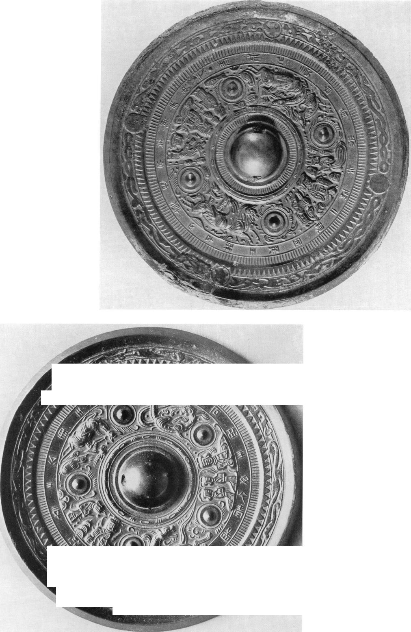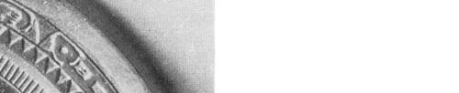

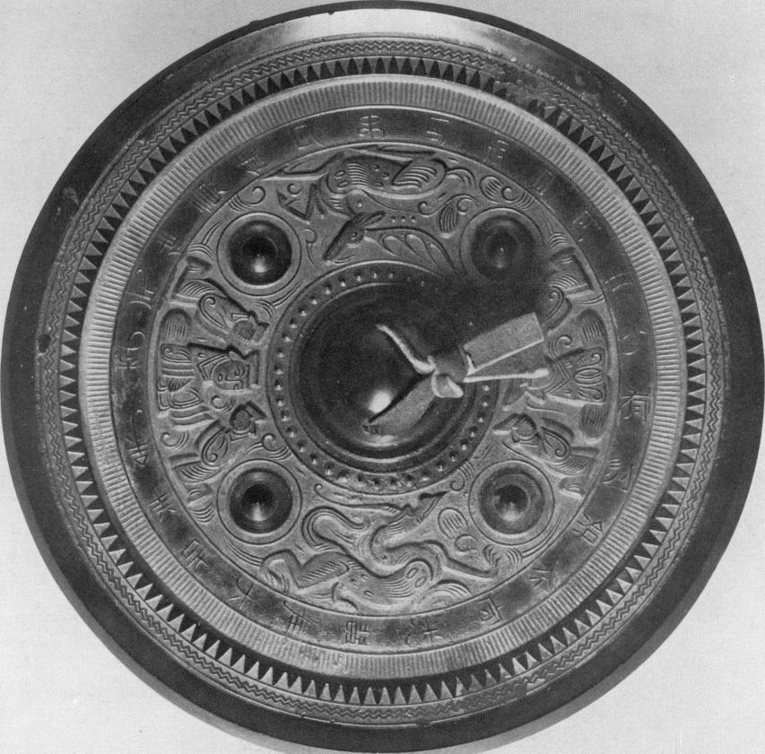

Plate 69  
*Hua-hsiang* mirror  
*Formerly Moriya Collection*  
*By courtesy of Professor S. Umehara*

Plate 71  
*Hua-hsiang* mirror  
(with chariots and horses, *ch'e* ma)  
Diam: zz cm

**• 6, 04**

**•q•-;:k1.,**

**'a' •**

*By courtesy of the British Museum, London*

Plate 7o  
*Hua-hsiang* mirror

*/1/riory'7/'*

*Will1/11/111/11///\*\** • c'

tee

Diam: **22 CM**

*By courtesy of the University*  
*Museum, Philadelphia*

Plate 72  
*Hua-hsiang* mirror *(ch'e-ma)*

•

4:4

' r-4

Yrj !,/".

., t).:- - ollimumummul

, ‘,$0

.4,

. ,

,,,,-

Diam: **21.4** cm

*By courtesy of Mr. Frank*  
*Caro, New York*

XLIV

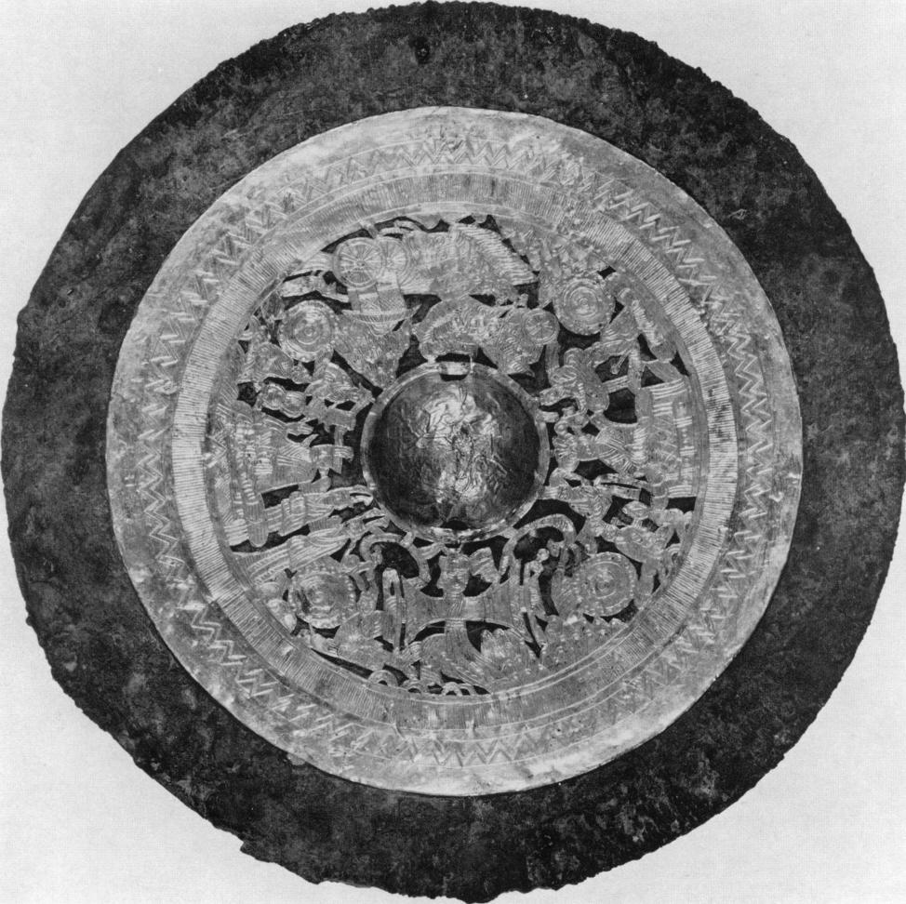

Plate 73  
*Hua-bsiang* mirror *(ch'e-ma)*  
Iron mirror with gold sheet  
Diam: 16.3 cm  
*By courtesy of the Smithsonian Institution,*  
*Freer Gallery of Art, Washington D.C.*

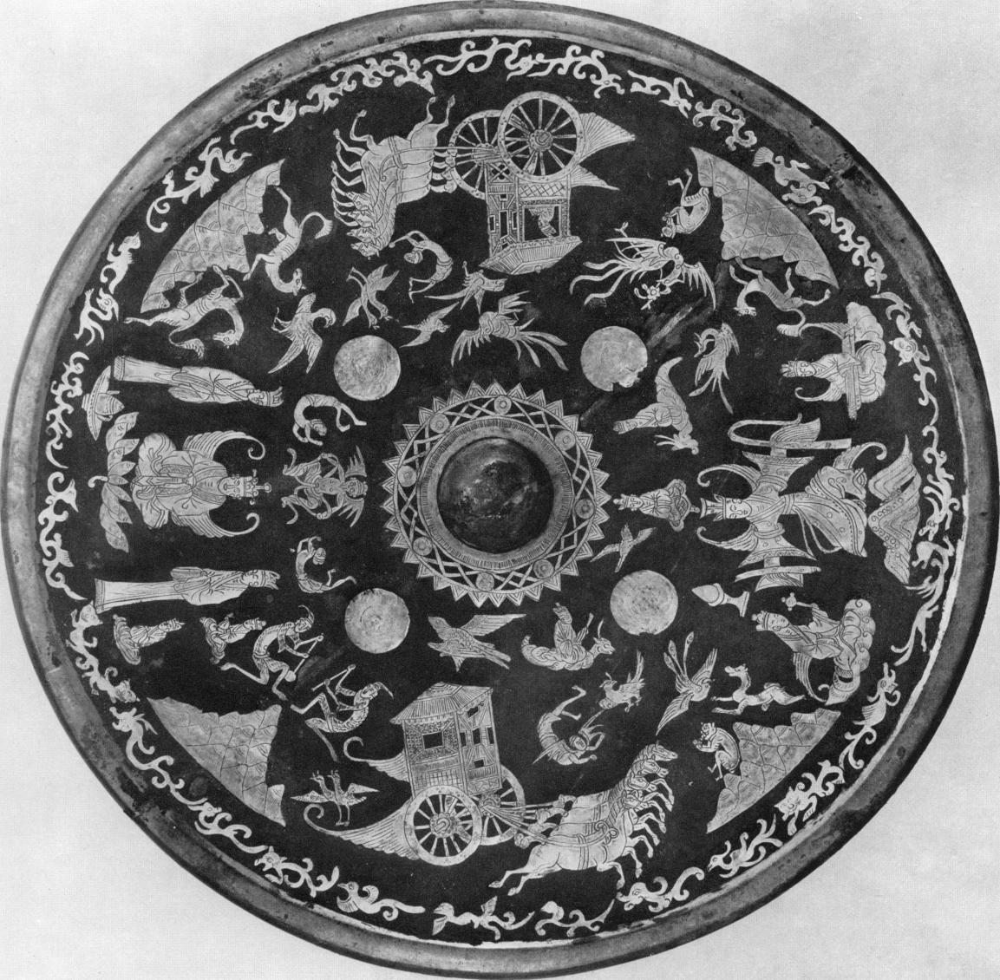

Plate 74  
*Hua-hsiang* mirror *( ch'e ma)*  
With engraved silhouettes of gold and silver  
embedded in lacquer  
Diam: 27 *cm*  
*By courtesy of the Smithsonian Institution,*  
*Freer Gallery of Art, Washington D.C.*

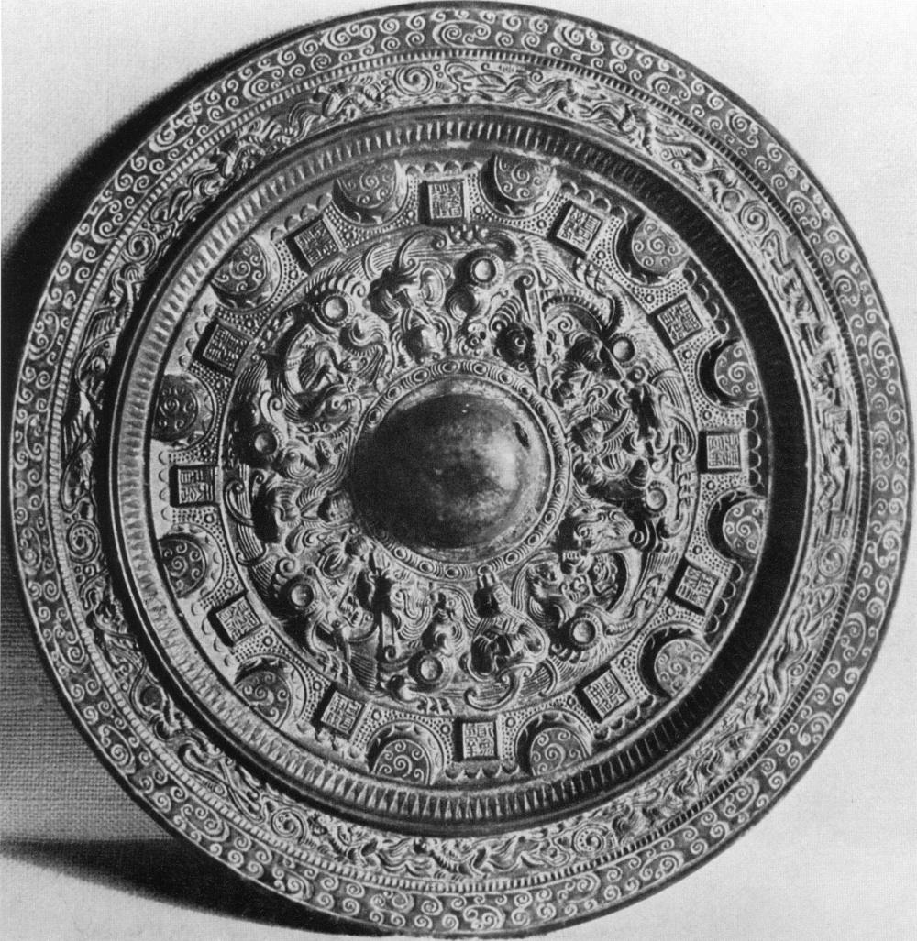

Plate 75

*Hua-hsiang* mirror with *pan-yiian fang-chio* belt  
*By courtesy of Mr. John Hadley Cox, Chevy Chase, Maryland*

|  |  |
| --- | --- |
|  | Plate 76  *Hua-hsiang* mirror with *pan-than* *fang-chio* belt Diam: i8 cm  *By courtesy of Hallwyl House,* *Stockholm* |

|  |  |
| --- | --- |
| Plate *77* *Hua-hsiang* mirror with *pan-than* *fang-chio* belt  *By courtesy of the Metropolitan* *Museum of Art, Rogers Fund.* *1917, New York*  X LVIII |  |

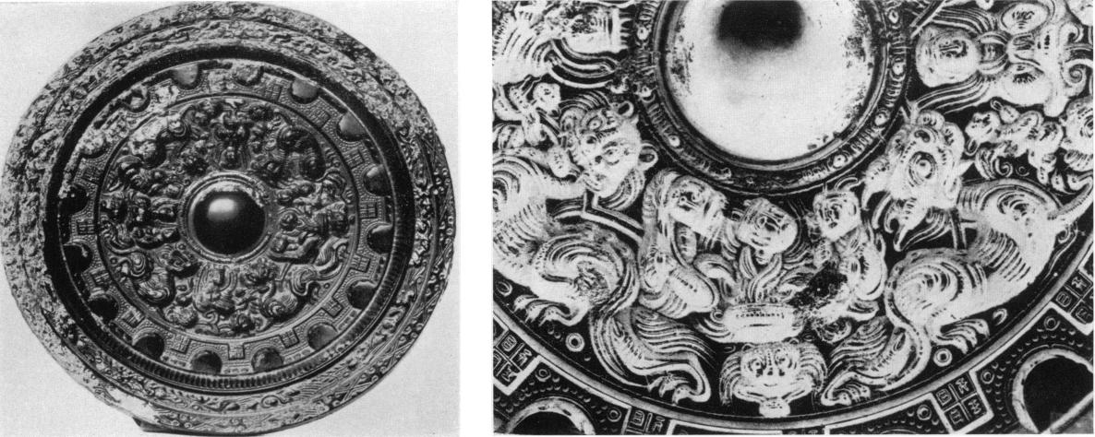

Plate 78 Plate 78 a

*Hua-hsiang* mirror with *pan-yiian fang-chio* belt Detail of Plate 78

Diam: 11.5 cm

*Formerly Ostasiatisches Museum, Berlin*

XLIX

Plate 79 *Hua-hsiang* mirror with *pan-yiian fang-chio* belt  
Diam: 18 cm

*By courtesy of Mr. Richard C. Bull, Villanova, Pa.*

Plate 8o  
Mirror arranged in tiers *(thing lieb)*  
Diam: II cm

*By courtesy of Mr. Frank Caro, New York*

Plate 81  
*Chung lieh* mirror

*By courtesy of the Museum of Fine Arts,*  
*Boston*

L